Federal Government of Somalia


‘BARWAAQO’ SOMALIA WATER FOR
RURAL RESILIENCE PROJECT



PRoject ID: 177627
dated: December 2022

Contents
Abbreviations and Acronyms viii
1. About This Manual 1-1
Governance of This Manual 1-1
2. Project Description 2-1
Project Geographic Coverage 2-4
Project Beneficiaries 2-4
Project Components and Subcomponents 2-1
Component 1: Support the Development of Multiuse Water Sources (US$26.3 million) 2-1
Component 2: Development of Agriculture and Livestock Services around Water Points (US$15.5 million) 2-3
Component 3: Development of Environmental Catchment Services in Project Areas (US$10 million) 2-5
Component 4: Project Management, Community Development, and Enhancing Livelihoods Planning (US$17.5 million) 2-7
3. Project Implementation Approach 3-1
Workplan Development and Budgeting 3-6
Quarterly Budget Process and NOLs 3-7
Component 1: Support the Development of Multiuse Water Sources 3-8
Key Activities for Component 1 3-8
Subcomponent 1.1: Construction of New Water Points 3-14
Key Activities for Subcomponent 1.1 3-14
Subcomponent 1.2: Rehabilitation of Existing Water Points 3-15
Key Activities for Subcomponent 1.2 3-15
Subcomponent 1.3: Institutional and Capacity Development 3-16
Key Activities for Subcomponent 1.3 3-16
Component 2: Development of Agriculture and Livestock Services around Water Points 3-17
Key Activities for Subcomponent 2 3-18
Subcomponent 2.1: Increased Sustainable Farming Production and Development 3-18
Key Activities for Subcomponent 2.1 3-19
Subcomponent 2.2: Increased Sustainable Livestock Production and Development 3-20
Key Activities for Subcomponent 2.2 3-21
Subcomponent 2.3: Institutional and Capacity Development 3-21
Key Activities for Subcomponent 2.3 3-22
Component 3: Development of Environmental Catchment Services in Project Areas 3-23
Implementation Arrangements 3-23
Key Activities for Component 3 3-23
Subcomponent 3.1: Environmental Restoration 3-24
Key Activities for Subcomponent 3.1 3-24
Subcomponent 3.2: Institutional and Capacity Development 3-25
Key Activities for Subcomponent 3.2 3-25
Component 4: Project Management, Community Development, and Enhancing Livelihoods Planning 3-26
Key Activities for Component 4 3-27
Subcomponent 4.1: Project Management 3-27
Key Activities for Subcomponent 4.1 3-28
Subcomponent 4.2: Community-Driven Development Planning 3-28
Key Activities for Subcomponent 4.2 3-29
Subcomponent 4.3: M&E, Knowledge Management, and Learning 3-30
Key Activities for Subcomponent 4.3 3-30
Subcomponent 4.4: Contingent Emergency Response 3-30
Key Activities for Subcomponent 4.4 3-31
4. Project Management and Institutional Arrangements 4-32
Project Locations 4-32
Roles and Responsibilities: Federal Level 4-33
Roles and Responsibilities: State Level 4-34
Roles and Responsibilities: Community Level 4-35
Oversight Arrangements 4-39
Staffing of PIUs 4-39
Implementation Support/ Supportive Supervisions 4-40
Sustainability 4-41
Operation and Maintenance of Water Points 4-41
5. Project Procurement Arrangements 5-1
Guidelines and Regulations 5-1
Procurement Implementation Arrangements 5-1
Project Procurement Strategy for Development and Procurement Plan 5-1
Systematic Tracking of Exchanges in Procurement 5-2
Main Procurement Activities 5-2
Forced Labor Risk in the Procurement of Solar Panels/Components 5-3
Service Delivery Contracts 5-3
Selection Methods for Goods, Works, and Nonconsulting Services 5-4
Request for Proposals (RfP) 5-4
Request for Bids (RfB) 5-4
Request for Quotations (RfQ)/Shopping 5-4
Direct Selection 5-5
Selection Methods for Consulting Services 5-6
Quality and Cost-Based Selection (QCBS) 5-6
Fixed Budget-Based Selection (FBS) 5-6
Least Cost-Based Selection (LCS) 5-6
Quality-Based Selection (QBS) 5-7
Consultant’s Qualification-Based Selection (CQS) 5-7
Direct Selection 5-7
Selection Methods for Individual Consultants 5-8
Complaint Handling 5-9
Thresholds 5-9
6. Financial Management 6-1
Project Planning and Budgeting Activities 6-2
Accounting Policies and Procedures 6-2
Internal Control Framework 6-3
Financial Reporting and Monitoring 6-4
Funds Flow Disbursement and Banking Arrangements 6-4
Fraud and Corruption Risks 6-8
Conclusion and Supervision Plan 6-8
Procedures for traveling and workshops 6-9
7. Adherence to the Agreed Environmental and Social Risk Management Arrangements 7-1
ESMF Instruments 7-3
Environmental Risks 7-4
Social Risk Management 7-6
Involuntary Resettlement 7-7
Gender 7-7
Disability 7-9
Grievance Mechanism 7-9
Incident and Accident Reporting 7-12
Safeguard Documentation, Disclosure, and Reporting 7-12
8. Reporting, Monitoring, and Evaluation 8-1
Annex 1. Readiness Criteria 1
Site Selection Criteria 1
Socioeconomic Criteria 2
Physical Criteria 2
Readiness Criteria for National and State Agency Participation in the Project 3
Readiness Criteria for Community Participation in the Project 3
Annex 2. Water Technology Options 1
Annex 3. Lessons Learned and Recommendations from WALP and Biyoole 1
Annex 4. Generic Environmental and Social Screening Checklist (from ESMF) 1
Annex 5. Environmental And Social Commitment Plan 1
Annex 6. Voluntary Land Donation Consent Form Template 1
Annex 6.1: Land Agreement Template (Land Agreement Form) 4
Annex 7. Indicative Outline of the Environmental and Social Management Plan 1
Mitigation 1
Monitoring 1
Capacity Development and Training 2
Implementation Schedule and Cost estimates 2
Integration of ESMP with Project 2
Annex 8. Project Implementation Unit: Staffing and Responsibility Allowances 3
Annex 9. Project Procurement Strategy for Development (PPSD) 1
Procurement 2
Summary of the Proposed Procurement Contracts 2
Operating Context 3
Annex 10. Contingency Emergency Response Component (CERC) 1
Emergency Operations Manual 1
Executive Summary 3
Background 3
Mechanism for Triggering the CERC 4
Coordination and Implementation Arrangements 5
Procurement 6
Fraud and Corruption 13
Disbursement and Financial Management 13
Safeguard Compliance 14
Monitoring and Evaluation 14
Annex 11. Implementation Support Plan 1
Annex 12. Action Plan 1
Annex 13. Procedures for Travel-Related Payments 1
Request and Approval of Travel 1
Requesting Travel Advances 1
Acquittal of Travel Advances 2
Travel Payment Guidelines, Rates and NOL Processes 2
Annex 14. Examples of Agricultural and Irrigation Technologies 1
Annex 15. Map of Somalia 2

List of Figures
Figure 1. Building Rural Resilience 2-2
Figure 2. Theory of Change 2-1
Figure 3. Project Implementation Timeline 3-4
Figure 4. Indicative Project Costs by Implementing Agency and Geography (In US$ million) 3-5
Figure 5. Identified Sites for Ground Truthing 3-11
Figure 6. Sites Identified: Somaliland and Puntland 3-12
Figure 7. Sites Identified: Galmudug and South West State 3-12
Figure 8. Sites Identified: Hirshabelle and Jubbaland 3-13
Figure 9. Component 1: Summary Flow Chart of Activities 3-17
Figure 10. Subcomponent 4.2: Summary Flow Chart of Activities 3-29
Figure 11. Approximated Area in Question 4-33
Figure 12. Organizational Flow of Services and Project Resources from Federal Government to Community Level 4-35
Figure 13. Flow of Community Engagement 4-36
Figure 14. Project Financial Management Arrangements 6-1
Figure 15. Fund Flow through Project Accounts 6-5
Figure 16. Grievance Mechanism: E&S Staff and Focal Points 7-10
Figure 17: Grievance Redress Mechanisms 7-11
Figure 18. Incident Management and Reporting Process 7-12
Figure 19. Readiness Criteria Preconditions 1
Figure 20. Examples of Agricultural and Irrigation Technologies 1

List of Tables
Table 1. Project Beneficiaries 2-4
Table 2. Summary of Activities and Implementation Agencies (by Component) 3-1
Table 3. Development and Approval of Annual Workplans, Budgets, and Procurement Plans 3-6
Table 4. Expected Outcomes from Component 1 3-8
Table 5. Component 1: Key Activities 3-8
Table 6. Subcomponent 1.1: Key Activities 3-14
Table 7. Subcomponent 1.2: Key Activities 3-15
Table 8. Subcomponent 1.3: Key Activities 3-16
Table 9. Expected Outcomes from Component 2 3-17
Table 10. Component 2: Key Activities 3-18
Table 11. Subcomponent 2.1: Key Activities 3-19
Table 12. Subcomponent 2.2: Key Activities 3-21
Table 13. Subcomponent 2.3: Key Activities 3-22
Table 14. Component 3: Intermediate Indicators and Expected Outputs 3-23
Table 15. Component 3: Key Activities 3-23
Table 16. Subcomponent 3.1: Key Activities 3-24
Table 17. Component 3.1: Summary Flow Chart of Activities 3-25
Table 18. Subcomponent 3.2: Key Activities 3-25
Table 19. Component 3.2: Summary Flow Chart of Activities 3-26
Table 20. Component 4: Intermediate Indicators and Expected Outputs 3-26
Table 21. Component 4: Key Activities 3-27
Table 22. Subcomponent 4.1: Key Activities 3-28
Table 23. Subcomponent 4.2: Key Activities 3-29
Table 24. Subcomponent 4.3: Key Activities 3-30
Table 25. Subcomponent 4.4: Key Activities 3-31
Table 26. Roles and Responsibilities of Project Implementing Entities 4-37
Table 27. Implementation Support Plan and Resource Requirements 4-41
Table 28. Procurement Approaches and Thresholds (in US$ million) 5-10
Table 29. Activities for Social and Environmental Risk Management 7-4
Table 30. Monitoring and Evaluation Plan: PDO Indicators 8-2
Table 31. Monitoring and Evaluation Plan: Intermediate Results Indicators 8-3
Table 32. Water Technology Options 1
Table 33. Site Selection Phase 1
Table 34. Design and Construction Phase 4
Table 35: General 5
Table 36. Biyoole Project: Responsibility Allowance Structure 3
Table 37. Salary Standardization Scale for Biyoole Project (FMS) 4
Table 38. Project Components and Allocated Spend Details 1
Table 39. Procurement Risks and Mitigation Measures 6
Table 40. Thresholds for Goods, Works, and Nonconsulting Services 9
Table 41. Thresholds for Consulting Services 9
Table 42. Steps for Implementation 5
Table 43. Positive List of Goods, Works, and Services 8
Table 44. Implementation Support Plan 1
Table 45. Action Plan 1
Table 46. Project Travel Allowance Rates: Visits outside Federal Member States 2
Table 47. Travel Allowance Rates: Site Visits inside Federal Member States 3
Table 48. Project-Related Travel Payments’ Procedures 3

Abbreviations and Acronyms
CAHW | Community Animal Health Worker
CERIP | Contingent Emergency Response Implementation Plan
CERC | Contingency Emergency Response Component
CQS | Consultant Qualification-based Selection
CSC | Civil Service Commission
DA | Designated Account
DG | Director General
DP | Development Partner
EAFS | External Assistance Fiduciary Section
EIA | Environment Impact Assessment
EMP | Environment Management Plan
EOM | Emergency Operations Manual
ESIA | Environmental and Social Impact Assessment
ESMF | Environment and Social Management Framework
ESMP | Environmental and Social Management Plan
FCV | Fragility, Conflict, and Violence
FM | Financial Management
FMIS | Financial Management Information System
FSNAU | Food Security and Nutrition Analysis Unit
GBV | Gender-Based Violence
GoSL | Government of Somaliland
GRM | Grievance Redress Mechanism
GRS | Grievance Redress Services
IBRD | International Bank for Reconstructing and Development
IEC | Information, Education and Communication
IDA | International Development Association
IDP | Internally Displaced Person
IFR | Interim Financial Report
INGO | International Nongovernmental Organization
IPF | Investment Project Financing
IRM | Immediate Response Mechanism
ISPSAS | International Public Sector Accounting Standards
ISA | International Standards on Auditing
ISN | Interim Strategy Note
ISP | Implementation Support Plan
IFR | Interim unaudited Financial Report
LCS | Least Cost Selection
MDA | Ministries, Departments, and Agencies
MIS | Management Information System
MoAD | Ministry of Agricultural Development
MoERD | Ministry of Environment and Rural Development
MoF | Ministry of Finance
MoFD | Ministry of Finance Development
MoLSA | Ministry of Labor and Social Affairs
MoLFD | Ministry of Livestock and Fisheries Development
MoWRD | Ministry of Water Resources Development
MTR | Mid-Term Review
M&E | Monitoring and Evaluation
NGO | Nongovernmental Organization
NOL | No Objection Letter
OAG | Office of the Accountant General
OAG | Office of Auditor General
OHS | Occupational Health and Safety
OP | Operational Policy
O&M | Operations and Maintenance
PAP | Project Affected Person
PIU | Project Implementation Unit
PDO | Project Development Objective
PFM | Public Financial Management
PFS | Project Financial Statement
PIU | Project Implementation Unit
POM | Project Operations Manual
PP | Procurement Plan
PPSD | Project Procurement Strategy for Development
PV | Payment Voucher
QBS | Quality-Based Selection
QCBS | Quality and Cost-Based Selection
QCRFP | Quantity and Cost and Reform Financing Program
RfB | Request for Bids
RfQ | Request for Quotation
RPF | Resettlement Policy Framework
SEA | Sexual Exploitation and Abuse
SL | Somaliland
SLFMIS | Somaliland Financial Management Information System
SLM | Sustainable Land Management
SME | Subject Matter Expert
SOE | Statement of Expenditure
STEP | Systematic Tracking of Exchanges in Procurement
TA | Technical Assistance
ToR | Terms of Reference
TTL | Task Team Leader
UN | United Nations
UNDP | United Nations Development Programme
USD | United States Dollar
VDC | Village Development Committee
WALP | Water for Agro Pastoral Livelihoods Project
WBG | World Bank Group
WET | Wadi Evaluation Tool

About This Manual
The Somalia Water for Rural Resilience Project, or ‘Barwaaqo’ Project Financing Agreement requires that the Federal Government of Somalia (FGS) prepares a Project Operations Manual (POM) to set forth detailed guidelines on the implementation of the Barwaaqo project in the areas of:
- Administration and coordination;
- Implementation and project management;
- Safeguards;
- Financial management;
- Procurement;
- Monitoring and evaluation; and
- Corruption and fraud mitigation.
The POM is divided into eight parts:
- About this manual;
- Project description;
- Project implementation approach;
- Project management and institutional arrangements ;
- Project procurement arrangements;
- Financial management;
- Adherence to the agreed safeguards arrangements; and
- Reporting, monitoring and evaluation.

Governance of This Manual
The FGS and its Federal Member States (FMSs) own the contents of this manual. To prevent confusion over the contents, the FGS will be responsible for version control:
- Maintaining a master copy of the manual.
- Disseminating copies to the FMSs.
- Collecting recommended revisions from the FMSs via the Project Implementation Units (PIUs).
- Reviewing all change requests and the processes to accept changes among the FMSs.
- Engaging the World Bank team for ‘No Objection’ to the changes.
- Communicating final changes to the FMS.
This manual is expected to be updated based on learnings from implementation. The process for updating this manual is:
- Request for edits may be made by the World Bank or Recipient representatives in writing/via email to the Coordinator, with a copy to the responsible Director General (DG) within the lead implementing Ministries, Departments, and Agencies (MDAs).
- The National Project Coordinator is to review the request and, if satisfied, request the Task Team Leader (TTL) for approval in writing/email to action the change.
- The TTL to approve or deny this request in writing/via email.
- The Coordinator, in consultation with the DG of the lead implementing MDAs, ensures the suggested edits are incorporated into the Manual, and the revised draft manual is shared with the TTL for approval.
- The World Bank Task Team reviews the draft. The TTL approves the revised Manual.
- Once approved by the World Bank TTL, the revised Manual is shared with those responsible for project implementation (see section ‘Project Management and Institutional Arrangements’).

Project Description
The project is aligned with the World Bank Group Country Partnership Framework (CPF) for the Federal Republic of Somalia (FY19–22) (Report No. 124734-SO) discussed by the Board on September 25, 2018. The project supports priorities in the two Focus Areas: (1) Strengthening institutions to deliver services; and (2) Restoring economic resilience and opportunities. Ongoing governance programs will be strengthened to improve the provision and quality of key social services and resilience in Focus Area 1, while economic resilience will be increased in Focus Area 2 to provide a base upon which durable poverty reduction and inclusive growth strategies can be made. The CPF is aligned with the development priorities set by the government’s 9th National Development Plan (NDP9), the Drought Impact Needs Assessment, Recovery and Resilience Framework, and the other individual Sector Strategic Plans. The Performance and Learning Review of the Country Partnership Framework, concluded in September 2022, introduced a new Focus Area 3, focused on strengthening resilience to support Somalia’s resilient recovery and capacity to respond to shocks. Focus Area 3 includes an expanded objective on strengthening rural resilience and food security, which this project embodies.
From 2016–2018 the World Bank Water for Agro-Pastoralist Livelihoods Pilot Project (WALP) was implemented in Somaliland and in Puntland. The project was meant as a first step in a longer journey, designed as a pilot project to learn the right tools and knowledge to lead the process in the future. The project was relatively short (two-and-a-half years) and small (US$2 million), meant to tread lightly in the intervention of a precious resource subject both to cooperation and occasional conflict. Based on the success of the WALP project and framed around rural resilience, the Government of Somalia prepared the Biyoole project, with support from the World Bank (US$42 million). The Project Development Objective (PDO) is “to develop water and agricultural services among agro-pastoralist communities in dryland areas of Somalia”. The Biyoole project will close on 28 February 2023.
The proposed Barwaaqo project will scale up the investments under Biyoole. The project will increase activities in the existing project areas of Somaliland, Puntland, Galmudug, and South West State and will expand to two additional Federal Member States (FMSs)—Hirshabelle and Jubbaland—where it will focus on the areas situated away from the floodplains of the Shabelle and the Jubba rivers. The project will not work in areas of high security risk and will adopt a flexible approach to selecting new sites should security concerns emerge. The project will provide water to 500,000 people—this is representative of 15 percent of the rural population who currently only have access to limited service, unimproved or surface water.
Achievement of the PDO will be measured using the following three outcome indicators:
- Number of people provided with access to improved water sources (of which proportion of females).
- Number of farmers/clients adopting improved technology (of which proportion of females).
- Land area (Ha) under sustainable landscape management practices.
The project outcome (PDO level) and intermediate (output level) indicators are presented under each component. All project interventions will be led by FMS ministries and Somaliland ministries, while tracking and reporting of the project will happen at the Federal level.
Rainfall events in the western areas of Somalia and Somaliland rush rapidly down wadis into the Indian Ocean and the Red Sea. The project will capture and store this water with the long term aim of conserving water and greening drylands. Figure 1 describes this process and is an illustrative depiction of turning sand into water and building rural resilience.
Figure 1. Building Rural Resilience
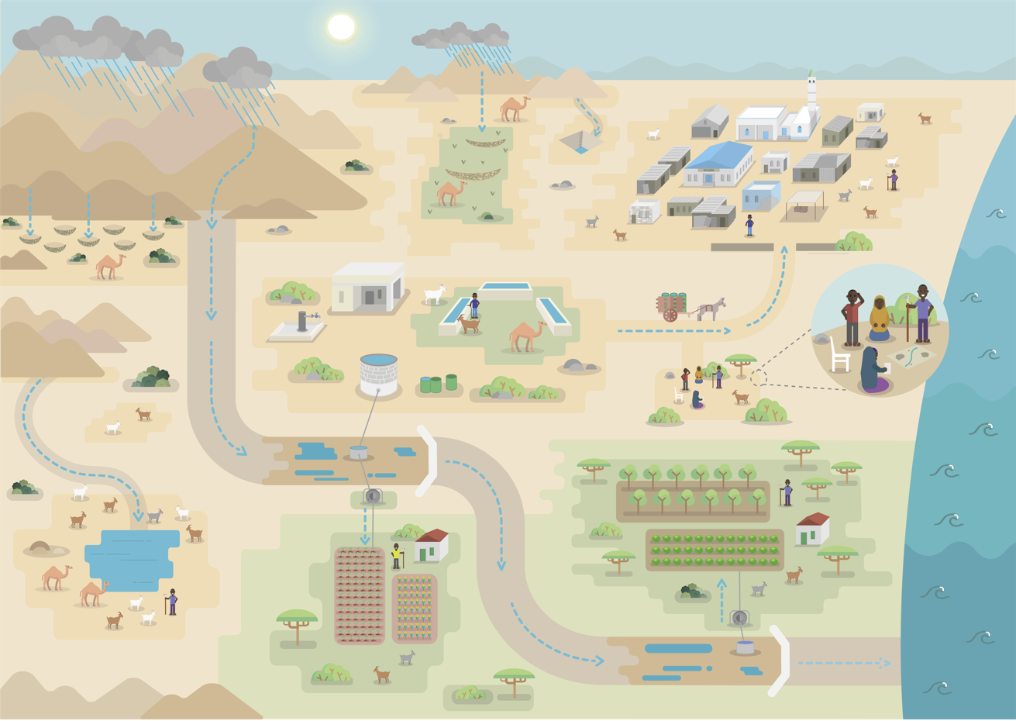

Examples of Activities from the Biyoole Project
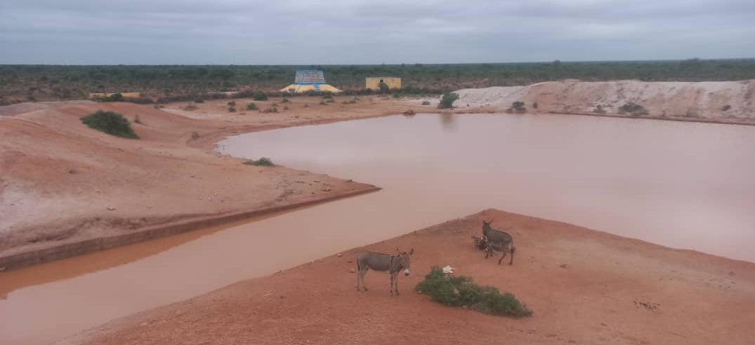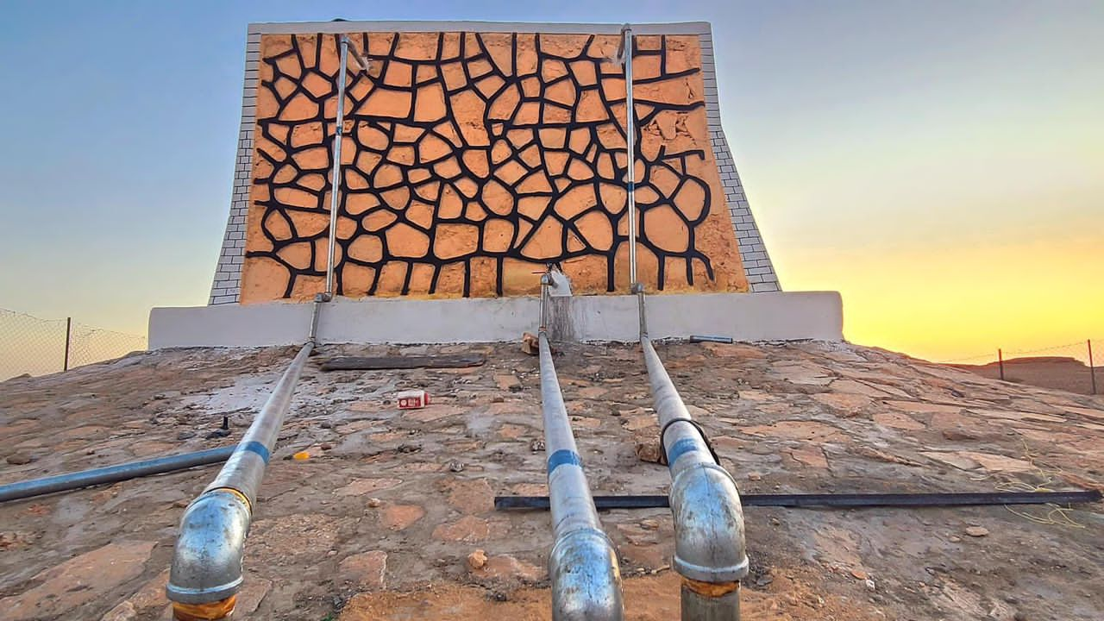
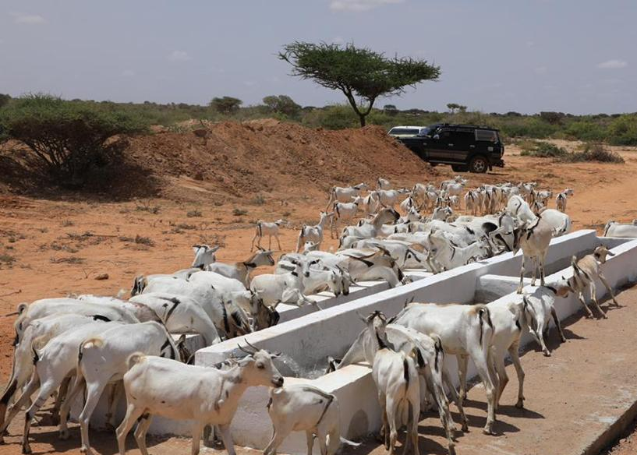 |  | 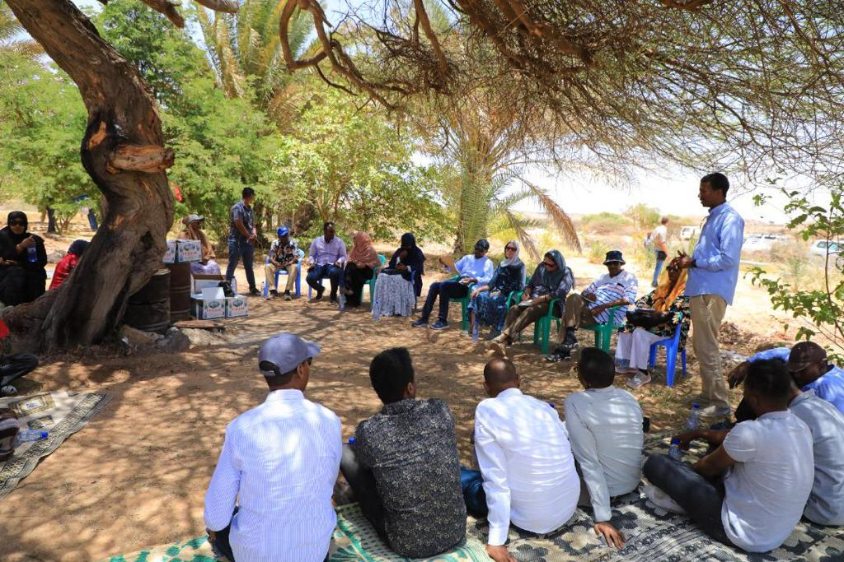
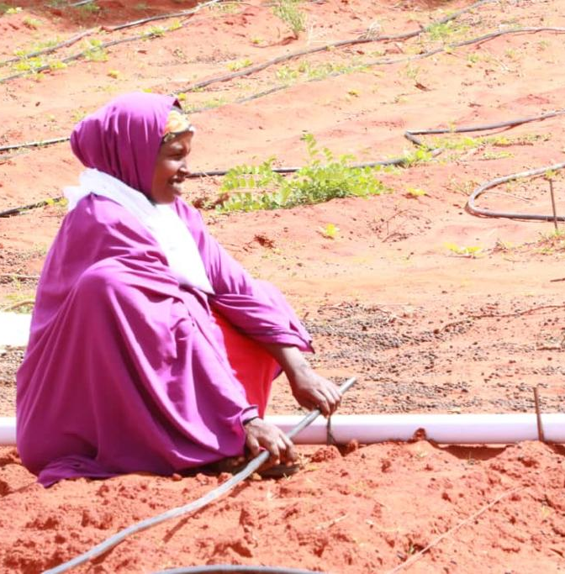 | 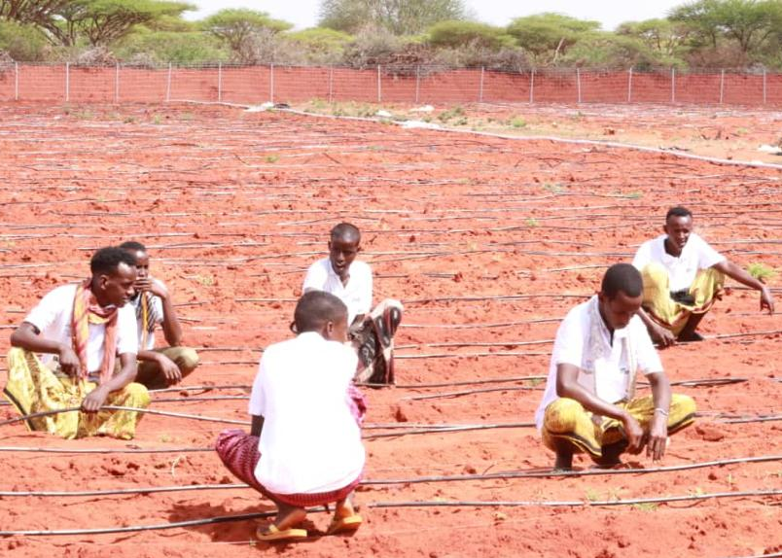 | 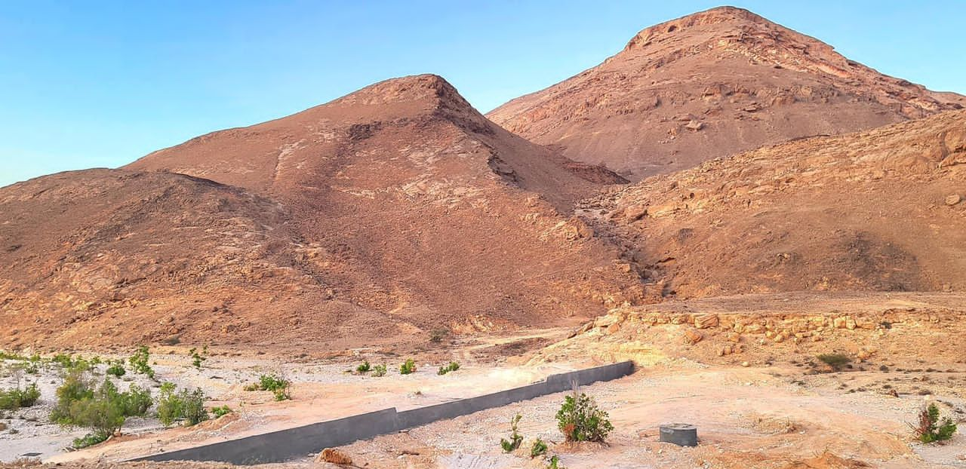
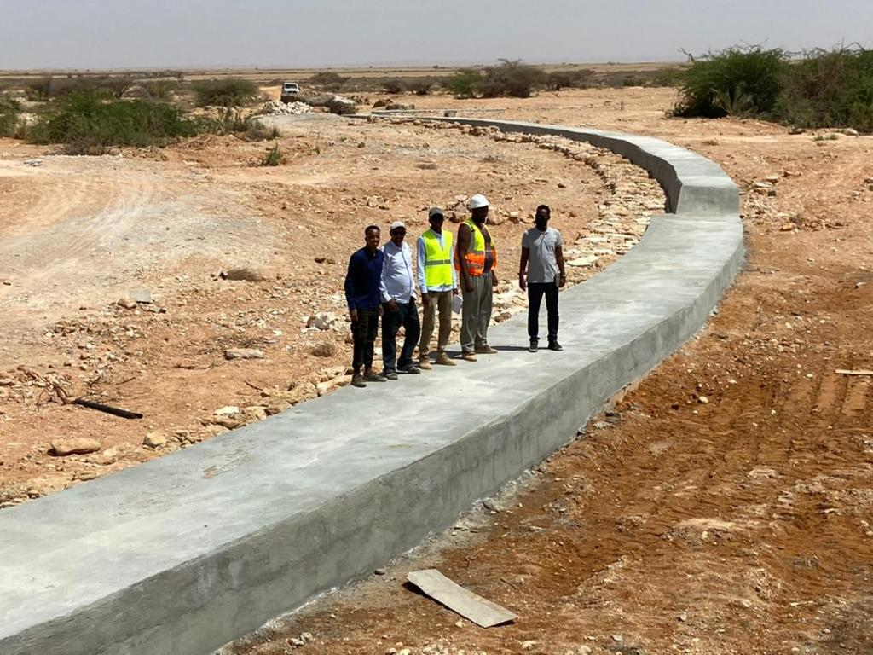

Project Geographic Coverage
As stated above, the project will increase activities in the existing project areas of Somaliland, Puntland, Galmudug, and South West State, and will expand to two additional FMSs—Hirshabelle and Jubbaland—where it will focus on the areas situated away from the floodplains of the Shabelle and the Jubba rivers.
Third party monitoring (TPM) will be contracted to provide monitoring support in South West State, Hirshabelle, and Jubbaland. Given the complexity of operating in these FMSs, the TPM will provide remote supervision, fiduciary compliance, and real-time risk and safeguards monitoring. The TPM will independently verify results on the ground and help ensure that funds are used for the intended purposes. It will also be able to provide technical guidance on the reliability of government monitoring and evaluation (M&E) systems

Project Beneficiaries
The primary project beneficiaries are more than 500,000 (of which 30 percent are women) farmers and pastoralists in Galmudug, Puntland, South West State, Jubbaland, Hirshabelle, and Somaliland. The project will provide benefits in the form of access to improved water sources for multiple uses (domestic, livestock, agriculture, and horticulture); agricultural (livestock and crops) extension and environmental services; improved livelihood resilience; and adaptive know-how.
Table 1. Project Beneficiaries
Project Beneficiaries | Somaliland | Puntland | Galmudug | South West State | Hirshabelle | Jubbaland | Total
Total | 150,000 | 125,000 | 75,000 | 100,000 | 25,000 | 25,000 | 500,000
Of which are women | 45,000 | 37,500 | 22,500 | 30,000 | 7,500 | 7,500 | 150,000
At the household level, women and children are typically responsible for collecting water in Somalia. Access to improved water supply and sanitation facilities is expected to contribute to poverty reduction and better gender equality among the beneficiary populations by addressing burdens especially borne by women and girls. This includes the benefits of reduced time and effort spent in collecting water, as well as associated benefits such as personal security, health, and economic productivity. The project will emphasize the role of women in the decision-making process at various stages of system design, implementation, and management to improve the sustainability of investments and improve the quality of life. Gender-disaggregated indicators will be used to track gender equity in roles and benefits from the project. Moreover, World Bank experience in other countries shows that families with members who have a disability are often among the poorest and most marginalized in communities. To maximize inclusion in decision making, implementation, and benefits, the project will identify beneficiaries affected with disability, so they are included in the design of the infrastructure, in the prioritization of livelihoods, and in linking to assistive services.
Given the large role women play in both agriculture and livestock activities, the project will address challenges that have traditionally limited women’s productivity, particularly, access to extension services and inputs. Drawing on lessons from ongoing agro-pastoral investments in Somalia, the project can make participation by women mandatory (for example, 30 percent of leadership positions) in Village Development Committees that participate in the project. In particular, women’s participation in integrated landscape management and agriculture and livestock support, provided under Components 2 and 3 will be monitored through project implementation.
An audit of processes will be conducted to determine risk points where women can be excluded, for instance, during selection for asset transfers and labor-intensive public works (LIPW) income earning opportunities. Training on livestock management and cropping will be designed to train family units together, where possible, which has been found to not only increase women’s access to training but also increase awareness among all family members of the role women play. Other training sessions will be designed and delivered at times and locations that are convenient to women, given the demands for their time from other duties, and child care will be provided to facilitate their participation. Service providers, namely nongovernmental organizations (NGOs), United Nations (UN) agencies, and government agencies will record the information of participants who receive training, with gender disaggregation. The information will be the basis for calculating activity progress; it will also be one of the intermediate result indicators (namely, ‘Farmers/clients reached with agricultural services, of which women (percentage)’), and will be included in the semi-annual progress report of the project.
As outlined in the CPF, job creation is a top priority for growth, development, and social stability in Somalia. By mobilizing and empowering women and youth as positive agents of change and supporting the growth and development of rural livelihoods, the project will help address key drivers of intergenerational poverty and conflict. In project areas, the construction of infrastructure (for example, dams, offices, community centers) and related procurement of good and services will create new jobs and revenue streams for local businesses. Land management and livelihood support interventions and cash-for-work programs will provide communities and households with crucial productive assets and income-generating opportunities. Core project interventions will be complemented by targeted investments in mobilizing and capacitating women and youth groups to engage in other income-generating activities such as sustainable charcoal production, provision of animal health and nutrition services, and community gardening. The project will also explore income-enhancing opportunities via value addition and, where feasible, linking communities with surplus production to downstream markets.

Figure 2. Theory of Change
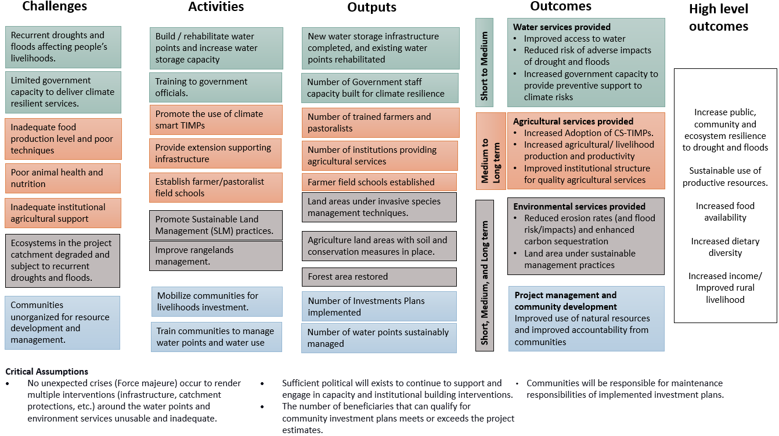

Project Components and Subcomponents
This project integrates water supply development, agriculture (farming and livestock) development, and environmental management with a focus on climate adaptation and climate mitigation. The project will continue to build the capacity of government to provide water, agriculture, and environment services to improve water access, strengthen sustainable livelihoods, and reduce vulnerabilities to extreme climate events. The project comprises four interlinked components: (1) Development of Multiuse Water Sources; (2) Development of Agriculture and Livestock Services around Water Points; (3) Development of Environmental Catchment Services in Project Areas; and (4) Project Management, Community Development and Enhancing Livelihoods Planning.

Component 1: Support the Development of Multiuse Water Sources (US$26.3 million)
The component aims to improve water availability for domestic use, farming, and livestock, and to address the effects of climate change–exacerbated droughts and floods by developing a slew of water supply infrastructure that provides reliable supply, including small sand and subsurface dams in dry riverbeds (wadis) and surface water storage infrastructure (for example, berkads and hafir dams). In line with the project’s climate mitigation emphasis, all water lifting will be done via low- to zero-carbon energy units, that is, solar pumps, coupled with elevated storage and gravity-fed auxiliary structures such as cattle troughs, water points for human use, and irrigation. This will eliminate carbon emissions by avoiding the use of fossil-based energy sources. By incorporating climate resilience into the planning process as well as into the design, new infrastructure, rehabilitation and/or retrofitted facilities will be more reliable (reduced risk of system failure), and less likely to be affected by climate-related shocks such as floods and droughts. This will in turn make the residents of the targeted areas more resilient to climate change–exacerbated water shortages and flooding. These investments will be the anchor assets around which other project activities in each selected subcatchment will seek to capitalize and manage. The project will work in areas that are of low security risk and will adopt a flexible approach to selecting new sites should security concerns emerge. The project will complement the advisory services and analytical work undertaken through the Untapping Resilience: Groundwater Management and Learning in the Horn of Africa’s Borderlands (P178786) project, which looks to enhance regional cooperation on groundwater management in the Horn of Africa with a focus on sustainable groundwater service delivery.
By developing water sources, the project will reduce the distance women and girls have to cover to fetch water, freeing up time for productive activities and education, thus addressing the gender gap. The Ministries of Energy and Water Resources at FGS and FMS levels, and Somaliland, will implement this component.

Subcomponent 1.1: Construction of new water points (US$17.8 million)
This subcomponent will finance the development of new, climate-resilient water infrastructure. To mitigate evapotranspiration (which is a significant challenge for surface water storage in Somalia) appropriate technologies for harvesting water in wadis, such as sand and subsurface dams, will be the principal form of infrastructure used. In situations where wadi water harvesting is not technically possible, other options such as berkads or balleys will be acceptable. As a last resort, and only if no surface storage options are feasible, the subcomponent may support construction of boreholes for groundwater extraction, particularly in project areas where seasonality plays a bigger role. These climate-informed infrastructure investments will enhance the resilience of beneficiaries as extreme temperatures and frequent droughts will be witnessed due to climate change. Site selection, including completed Construction Investment Reports, of the new 100 sites would be done in quarterly batches with 25 sites selected by March 2023, cumulative 50 sites by June 2023, 75 sites by September 2023, and finally all 100 new sites by December 2023.The project will coordinate closely with the Horn of Africa Groundwater for Resilience Project (GW4R—P174867) to ensure complementarity. In communities where traditional Biyoole technologies as listed above are not feasible, the GW4R may be requested to support the construction of boreholes.

Subcomponent 1.2: Rehabilitation of existing water points (US$6 million)
This subcomponent will finance the rehabilitation of existing water infrastructure and small prioritized boreholes. Selected sites can include multiple interventions in terms of infrastructure and catchment protection to ensure adequate water through periods of drought and for multiple purposes. Facilities may be extended or expanded so as to increase water storage capacity. Given that it is not only the water infrastructure itself but the surrounding catchment which is central to fostering drought and flood resilience, appropriate catchment protection measures need to be considered fully. Catchment interventions will be integrated into activities under Component 3. Increasing water storage capacity is a key component of building resilience to drought. In times of severe drought, emergency borehole rehabilitation will be fast-tracked.

Subcomponent 1.3: Institutional and capacity development (US$2.5 million)
This subcomponent will finance global learning exchanges and capacity-building activities for Somaliland, the FGS, FMSs, and community structures to manage water points and prepare and institutionalize water sharing agreements, thereby making water shortages less likely, and the residents more resilient to droughts. The governing structures are responsible for planning and selecting sites, procuring works, overseeing the construction and rehabilitation of community water points, monitoring results, and undertaking hydrogeological monitoring for water development as well as developing their capacity to plan and design climate-resilient infrastructure. The criteria for site selection, design, and works planning will be based on consideration of low-carbon emissions, coupled with taking measures that increase resilience to floods and droughts, as per the needs of the specific geographic areas. This work will be guided by recent World Bank analytic work as well as consideration of acute needs and inclusivity. With the maturing of water services institutions, the foundation is laid to deepen water allocation discussions ensuring that services are provided equitably. Building on the Wadi Evaluation Tool (WET) developed under WALP, and modified during Biyoole and in Barwaaqo preparation, the project will pilot the application of an innovative web tool, the ‘water harvester explorer’, designed by the World Bank, and implemented in West Africa, to facilitate the selection of water harvesting interventions in the field. Somalia water technologies (as described above) are reproduced repeatedly and opportunity exists to explore more innovative water storage and water access options, which in turn will further enhance resilience of beneficiaries to droughts. Sustainability of water points is an area that needs deeper focus in Somalia, and more understanding of what the roles and responsibilities from community to state level are.

Component 2: Development of Agriculture and Livestock Services around Water Points (US$15.5 million)
This component will be implemented by the Ministries of Agriculture and Livestock in the FGS, FMSs, and Somaliland. It will support interventions aimed at creating and strengthening sustainable and productive livelihoods for communities around water points, ensuring that access to water translates into improved livelihoods while addressing vulnerabilities to flood and drought. It will scale up agriculture support services in the existing approximately 100 sites targeted by Biyoole where water infrastructure has already been installed and Community Investment Plans (CIPs) are available. In the 150 communities targeted in the proposed Barwaaqo project, once the water points are constructed, the priority agricultural services as identified by the CIPs developed under Component 4.2 will be implemented. The agricultural activities supported by the project will improve food security and reduce the gender gap in agricultural and livestock productivity, as well as assets, through several measures targeted towards women and women-owned businesses and collectives. This component will provide the foundation for possible future support to Somali agriculture under the Regional Food Systems Resilience Program (P178566).

Subcomponent 2.1: Increased sustainable farming production and development (US$7 million)
This subcomponent will finance the introduction of technologies, innovations, and management practices (TIMPs) related to improved water use efficiency and climate-smart agriculture to farm communities around each of the developed water points. The intention is to build up terrestrial carbon stocks while increasing the production of diversified agricultural products for improved household food security and incomes, and to increase the resilience of farmers to drought. TIMPs would be introduced using a community-based extension architecture and will include, among others, microirrigation systems; high-yielding drought-tolerant seeds/planting materials, balanced soil fertility management; integrated pest management; and farm machinery for conservation agriculture and efficient harvest and postharvest handling. The project will promote the use of TIMPs which will hence incorporate climate-smart agricultural practices while reducing greenhouse gas (GHG) emissions through activities including solar pumping, minimum soil tillage, and intercropping. The subcomponent will support mobilization and strengthening of farmers into common interest groups (CIGs) of 15–20 members each and Farmer Producer Organizations, including female-led associations, cooperatives, and self-help groups, for ease of access to extension services, inputs, and output markets. Mobilization and subsequent support to CIGs will focus on high inclusion of female farmers and vulnerable member groups and development of resources and capacity at the community level for long term sustainability. Female extension agents will be engaged to facilitate access to extension services by female farmers, and female-led groups and collectives. Where possible, access to capital will be facilitated for female groups to improve their farm production. This subcomponent will also support building a community-based extension ecosystem, complementing farmer-level interventions, and anchoring various promotional support for TIMPs’ adoption by farmers. To build a robust community-based extension architecture, the project will support the development of demonstration plots at each water point, identification and training of lead farmers tagged to CIGs for ongoing extension support and establishment of farmer field schools (FFSs). The project will also invest in upgrading infrastructure for a community-based extension such as local tool banks, mini-labs, mobile service delivery systems, and digital infrastructure. Community-based extension facilitators (CBFs)will also be recruited to anchor FFSs and function as mentors and master trainers to lead farmers. In addition to CBFs at the FFS level, every CIG will be supported to identify best practicing lead farmers among themselves, with the strong encouragement of female lead farmers, who will be provided intensive training support to deliver ongoing extension services to other group members. Participating farmers will then be provided with microproject grants at the CIG level to facilitate their adoption of climate-smart TIMPs promoted under the project.

Subcomponent 2.2: Increased sustainable livestock production and development (US$6.5 million)
This subcomponent will support the development and diversification of livelihoods among target pastoralist communities. It will facilitate improved grazing management, the demand-driven delivery of climate-smart livestock production assets, appropriate activities that enhance carbon stock, and extension services based on community-specific priorities and context-specific conditions. Based on CIPs developed and prioritized livelihoods, the Ministries of Water will be supported to estimate water availability and water use demand for animal consumption and poultry production. Training on climate-smart livestock management will be offered by the Ministries of Livestock for family units to increase female participation. The project will train and deploy female extension agents and veterinarians to support female livestock keepers and facilitate the formation of inclusive cooperatives and self-help groups. Where possible, access to capital will be facilitated by the Ministries of Livestock to enable female pastoralist groups to improve animal stock. The subcomponent will build on significant gains realized under Biyoole in animal husbandry and veterinary services. Similar to subcomponent 2.1, support will be provided by the Ministries of Livestock for the mobilization and strengthening of pastoralist communities into strong farmer institutions to help access animal health and production extension services, inputs, and markets. Pastoralist field schools will be established to intensify the training of farmers on fodder production and management, animal health and disease control, and rangeland management. Microproject grants will be provided at the CIG level to support participating farmers to adopt promoted technologies, including but not limited to improved drought-tolerant breeds; dairy farming; improved animal finishing; fodder production and management, and improved animal health and disease control. The Ministry of Livestock at the FGS and FMS levels, and Somaliland, will implement this subcomponent.

Subcomponent 2.3: Institutional and capacity development (US$2 million)
This subcomponent will strengthen the FGS and FMSs, Somaliland government, as well as the Ministries that are responsible for agriculture and livestock, to create an enabling environment for agriculture and animal husbandry. This will build their capacity to boost food security and livelihoods’ development among rural communities as well as their capacity to plan and design climate-resilient interventions that support sustainable agricultural and livestock production. This subcomponent will strengthen the capacity of national and state institutions to plan, implement, and monitor integrated agriculture and livestock development programs. It will finance the establishment of a coherent agriculture (farming and livestock) extension ecosystem that combines public, private, and community-led extension services. It will also provide targeted support to improve linkages between the nascent agricultural research system to the community-based extension ecosystem to be developed to support farmers with context specific climate-smart agro-weather and market advisories. To the extent possible, the subcomponent will also support agriculture digitization, including geo-tagged registration of participating farmers, digitization of prioritized TIMPs for delivery to farmers, and provision of digital agriculture solutions to targeted farmers. Building on ongoing pilot work under Biyoole, the focus on digital agriculture will incorporate access to solar-powered irrigation systems, the provision of e-extension and advisory services, bundled with digitally enabled access to inputs and technologies to improve productivity. Other agro-tech innovations include access to finance and marketing of livestock and farm produce from targeted farming and pastoral communities. It will also focus on capacity building on climate-smart agriculture technologies and support to women and youth as e-extension service providers. In addition, the subcomponent will include targeted exposure visits to neighboring countries to learn from similar work. Enhancing the institutional and regulatory capacity of Somali institutions will ultimately lead to increased resilience to floods and droughts by ensuring that the necessary knowledge and skills are embedded in government, rather than mainly with external agencies.

Component 3: Development of Environmental Catchment Services in Project Areas (US$10 million)
This component will be implemented by the Ministries of Environment in the FGS, FMSs, and Somaliland. It aims to address vulnerabilities to extreme climate events and enhance the benefits from the sustainable management of catchments in project areas. It includes the promotion of rangelands restoration—thus contributing to land degradation neutrality (LDN) and introduction of appropriate practices for sustainable land management (SLM), thereby reinforcing national climate mitigation measures to increase forest cover and soil organic carbon (SOC). More specifically, increased vegetation cover, riverbank protection, and promotion of water storage will contribute to mitigate the impacts of flooding, while soil and water conservation techniques reduce soil loss and increase soil moisture content and thus help to reduce vulnerability to droughts. The project will invest in efforts to restore ecosystems and mitigate, as well as adapt to, climate change. This will not only improve livelihoods and contribute to poverty reduction, but also help to mitigate the effects of Somalia’s variable climate. It will increase much needed water harvesting opportunities—key to increasing water security and, thus, communities’ resilience to droughts. It will further strengthen the capacity of the different government and community institutions to develop and implement environmental activities and regulations. The Directorate of Environment and Climate Change at the FGS level, and the Ministries of Environment at FMS levels and Somaliland, will implement this component. This component will complement the Somalia Climate Change Program (P178248), which aims to strengthen and mainstream climate change actions in rural water and agricultural projects, and urban and infrastructure investments.

Subcomponent 3.1: Environmental restoration (US$8 million)
This subcomponent aims to support ecosystem restoration interventions while enhancing the livelihoods of beneficiary communities around the water point, and addressing land degradation, flooding, and desertification. There will be an emphasis on climate mitigation measures such as increasing carbon stocks, and climate adaptation measures, particularly those that mitigate against extreme climate events. The subcomponent will finance nature-based solutions and approaches to SLM at micro and macro levels, such as: the regeneration of naturally growing trees; increasing SOC; regeneration of shrubs and grasses; local (village) level approved rules and regulations for use and sanctions; restoration of degraded and severely destroyed ecosystems; the promotion of suitable water harvesting for soil and water conservation techniques (for example, semi-circular bunds, soil bunds, and rock catchments); promotion of improved rangeland management and assessments and surveys of soil and erosion. It will consider ecosystem-based adaptation (EbA), a win-win approach that uses ecosystem services as part of a holistic adaptation strategy. This may include, for example, socioeconomically and ecologically viable species producing nontimber forest products (NTFPs) for commercial extraction while minimizing the risks of environmental destruction. To avoid decreasing downstream water availability and to increase upstream productivity, the project will introduce techniques to manage invasive plant species. The subcomponent will consider sedimentation, dry season water flows, flood reduction, and broader disaster risk reduction; it will work closely with local government for planning and monitoring. The subcomponent includes technical assistance and support to the capital investments for financing market-based mechanisms that support the above.

Subcomponent 3.2: Institutional and capacity development (US$2 million)
This subcomponent will strengthen the capacity of the FGS, FMSs, and Somaliland governments on environmental protection, and the development and implementation of nature-based solutions and SLM practices. The aim is for them to support social and environmental protection, enhance resilience to extreme climate events, particularly droughts and floods, reduce land-based GHG emissions and ultimately optimize usage of the country’s natural resources. It will also raise awareness about the natural resource conditions, climate variability, and how these link to the livelihood opportunities financed under Component 2. Basic resources will be put in place (offices, equipment, staff) forming the foundation for environmental management. This subcomponent will explore opportunities for partnering with national and international organizations that specialize in water and soil monitoring, climate adaptation, and climate mitigation. It will also monitor key elements (for example, change in organic matter, soil composition, and vegetation cover) over an extended period, and link this to the precipitation pattern to have an assessment of the performances of the water point, ideas for improving those in the future, and to contribute to strengthening future climate change adaptation processes. Monitoring systems for land degradation, dynamic mapping, and early warning systems such Hydromet, and enhancement of early warning systems developed by Somali institutions, such as the Somalia Water and Land Information System (SWALIM), will be utilized to enhance resilience to extreme climate events and monitor changes in soil organic and above-ground carbon stocks and help government institutions be better prepared and respond to extreme climate events. Communities will be consulted regarding community labor and modalities preferred, for example, volunteer contributions or cash for work. Enabling conditions, local leadership, culture and common law (known as Xeer in Somali culture) volunteering antecedents, and social mobilization experiences will guide the choice of implementation modality. The project will take into account that rehabilitation works, soil conservation measures, and nature-based solutions require significant cheap labor and the procurement designs of these activities require special attention. Cash injection into communities provides immediate benefits but can create long term dependency problems which will reduce sustainability. The pros and cons will be unpacked in the early stages of community engagement and mobilization. The project will support the construction or rehabilitation of Ministry of Environment buildings. Access to climate financing or adaptation funds is important to the combating of climate change and the project will support the development of relevant project proposals.

Component 4: Project Management, Community Development, and Enhancing Livelihoods Planning (US$17.5 million)
This component will finance the operational costs of the project management units in Somaliland and FMSs and a National Project Coordination Unit at the FGS level. It will be implemented by the Ministries of Planning in the FGS, FMSs, and Somaliland.

Subcomponent 4.1: Project management (US$10 million)
The subcomponent will ensure that the project is implemented efficiently, on time, and in accordance with the Loan Agreement. This would be the responsibility of the National Project Coordination Unit (NPCU) at the Federal level and Project Implementation Units (PIUs) at state levels and Somaliland. The NPCU at Federal level and FMS PIUs of Puntland, South West, and Galmudug and in Somaliland were already established under Biyoole, and Jubbaland and Hirshabelle PIUs will be set up under Barwaaqo. The same implementation arrangements will be replicated. This subcomponent will support (a) the incremental operating costs for ministry staff managing the project and for inputs from other technical ministries, departments, and agencies (MDAs: water, livestock and agriculture, environment); (b) the cost of procurement and financial management specialists; and development of procurement guidelines offering extra points in bidding to female-friendly firms (for example, those with inclusive policies, equitable and inclusive recruitment and advancement, equal pay for equal work, sexual exploitation and abuse/prevention measures); and (c) outreach and communications on the governments’ role and leadership on the project to the broader Somali community.

Subcomponent 4.2: Community-driven development planning (US$1.2 million)
The subcomponent will refine institutional responsibilities and support the Ministries of Planning in their mandates of overseeing development from State to district to community level. The multisectoral nature of the project, and the need for cross ministry coordination for multisectoral support for economically viable and resilient communities, require the PIUs to manage community engagement. A community-driven development (CDD) approach remains highly relevant for this project given the interdependency focus on rural, local area development and natural resources management, and pulls together the activities under Components 1, 2, and 3 into one holistic livelihoods development project. It will also deepen familiarization of communities to the principles of women and youth as agents of change, inclusion, and transparency, building on successes and experience achieved in the current project. To build the capacity of the Ministries of Planning, which have fairly limited expertise in managing and delivering CDD, expertise in CDD and CIPs will be contracted.

Subcomponent 4.3: M&E, knowledge management, and learning (US$6.3 million)
The project will support continuous learning and adaptable knowledge management, using the Ministry of Planning’s web-based management information system (MIS) and M&E systems. A web-based MIS will be set up to track real-time performance of the project and is linked to an M&E system to focus on project results and outcomes, including sex-disaggregation of staffing, training, and other project data. This subcomponent will finance baseline, concurrent monitoring of inputs and outputs and monitoring of safeguards, conflict, and gender, and will focus on developing and disseminating knowledge generated through various project activities. Subcomponent activities will incorporate new modern technology such as geo-tagging of site investments, collection of field data with tablets/smartphones, and application of geospatial imaging for quantifying before-and-after comparisons for specific indicators. With a view to obtain more information and knowledge on the extent and period of flood, this subcomponent will support technical work such as flood mapping and support to information sharing. Thus, improved availability and quality of data from the monitoring network will be essential while planning for and responding to climate change vulnerabilities.

Subcomponent 4.4: Contingent emergency response (US$0)
This subcomponent will support immediate and rapid response to an eligible crisis or emergency, as needed. This zero-cost component will finance eligible expenditures under the Immediate Response Mechanism (IRM) in the case of natural or manmade crises or disasters, severe economic shocks, or other crises and emergencies in Somalia. It can be triggered through formal declaration of a national emergency by the government authority and upon a formal request from the Federal Republic of Somalia (FRS) to the World Bank through the Ministry of Finance (MoF).

Project Implementation Approach
To achieve the project objectives, a detailed and specific implementation approach exist for each of the components and subcomponents. This approach will be laid out in this chapter, by component, first describing them in detail, then identifying the indicators, outputs and key activities, followed by the key assumptions, risks, and mitigation measures.
Table 2 presents a summary of each implementation agency involved in the project, by component. The table describes the activities that each implementing agency is to perform and complete under each of the Biyoole project’s components.
Table 2. Summary of Activities and Implementation Agencies (by Component)
Components | Activities | Implementing Agency
Component 1. Support the Development of Multiuse Water Sources
Subcomponent 1.1: Construction of new water points  Subcomponent 1.2: Rehabilitation of existing water points  Subcomponent 1.3: Institutional and capacity development | - Oversight of water policy and standards, M&E, and safeguards  - Facilitating community engagement on selection of water technologies and/or interventions  - Constructing water assets, incorporating labor-intensive approaches  - Rehabilitating existing water points | Somaliland and state-level implementing agencies  Contracting of engineering firms  Contracting of construction firms
Component 2: Development of Agriculture and Livestock Services around Water Points
Subcomponent 2.1: Increased sustainable farming production and development  Subcomponent 2.2: Increased sustainable livestock production and development  Subcomponent 2.3: Institutional and capacity development | - Disseminating technologies, innovations, and management practices (TIMPs)  - Supporting farmers with context specific climate-smart agro-weather and market advisories  - Mobilizing Common Interest Groups (CIGs) and Farmer Producer Organizations  - Identifying and training of lead farmers tagged to CIGs  - Geo-tagging of registration of participating farmers  - Establishing community gardens and fruit tree groves  - Establishing FLID and Farmer Field Schools  - Training on climate-smart farming techniques  - Microproject investment on community-led irrigation  - Training on adoption of drought-resistant crops and seeds  - Forming implementation subgroups (for example, pastoralist groups, farmer groups, community garden groups, and so on)  - Forming pastoralist village committee groups  - Microproject investment on livestock breeding training  - Establishment of veterinary clinics and/or centers  - Animal health workers’ training  - Facilitating, where possible, access to capital to enable female pastoralist groups to improve animal stock | Respective line ministries; multiple TA options will be explored including in- house capacity, FAO, civil society or educational institutions
Component 3: Development of Environmental Catchment Services in Project Areas
Subcomponent 3.1: Environmental restoration  Subcomponent 3.2: Institutional and capacity development | - Developing village profiles—as part of Environmental and Social Assessments and Management Plans (ESAMPs)  - Establishing community committees and support them to establish resource mobilization mechanisms  - Introducing SLM guidelines among beneficiary communities  - Training and supporting communities to:  - Develop suitable water harvesting for soil and water conservation techniques (for example, semi-circular bunds, soil bunds, and rock catchments)  - Regenerate naturally growing trees, shrubs, and grasses  - Adopt sustainable landscape management (invasive species management techniques)  - Developing and using a Geographical Information System (GIS) to monitor the introduction and uptake of nature-based-solutions  - Supporting social and environmental protection—as part of ESAMPs  - Organizing a regional/national conference on environment and climate change | Multiple TA options will be explored including in-house capacity, UN agencies, and civil society or educational institutions
Component 4: Project Management, Community-Driven Development, and Enhancing Livelihoods Planning
Subcomponent 4.1: Project management  Subcomponent 4.2: Community-driven development planning  Subcomponent 4.3: Monitoring and evaluation, knowledge management, and learning  Subcomponent 4.4: Contingent emergency response | - Project management and fiduciary support including ESF  - National policy development  - FMS implementation strategy development  - Community mobilization  - Community Investment Planning  - Regional projects coordination  - Developing management information systems  - Monitoring and evaluation | Ministry of Planning
The step-wise approach to implementation will be pursued on two tracks. Project activities would be rolled out in Somaliland, Puntland, Galmudug, and South West State immediately following project effectiveness. In Hirshabelle and Jubbaland, activities will focus during the initial 18 months of the project on laying the necessary groundwork through training and other support to address readiness criteria for accession to the project. This would provide more time for the Project Implementation Units (PIU) and extended project teams to gain experience and refine the approach as challenges, not to be underestimated, of scaling out to new areas are encountered and overcome.
This approach will also imbed flexibility during initial project ramp-up to make any adjustments to the project’s implementation schedule and planning if the need arises. The project could then more comfortably, and with less risk, initiate project activities in the two Federal Member States (FMSs) in Southern and Central Somalia at Month 18 of project implementation.
Figure 3. Project Implementation Timeline
Among criteria the project will use to evaluate the readiness for the entry of the two new states are:
- The presence of a State Ministry of Finance with External Assistance Fiduciary Section (EAFS).
- Evidence of an appropriate level of institutional capacity (that is, human resources, office facilities) across line ministries.
- Strong experience with inter-ministerial collaboration, including with the Federal Government of Somalia (FGS).
Readiness criteria are presented in Annex 1, together with the approach to readiness assessments.

Figure 4. Indicative Project Costs by Implementing Agency and Geography (In US$ million)

Workplan Development and Budgeting
At project inception, and then annually thereafter for the coming calendar year, the project coordinator is responsible for the preparation of a consolidated workplan and budget. The sequencing, timing, and budget for each of the activities will be reflected in the project’s annual work plans along with the detailed specifications for project activities to be undertaken. The process to develop and approve annual workplans and budgets is described in Table 3. The timelines are designed to enable costs to be included in annual government budgets ahead of submission to Parliament.
Table 3. Development and Approval of Annual Workplans, Budgets, and Procurement Plans
Activity | Deadline
Annual review of the project | Before August 15
Receive and review decisions through aides memoire | August 30
Annual workplans, budgets, and cash flow forecasts are compiled by the project coordinator with inputs from project teams for each participating government | September 15
Annual workplans, budgets, and cash flow forecasts are compiled by the project coordinator and submitted to the national project steering committee for review and endorsement | September 22
After enforcement by the national steering committee, the project coordinator is responsible for submitting a draft consolidated workplan and budget to the Task Team Leader (TTL), via email. The coordinator will communicate workplans and budgets to project teams in each geography via email | September 31
The task team and the coordinator are to conclude exchanging views on the workplan and budgets | October 15
The project coordinator is responsible for ensuring that consolidated workplans and budgets are submitted to the TTL, via email | October 30
Consolidated workplans, budgets, and procurement plans are approved by the TTL | TTL to provide approval or comments within two weeks of receiving workplans, budgets, and procurement plans
The project coordinator is responsible for ensuring the procurement plan for the coming calendar year activities for all via the Systematic Tracking of Exchanges in Procurement (STEP) System, which is the World Bank’s  e-procurement platform | November 30
The project coordinator of the PIU in each state is responsible for communicating the annual project budget allocations to the respective MoF for inclusion in the draft budget submitted to Parliament in accordance with each government’s budget timetable.

Quarterly Budget Process and NOLs
The project finance specialists prepare quarterly operation budgets every quarter. The Quarterly Operation budgets are developed and submitted to the project task team leader (TTL), five working days prior to the start of the quarter, for review and clearance. The quarterly budget should provide details of the operations and activities for the quarter and budget estimates for the three months. The budget is based on the annual budget developed by the project. The quarterly budgets serve the purpose of petty cash and additionally, enhance management of the project operations.
Quarterly budgets should be comprehensive—clearly setting out all operations and planned travel costs during the quarter, including meetings, training, implementation supportive supervisions, and so on. Any travel not budgeted in advance will not be approved or processed. Each participating FMS develops the quarterly operation budgets and plans, which need to be submitted on time to the National Project Coordination Unit Finance Specialist for review before submission to the Bank for a ‘No Objection Letter’ (NOL) and clearance.
The Barwaaqo project encourages all FMSs to slowly consume recurrent administrative costs (such as office rent, fuel, and others) by the line ministry or agency so as to ensure sustainability. This includes:
  - Cost of fuel and per diem for Ministry of Livestock mobile clinics;
  - Day-to-day fuel and administrative costs of federal line ministries; and
  - Payments to all support staff such as security (personnel at the gate), cleaners, drivers, and office assistants. The payments should be uniform across FMSs and in line with the project payment grades (CIM guidelines).
NOLs will only be provided once per quarter and as such PIUs need to plan in advance and ensure that all costs are incorporated in the quarterly operational budget.

Component 1: Support the Development of Multiuse Water Sources
Based on detailed basin-level hydrology assessments, microwatershed action plans, and groundwater investigations, this component will finance investments in key water management infrastructure for harvesting, storing, and delivering water for people, livestock, and agriculture. The infrastructure will be designed to deliver on both improved human health outcomes and water for productive uses (mainly agricultural production and agroforestry services for landscape restoration).
The component will support the construction of 100 new, and rehabilitation of 50, water infrastructures. The component will also finance the associated infrastructure needed to provide multiple-use water services (standpipes or shallow wells with hand or solar pumps and watering troughs for livestock).
Site selection is the most crucial and time-consuming phase in the project. Sites will be selected initially through remote sensing using the Wadi Evaluation Tool (WET) developed under the Water for Agro-Pastoralist Livelihoods Pilot Project (WALP) and then ground truthing field visits to confirm suitability.
Table 4. Expected Outcomes from Component 1
Result Indicator | Unit of Measurement | Expected Achievement by the End of the Project
New community water points constructed | Number | 100
Existing community water points rehabilitated | Number | 50
This component involves building water infrastructure that will include small and sand subsurface dams in dry river beds (wadis), surface water storage infrastructure (berkads and hafir dams), area infiltration interventions such as semi-circular bunds or soil bunds, and rock catchments. Further, solar units will lift water and then use gravity to feed auxiliary structures such as cattle troughs, water points for human use, and so on. In addition, if no other options are feasible, the component will support rehabilitation and/or construction of boreholes for groundwater extraction.

Key Activities for Component 1
Table 5. Component 1: Key Activities
Key Activity | Activity Description
1 | Procure and mobilize the backstopping support engineering consulting firm supporting the site selection and water source construction monitoring by each participating government to take on individual site feasibility studies as well as investment plans.
2 | Site selection is the most crucial phase in the project. Sites are selected initially through remote sensing using the Wadi Evaluation Tool (WET) developed under the Water for Agro-Pastoralist Livelihoods Pilot Project (WALP)/Biyoole and then ground truthing field visits to confirm suitability are necessary. Ground truthing should include environmental and social screening and assessment and management plans, assessment of land ownership, and downstream social and economic impacts. In cases of community or private ownership where there is a desire for donation for public use, a Land Agreement Template is included in Annex 6. Land acquisition leading to involuntary resettlement is not anticipated, but if it is required or there is physical or economic displacement, a resettlement action plan will need to be prepared and compensation paid from the government’s own funds. Selected project sites can include multiple interventions to ensure adequate water through periods of drought and for the multiple purposes: high quality water for domestic use; and moderate quality for livestock and agricultural uses. These investments will be the anchor assets around which other project activities in each selected subcatchment will seek to capitalize and manage. The diversification of water sources based on the WET, extensive ground truthing, and ground water assessment will increase the supply of water and therefore mitigate the risk of droughts.  Site assessment activities should include:  - Taking overview pictures of site, ideally with some reference like a person standing in it to allow understanding of scale;  - Taking 360-degree pictures from site;  - Taking exact latitude/longitude coordinates of site photographed;  - Making sure the GPS has found its position, so the location is accurately logged;  - Digging test pit about half-a-meter deep for understanding soil composition;  - Taking close-up photos of sediments found (mixed samples) together with a measuring tape/ruler with millimeter scale so that there is an orientation of scale/grain size; and  - Filling out the survey sheet.  Readiness. Site selection is at an advanced stage of readiness with sites selected in all FMS and Somaliland. A total of 125 sites have been identified, 25 in each FMS and in Somaliland. The potential sites are presented in a full map (see below), and complemented by maps and locations detailed per FMS and Somaliland. This work has been done under the ongoing Biyoole 1 project. Each map has a clear legend to explain the potential technologies. Identification has been done through desk-based remote sensing, which will be followed with rapid prefeasibility assessments, meaning that by the time the project is effective sites will have been selected. A review of drought needs in sites as well as equity considerations will be carried out before proceeding with sites. Once sites are selected, inclusive consultations will determine the exact location and the design of the infrastructure to ensure inclusive access and avoid elite capture. A preliminary identification of potential water harvesting sites was conducted to identify a list of 25 potential locations in each one of the five states, thus resulting in a long list of 125 water harvesting sites to choose from.  The preliminary site selection followed the approach outlined below:  - The WET GIS tool was used for a fast and broad spatial analysis of wadi water harvesting potential in the regions under study, yielding a weighted ranking between the potential sites.  - The WET application results were combined with a remote sensing analysis, to account for morphological settings and specific hydrological conditions.  - In Jubbaland, Hirshabelle, South West and Galmudug states, site selection was limited to areas under government control. The delineation of such areas was discussed with government officials from all those states during two workshops held in Kismayo (May 2022) and in Garowe (June 2022).  - At this preliminary stage, the type of structures that were taken into consideration were limited to sand dams, subsurface dams, and hafir dams.  - The governments of the five states provided support in ground truthing the preliminary list of sites to make sure that target communities are effectively located within reach from the proposed locations.

Figure 5. Identified Sites for Ground Truthing
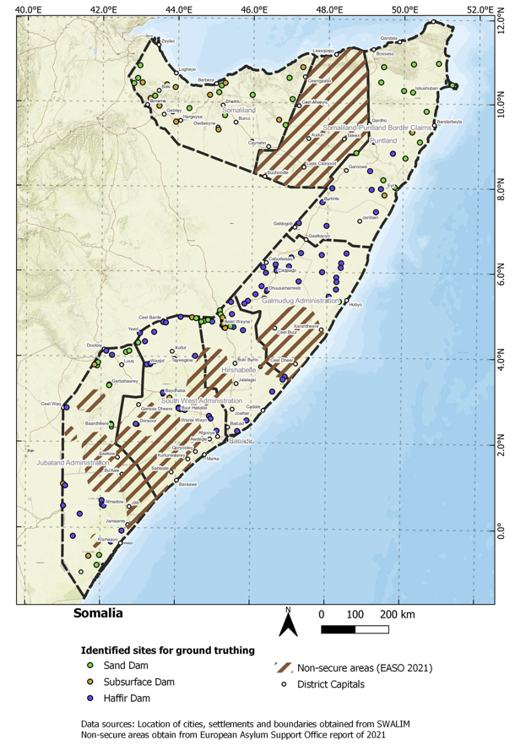

 | Figure 6. Sites Identified: Somaliland and Puntland
 | 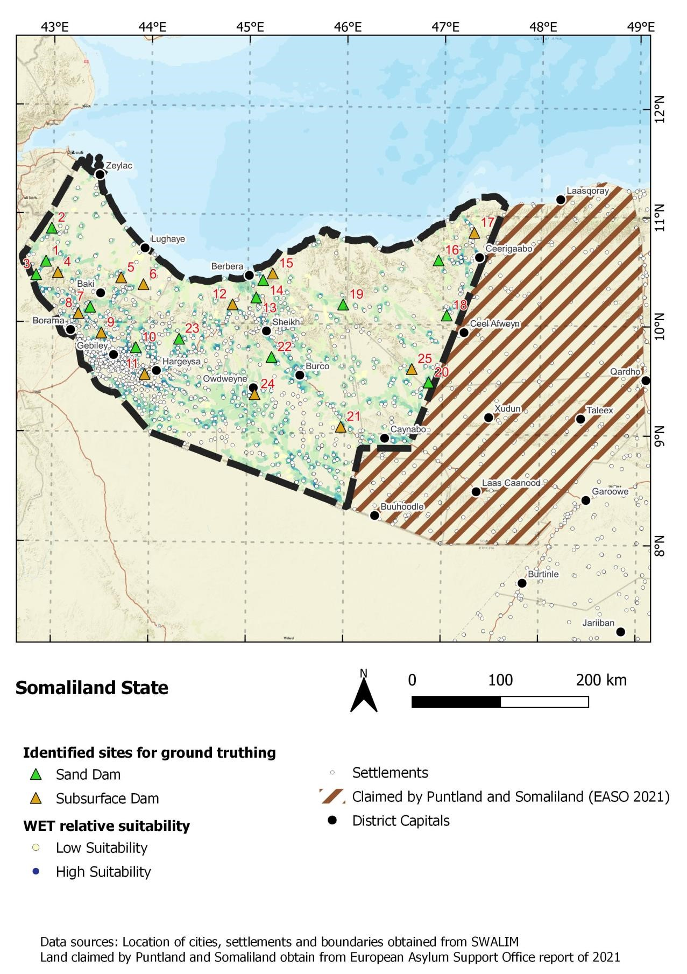 | 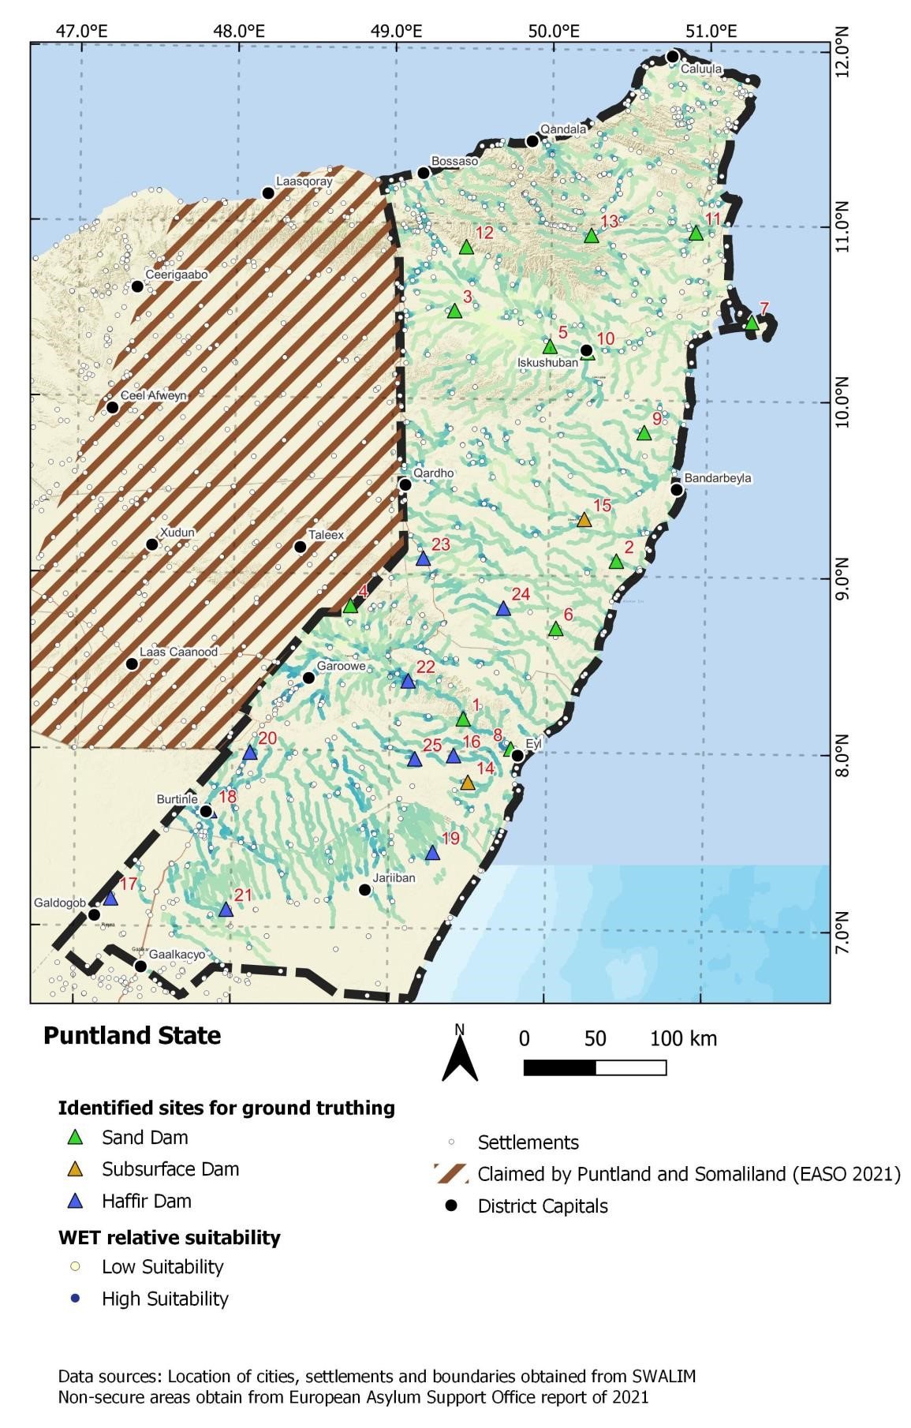
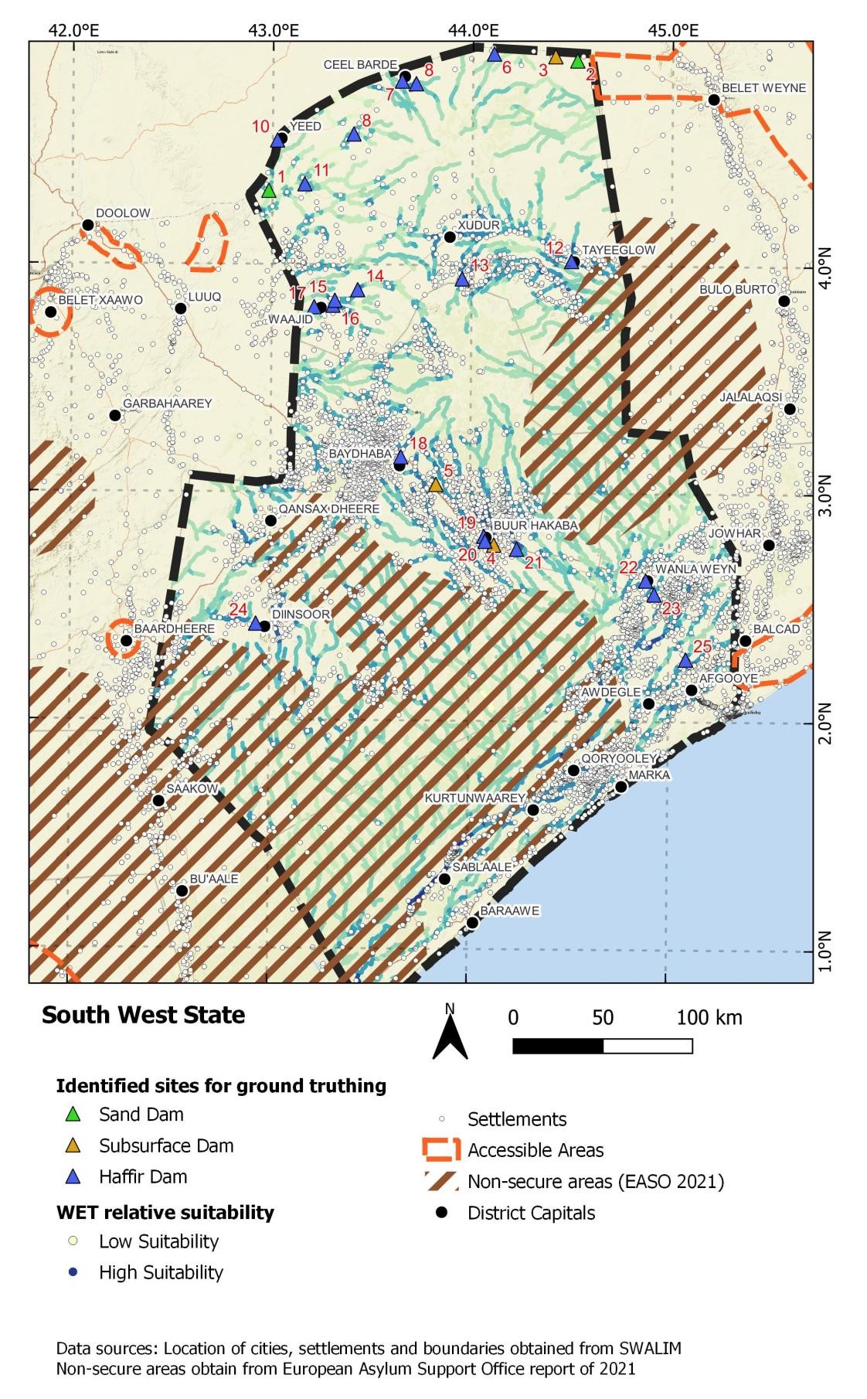
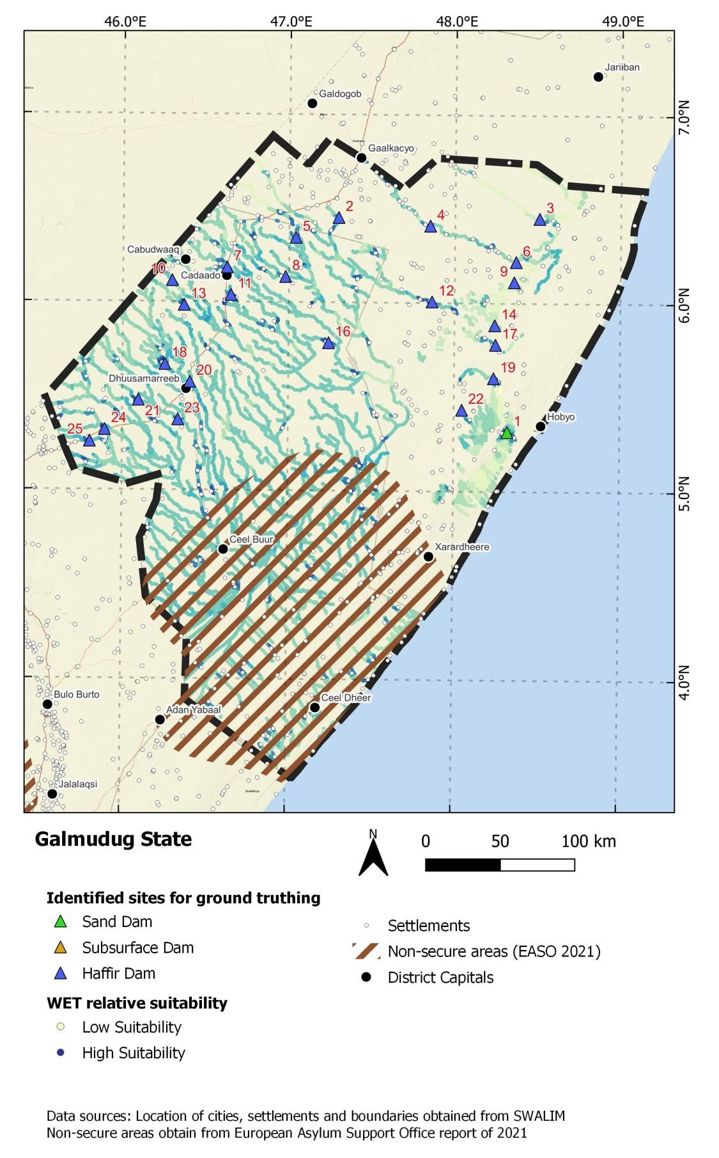
Figure 7. Sites Identified: Galmudug and South West State

 | Figure 8. Sites Identified: Hirshabelle and Jubbaland
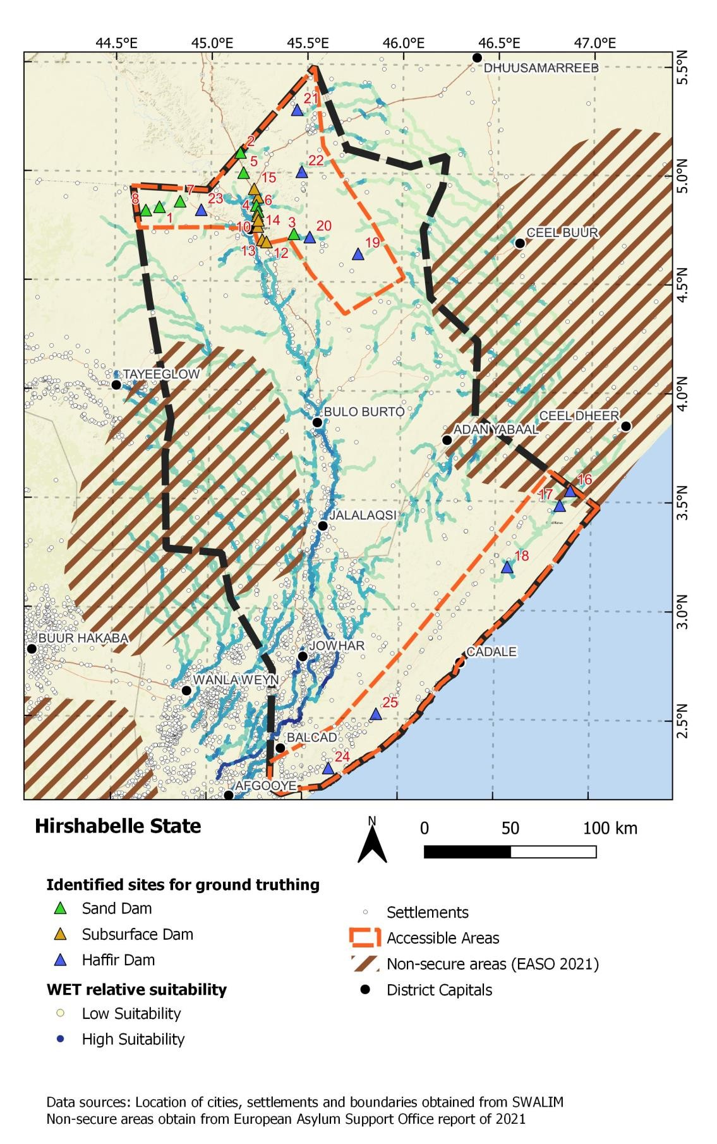
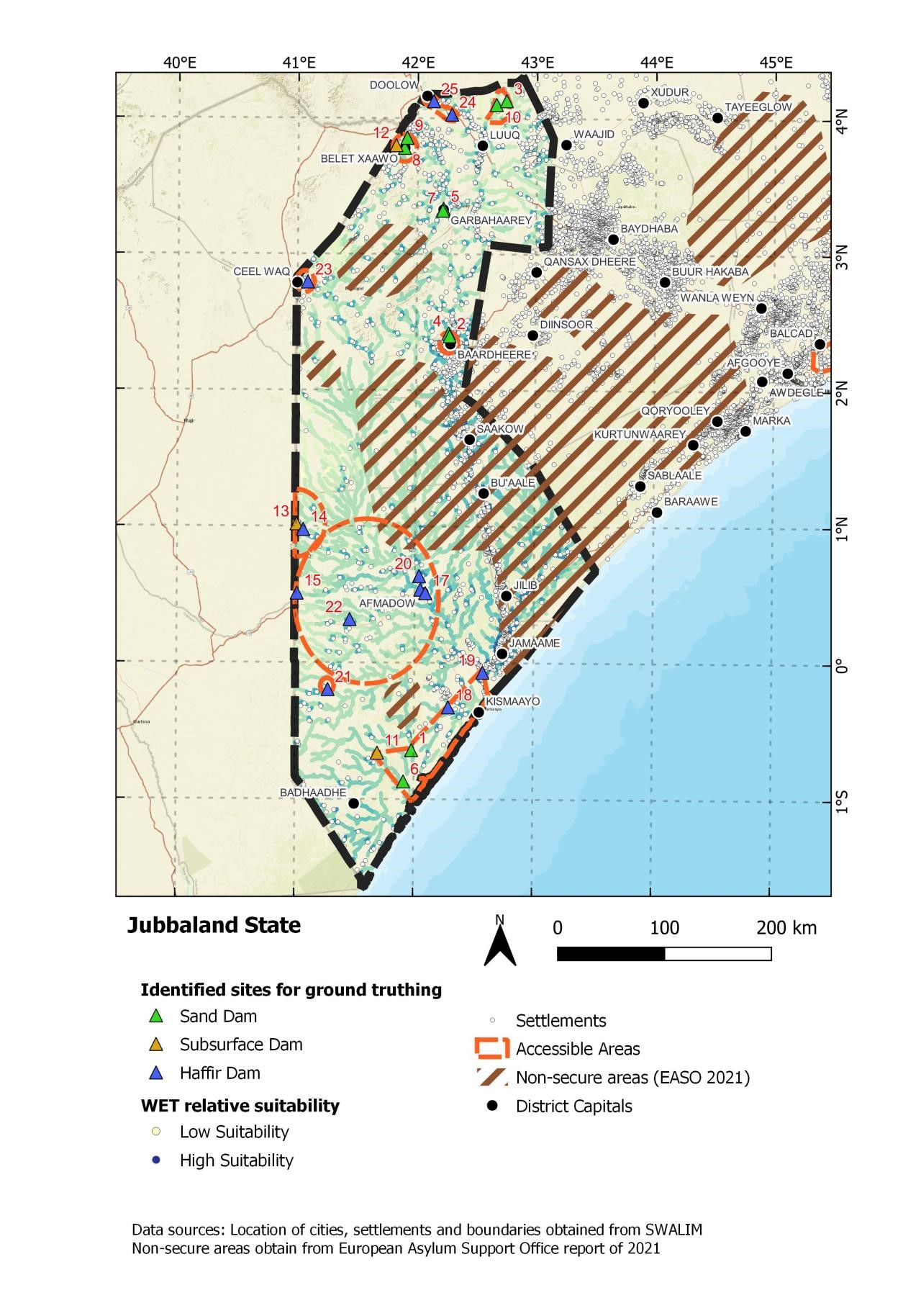
 | The menu of water infrastructure investments will include small sand and subsurface dams in dry river beds (wadis), surface water storage infrastructure (for example, berkads and hafir dams), area infiltration interventions (such as semi-circular bunds or soil bunds), rock catchments, of which most will use solar units to lift water and use gravity to feed auxiliary structures (such as reservoirs, camel and shoats troughs, washing slabs, sanitation facilities, water points for human use and others) (Annex 2 describes these technologies), and possibly, only if no other options are feasible, the rehabilitation and/or construction of boreholes for groundwater extraction. Boreholes are an important source of water in times of severe drought, especially for humanitarian response and particularly in nonriverine regions of Somalia.
3 | Estimate water availability depending on the planned water technology deployed, so as to inform the community mobilization and planning process, and community identification of water resource use, and so on.
4 | Surveys and design of dams and associated structures: Engineering consulting firm to carry out individual site feasibility studies and prepare investment plans for each participating government.
5 | Specifications, tenders and contract awards: Procurement for works at selected sites will be managed by each PIU pursuant to the project procurement and workplans and in accordance with the procurement arrangements detailed in this document.
6 | Construct dam/water infrastructure: Construction will be undertaken in the selected sites by selected construction firm(s) that are contracted by the respective PCUs. The construction of the dams will also include all the associated civil works to make the dams multipurpose in nature.
7 | Site supervision: Site supervision will be carried out by combined teams from the project ministries during construction and to monitor performance afterwards.  The teams will continue with the supervisions until the end of the project so as to facilitate the collection and analysis of information on the durability of the sand dams.
8 | Contract management will be undertaken by each PIU, guided by World Bank Procurement Guidance: Contract Management (September 2018). This includes:  - Administration of contract:  - verification of adherence to contract, informed by site supervision;  - maintenance of contract documentation;  - tracking of costs and progress;  - communicating with external stakeholders; and  - disseminating reporting.  - Managing changes to contract, if needed.  - Managing contract disputes and resolutions.
9 | Commission dam/water infrastructure: Certification of the water infrastructure will be undertaken by the Ministries of Water.

Subcomponent 1.1: Construction of New Water Points
This subcomponent will finance the development of new, climate-resilient water infrastructure. To mitigate evapotranspiration (which is a significant challenge for surface water storage in Somalia) appropriate technologies for harvesting water in wadis, such as sand and subsurface dams, will be the principal form of infrastructure used. In situations where wadi water harvesting is not technically possible, other options such as berkads or balleys will be acceptable. As a last resort, and only if no surface storage options are feasible, the subcomponent may support construction of boreholes for groundwater extraction, particularly in project areas where seasonality plays a bigger role. These climate-informed infrastructure investments will enhance the resilience of beneficiaries as extreme temperatures and frequent droughts will be witnessed due to climate change. Site selection, including completed construction investment reports, of the new 100 sites would be done in quarterly batches with 25 sites selected by March 2023, cumulative 50 sites by June 2023, 75 sites by September 2023, and finally all 100 new sites by December 2023.

Key Activities for Subcomponent 1.1
Table 6. Subcomponent 1.1: Key Activities
Key Activity | Activity Description
1 | Finance the development of new, climate-resilient water infrastructure and mitigate evapotranspiration.
2 | Climate-informed infrastructure investments to enhance the resilience of beneficiaries.
3 | Use appropriate technologies for harvesting water.
4 | Site selection, including completed construction investment reports, of the new 100 sites would be done in quarterly batches with 25 sites selected by March 2023, cumulative 50 sites by June 2023, 75 sites by September 2023, and finally all 100 new sites by December 2023.

Subcomponent 1.2: Rehabilitation of Existing Water Points
This subcomponent will finance the rehabilitation of existing water infrastructure and small prioritized boreholes. Selected sites can include multiple interventions in terms of infrastructure and catchment protection to ensure adequate water through periods of drought and for multiple purposes. Facilities may be extended or expanded to increase water storage capacity. Given that it is not only the water infrastructure itself but the surrounding catchment, which is central to fostering drought and flood resilience, appropriate catchment protection measures need to be considered fully. Catchment interventions will be integrated into activities under Component 3. Increasing water storage capacity is a key component of building resilience to drought. In times of severe drought, emergency borehole rehabilitation will be fast-tracked.

Key Activities for Subcomponent 1.2
Table 7. Subcomponent 1.2: Key Activities
Key Activity | Activity Description
1 | Finance the rehabilitation of existing water infrastructure and small prioritized boreholes.
2 | Extend or expand facilities to increase water storage capacity.
3 | Appropriate catchment protection measures will be considered fully, given that it is not only the water infrastructure itself but the surrounding catchment which is central to fostering drought and flood resilience.
4 | Catchment interventions will be integrated into activities under Component 3.
5 | In times of severe drought, emergency borehole rehabilitation will be fast-tracked.

Subcomponent 1.3: Institutional and Capacity Development
This subcomponent will finance global learning exchanges and capacity-building activities for Somaliland, FGS, FMSs, and community structures to manage water points and prepare and institutionalize water sharing agreements, thereby making water shortages less likely, and the residents more resilient to droughts. The governing structures are responsible for planning and selecting sites, procuring works, overseeing the construction and rehabilitation of community water points, monitoring results, and undertaking hydrogeological monitoring for water development as well as developing government capacity to plan and design climate-resilient infrastructure. This work will be guided by World Bank analytical work as well as consideration of acute need and social inclusivity. With the maturing of water services’ institutions, the foundation is laid to deepen water allocation discussions ensuring that services are provided equitably. Building on the Wadi Evaluation Tool (WET) developed under WALP, and modified during the Biyoole project and under the Barwaaqo project preparation, the project will pilot the application of an innovative web tool, the ‘water harvester explorer’, designed by the World Bank, and implemented in West Africa, to facilitate the selection of water harvesting interventions in the field.
To help ensure sustainability of investments, operations and maintenance (O&M) guidelines prepared under the Biyoole project will be strengthened under the Barwaaqo project. Supported by the World Bank’s technical assistance, standardized O&M guidelines will be finalized, based on experiences from the Biyoole project, and adopted nationally. This process will contribute to the development of national policies for O&M.

Key Activities for Subcomponent 1.3
Table 8. Subcomponent 1.3: Key Activities
Key Activity | Activity Description
1 | Finance global learning exchanges and capacity-building activities for Somaliland, FGS, FMSs, and community structures.
2 | Pilot the application of an innovative web tool, the ‘water harvester explorer’, designed by the World Bank, and implemented in West Africa, to facilitate the selection of water harvesting interventions.
3 | Strengthen operations and maintenance (O&M) guidelines (prepared under the Biyoole project) under the Barwaaqo project to help ensure sustainability of investments.
4 | Supported by the World Bank’s technical assistance, finalize standardized O&M guidelines, and adopt them nationally. This process will contribute to the development of national policies for O&M.
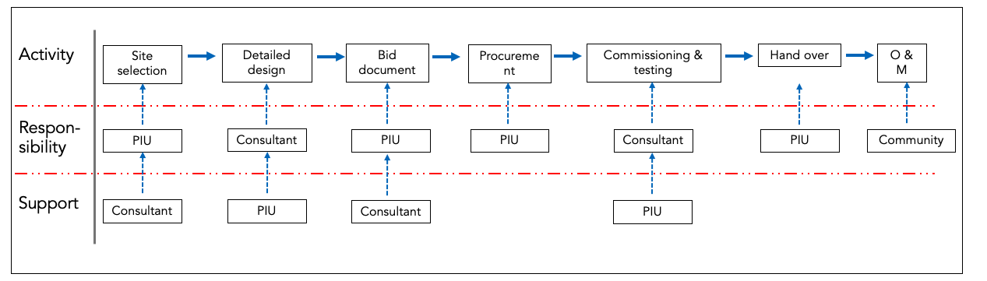
Figure 9. Component 1: Summary Flow Chart of Activities

Component 2: Development of Agriculture and Livestock Services around Water Points
This component will support interventions aimed at creating and strengthening sustainable and productive livelihoods for communities around water points, ensuring that access to water translates into improved livelihoods while addressing vulnerabilities to flood and drought. It will scale up agriculture support services in the existing approximately 100 sites targeted by Biyoole where water infrastructure has already been installed and Community Investment Plans (CIPs) are available. The agricultural activities supported by the project will improve food security and reduce the gender gap in agricultural and livestock productivity, as well as assets, through several measures targeted towards women and women-owned businesses and collectives.
There are seven indicators in the project results framework that will track the activities under Component 2 (see Table 9).
Table 9. Expected Outcomes from Component 2
Indicator Name | Unit of Measure | End Target
Number of functional Farmer Field Schools established | Number | 80
Number of animals that received veterinary services | Number | 1,800,000
Number of Community Animal Health Workers trained | Number | 500  (of which 150 female)
Number of female Community Animal Health Workers trained | Number | 150
Number of institutions providing veterinary services/certifications strengthened | Number | 15
Livestock managers with increased productivity | Percentage | 70
Female share of livestock managers with increased productivity | Percentage | 30
Management responsibility: The Ministry of Agriculture, Livestock and Husbandry will closely work with each of the PIUs at FGS and FMS level for implementation of Component 2.

Key Activities for Subcomponent 2
Table 10. Component 2: Key Activities
Key Activity | Activity Description
1 | support interventions aimed at creating and strengthening sustainable and productive livelihoods for communities around water points.
2 | Ensure that access to water translates into improved livelihoods while addressing vulnerabilities to flood and drought.
3 | Finance the integration of improved technologies for enhanced agricultural and livestock production.
4 | Scale up agriculture support services in the existing approximately 100 sites targeted by the Biyoole project where water infrastructure has already been installed and Community Investment Plans (CIPs) are available.
5 | Improve food security and reduce the gender gap in agricultural and livestock productivity, as well as assets, through several measures targeted towards women and women-owned businesses and collectives.
6 | Provide the foundation for possible future support to Somali agriculture under the Regional Food Systems Resilience Program for Eastern and Southern Africa (P178566).

Subcomponent 2.1: Increased Sustainable Farming Production and Development
This subcomponent will finance the introduction of technologies, innovations, and management practices (TIMPs) related to improved water use efficiency and climate-smart agriculture to farm communities around each of the developed water points. TIMPs will be introduced using a community-based extension architecture and will incorporate climate-smart agricultural practices. The subcomponent will support mobilization and strengthening of farmers into common interest groups (CIGs) of 15–20 members each and Farmer Producer Organizations, including female-led associations, cooperatives, and self-help groups, for ease of access to extension services, inputs, and output markets. Mobilization and subsequent support to CIGs will focus on high inclusion of female farmers and vulnerable member groups and development of resources and capacity at the community level for long term sustainability. training sessions will be offered at times and locations that are convenient to women given the demands for their time from other duties, and child-care will be provided to facilitate their participation. Where possible, the training on climate-smart agriculture will be designed to train family units together, which has been found to not only increase women’s access to training but also increase awareness among all family members of the role women play. Minority and marginalized groups will also be included where possible.

Key Activities for Subcomponent 2.1
Table 11. Subcomponent 2.1: Key Activities
Key Activity | Activity Description
1 | PIUs to establish demonstration plots and other farmer training infrastructure and incorporate lessons learned from Biyoole Demonstration Plots; provide agricultural inputs and training for community learning and capacity strengthening.
2 | The FGS to share the fodder production strategy developed under Biyoole for utilization of fodder production activities under Barwaaqo, and the implementation of lessons learned from Kenya and Ethiopia fodder production sites’ visits.
3 | Procure and distribute seeds, tools, soil testing kits, and other inputs to farming communities, giving priority to certified or quality declared seeds and tools from local suppliers, where possible.
4 | Provide extension and other training services to farmer groups for specific crops and climate-smart agriculture (CSA) technologies and TIMPs. This is to be led by state and local staff from the Ministry of Agriculture, with support from United Nations agencies or nongovernmental organizations (NGOs) where necessary.
5 | Provide farmer training via equipment/service provider contracts, with oversight by the Ministry of Agriculture, on use and management of microirrigation systems.
6 | Train lead farmers, community-based facilitators, and farmer groups on fodder production systems and storage with oversight by the Ministries of Agriculture and Livestock.
7 | Provide farmer training on improved storage techniques for grain and planting seed and constructing household and community storage.
8 | Train Community Animal Health Workers and procure needed supplies/equipment.
9 | Each Federal Member State (FMS) ministry and federal ministries—coordinating through the national level Project Implementation Unit (PIU)—should provide copies of any existing guidelines, manuals, procedures, and others that they have created for activities pertaining to agriculture/crop management, livestock management, pasture/rangeland management, and so on. The goal is to make sure that each PIU can learn from the others. Good practices should be shared and adopted. No PIU should have to start from zero if another state already has guidelines that they can use and customize to meet their needs. This cross-FMS sharing should continue throughout the project.
10 | Establish Farmer Field Schools (FFSs) for demonstration of improved agricultural technologies, irrigation practices, crop rotation and other climate-smart agricultural practices including technologies, innovations, and management practices (TIMPs).
11 | Farmer-led irrigation: Community-level microproject investments, agricultural tools, and equipment provision to common interest groups (CIGs) for irrigation.
12 | Develop a community operations manual (COM): The FMS PIUs should learn from and build on existing models for community mobilization to develop their guidelines. The content of the COM must be agreed with the World Bank project team. The COM will outline the process of community engagement throughout the project including the structure of community groups, the approach of the engagement and mobilization process, templates for village and household profiles, and so on.  Community mobilization activities should include, inter alia, local problem analysis; assessment of vulnerabilities, capabilities, and available resources; building awareness of the benefits of collective action; preparation of village profiles; formation or strengthening of Village Development Committees (VDCs) and associated subcommittees (for example, procurement committee, monitoring committee, committees to oversee land management, agriculture, and livestock activities, and so on); election of VDC officers; preparation of prioritized Community Action Plans (CAP) and Community Investment Plans (CIPs).
13 | Training materials should be a mix of media keeping in mind the language of the target audiences and the literacy levels within the communities where the project will operate. Materials should have limited, simple text supplemented by graphics.
14 | Mobilize and form production groups: Groups will form according to their specific goals and common interests—for example, orchard production groups, pastoral production groups, community garden groups, cereal producer groups, and so on.
15 | Develop rangeland/pasture management guidelines: The FMS PIUs should learn from and build on existing models of rangeland/pasture management for their guidelines. State civil servants should play a central role in the development of the guidelines, but it is also possible to contract a consultant, an agency or an NGO to develop and validate guidelines for community-led rangeland management programs planned under Component 2. The contract would be managed by the state PIU and would be carried out in accordance with the Project Procurement Strategy for Development (PPSD).
16 | Provide agriculture extension services to communities: The FMS PIUs should learn from and build on existing extension messages, training curricula, and activities to support successful cropping for improved food security, improved nutrition, and increased income opportunities for the entire community.
17 | Identify the committee to manage labor-intensive public works within the community.

Subcomponent 2.2: Increased Sustainable Livestock Production and Development
This subcomponent will support the development and diversification of livelihoods among target pastoralist communities. It will facilitate improved grazing management, the demand-driven delivery of climate-smart livestock production assets, appropriate activities that enhance carbon stock, and extension services based on community-specific priorities and context-specific conditions. The project will train and deploy female extension agents and veterinarians to support female livestock keepers and facilitate the formation of inclusive cooperatives and self-help groups. The subcomponent will build on significant gains realized under the Biyoole project in animal husbandry and veterinary services. Pastoralist field schools will be established to intensify the training of farmers on fodder production and management, animal health and disease control, and rangeland management.

Key Activities for Subcomponent 2.2
Table 12. Subcomponent 2.2: Key Activities
Key Activity | Activity Description
1 | Enhance the capacity for community governance by training leaders on meeting management, ensuring inclusion and participation, conflict resolution, and so on.
2 | Develop Community Investment Plans (CIPs) to identify priority needs that can be met by collective action, specific project interventions or leveraging other programs. These plans will inform and guide landscape and livelihood interventions.
3 | Develop a geo-tagged village profile with the number of households, livelihood profiles, and constraints to livelihoods; estimated wealth ranking; number and size of different stakeholder groups (youth of working age, women, women-headed households, pastoralist households, agriculture households, agro pastoral households, unemployed, disabled, and so on).
4 | Implement microproject investments at CIG level (breed Improvement, animal health, rangeland and fodder management); provide training on breed improvement, and management of fodder and rangeland.
5 | Establish Pastoralists' Field Schools, livestock management, and demonstration plots.
6 | Establish veterinary clinics service centers, and training of veterinary service providers
7 | Provide veterinary clinics, supplies, and equipment procurement and operation management
8 | Organize capacity-building training of lead farmers and community-based facilitators
9 | Organize capacity building and knowledge sharing of FPOs and linkages creation for common interest groups/vulnerable and marginalized groups.

Subcomponent 2.3: Institutional and Capacity Development
This subcomponent will strengthen the FGS and FMSs, Somaliland government, as well as the Ministries that are responsible for agriculture and livestock, to create an enabling environment for agriculture and animal husbandry. This will build their capacity to boost food security and livelihoods’ development among rural communities as well as their capacity to plan and design climate-resilient interventions that support sustainable agricultural and livestock production. This subcomponent will strengthen the capacity of national and state institutions to plan, implement, and monitor integrated agriculture and livestock development programs. To the extent possible, the subcomponent will also support agriculture digitization, including geo-tagged registration of participating farmers, digitization of prioritized TIMPs for delivery to farmers, and provision of digital agriculture solutions to targeted farmers. It will also focus on capacity building on climate-smart agriculture technologies and support to women and youth as e-extension service providers.

Key Activities for Subcomponent 2.3
Table 13. Subcomponent 2.3: Key Activities
Key Activity |  | Activity Description
1 |  | Create an enabling environment for agriculture and animal husbandry.
2 |  | Strengthen the FGS and FMSs, Somaliland government, as well as the Ministries that are responsible for agriculture and livestock.
3 |  | Strengthen the capacity of national and state institutions to plan, implement, and monitor integrated agriculture and livestock development programs.
4 |  | Finance the establishment of a coherent agriculture (farming and livestock) extension ecosystem that combines public, private, and community-led extension services.
5 |  | Provide targeted support to improve linkages between the nascent agricultural research system to the community-based extension ecosystem to be developed
6 |  | Support farmers with context specific climate-smart agro-weather and market advisories.
7 |  | To the extent possible, support agriculture digitization, digitization of prioritized TIMPs for delivery to farmers, and provision of digital agriculture solutions to targeted farmers.
8 |  | Focus on digital agriculture to incorporate access to solar-powered irrigation systems, provision of e-extension and advisory services, bundled with digitally enabled access to inputs and technologies to improve productivity, building on ongoing pilot work under the Biyoole project.
9 |  | Access to finance and marketing of livestock and farm produce from targeted farming and pastoral communities.
10 |  | Capacity building on climate-smart agriculture technologies and support to women and youth as e-extension service providers.
11 |  | Targeted exposure visits to neighboring countries to learn from similar work.
12 |  | Enhance institutional and regulatory capacity of Somali institutions, leading to increased resilience to floods and droughts.
13 |  | Ensure that the necessary knowledge and skills are embedded in government, rather than mainly with external agencies.
14 | Prepare proposals for targeted exposure visits to neighboring countries to learn from best-practice approaches. These should be co-financed by the government and the project through subcomponent 2.3 funds. The visits should directly address knowledge needed to implement the project. Guidelines for the visits should be developed and agreed among all the PIUs.

Component 3: Development of Environmental Catchment Services in Project Areas
Component 3 includes the promotion of rangelands restoration and introduction of appropriate practices for Sustainable Land Management (SLM). This component thus reinforces national climate mitigation measures to increase forest cover and soil organic carbon (SOC). Increased vegetation cover, riverbank protection, and promotion of water storage are intended to contribute to mitigate the impacts of flooding, while soil and water conservation techniques set out to reduce soil loss and increase soil moisture content and thus help to reduce vulnerability to droughts.
Table 14. Component 3: Intermediate Indicators and Expected Outputs
Indicator Name | Unit of Measure | End Target
Land area under invasive species management techniques | Hectare | 1,000
Agriculture land area with soil and water conservation measures | Hectare | 3,000
Forest area under restoration | Hectare | 1,000

Implementation Arrangements
The component will train staff from central and local governments involved in implementation of the project who will work with the Barwaaqo beneficiary communities. In this arrangement, the central ministry staff will essentially provide technical back up services to and supervision of their decentralized colleagues who will be working directly with the communities through mobilizing/sensitizing them as well as engaging them in participating in the project activities.

Key Activities for Component 3
Table 15. Component 3: Key Activities
Key Activity | Activity Description
1 | Address vulnerabilities to extreme climate events and enhance the benefits from the sustainable management of catchments in project areas.
2 | Promote rangelands restoration.
3 | Invest in efforts to restore ecosystems and mitigate, as well as adapt to, climate change.
3 | Improve livelihoods and contribute to poverty reduction, and also help mitigate the effects of Somalia’s variable climate.
4 | Increase the much-needed water harvesting opportunities—key to increasing water security and, thus, communities’ resilience to droughts.
5 | Strengthen the capacity of the different government and community institutions to develop and implement environmental activities and regulations.

Subcomponent 3.1: Environmental Restoration
The subcomponent will finance nature-based solutions and approaches to SLM at micro and macro levels, such as: the regeneration of naturally growing trees, increasing SOC, regeneration of shrubs and grasses; local (village) level approved rules and regulations for use and sanctions; restoration of degraded and severely destroyed ecosystems; the promotion of suitable water harvesting for soil and water conservation techniques (for example, semi-circular bunds, soil bunds, and rock catchments); promotion of improved rangeland management; and assessments and surveys of soil and erosion.
To avoid decreasing downstream water availability and to increase upstream productivity, the project will introduce techniques to manage invasive plant species. The subcomponent will also consider sedimentation, dry season water flows, flood reduction, and broader disaster risk reduction. Its implementation will be undertaken in collaboration with local governments for planning and monitoring.

Key Activities for Subcomponent 3.1
Table 16. Subcomponent 3.1: Key Activities
Key Activity | Activity Description
1 | Organize communities for training (by Ministry of Environment Specialist and Project Implementation Units [PIUs]) to undertake soil/farm management interventions as identified and mapped in the Community Investment Plans (CIPs) developed under component 4.
2 | Train and support Grovernment and communities on suitable water harvesting for soil and water conservation techniques (for example, semi-circular bunds, soil bunds, and rock catchments). Develop training syllabus’s and materials.
3 | Regenerate naturally growing trees, shrubs and grasses through tree planting, zoning areas for protection of seedlings, training of communities on tree planting and tree nursery establishments.
4 | Sustainable landscape management (invasive species management technique): Ministry of Environment at Federal Government of Somalia (FGS) to share the Prosopis Management Strategy developed under Biyoole for invasive species management.
5 | Utilize the existing or develop sustainable land management (SLM) guidelines for implementation of SLM activities , involving communities to do the activities and supervising and documenting progress.
6 | Establish village profiles and common interest groups (CIGs) for microproject community investments, and training for suitable water harvesting for soil and water conservation techniques.
7 | Geographical Information System (GIS): Project monitoring and evaluation to incorporate data collection with environmental and climate change information to inform activity implementation and for the ministries of environment creating awareness and intervention at the community levels.
8 | FGS Ministry of Environment to host quarterly forums for climate and environment workshops for awareness and knowledge exchange between PIUs, and knowledge exchange at the local level (community microwatershed management plans).
9 | Community microinvestments on suitable water harvesting for soil and water conservation techniques (for example, semi-circular bunds, soil bunds, and rock catchments).
10 | Monitor activities for quality control, and evaluate and document impacts.

Table 17. Component 3.1: Summary Flow Chart of Activities
Activity | CIGs formation | GIS establishment | SLM guidelines and strategies | SLM management | Community microinvestments
Responsibility | PIUs | PIUs/M&E | PIUs | PIUs | PIUs
Support | MoE | MoE | MoE | MoE | MoE

Subcomponent 3.2: Institutional and Capacity Development
This subcomponent will strengthen the capacity of the FGS, FMSs, and Somaliland governments on environmental protection, and the development and implementation of nature-based solutions and SLM practices.

Key Activities for Subcomponent 3.2
Table 18. Subcomponent 3.2: Key Activities
Key Activities | Activity Description
1 | The Ministry of Environment to maintain communication on climate change awareness and lead technical training and workshops.
2 | Participate in climate conventions/workshops at international and national level, and in regional/national conferences on environment and climate change.
3 | Identify community committees, and form community groups for microproject support on climate-smart interventions and SLM management as described in sub-component 3.1.
4 | Support to community committees to establish resource mobilization mechanisms for prevention of diverse impacts due to climate change.
5 | Support ministry offices’ building and rehabilitation, equipment and furniture of offices and environmental specialist as well as focal point staffing.

Table 19. Component 3.2: Summary Flow Chart of Activities
Activity | Community committee formation | Community training on climate change management | Community groups for microproject support on climate-smart interventions | Training and workshops
Responsibility | PIUs | PIUs/M&E | PIUs | PIUs
Support | MoE | MoE | MoE | MoE

Component 4: Project Management, Community Development, and Enhancing Livelihoods Planning
This component will finance the operational costs of the project management units in Somaliland and FMSs, as well as a national project coordinator and fiduciary support unit at the FGS level. It will help manage the project as planned, including project coordination, as well as conduct monitoring and evaluation (M&E) and produce policy-based input.
Table 20. Component 4: Intermediate Indicators and Expected Outputs
Indicator Name | Unit of Measure | End Target
Efficient and functional web-based management information system | Number | 2
Beneficiaries that feel project investments reflected their needs | Percentage | 70
Project Implementation Units (PIUs) staffed | Number | 6
Community Investment Plans developed | Number | 150
Female share of PIU staff, interns, and seconded staff in line ministries and other water institutions | Percentage | 30
Proportion of contracts awarded to female-friendly contractors | Percentage | 20
Women share of leadership positions in Village Development Committees | Percentage | 20
Grievances registered related to delivery of project benefits that are addressed | Percentage | 75
Number of new line ministry buildings constructed | Number | 6
Number of line ministry buildings, laboratories, and offices renovated | Number | 10
The component will initiate the establishment of Project Implementation Unit (PIU) capabilities: all governments will recruit and hire PIU staff. For Hirshabelle and Jubbaland states, there will be establishment of office space and procurement of equipment and supplies (for example, cars and computers) after recruitment and hiring of PIU staff.

Key Activities for Component 4
Table 21. Component 4: Key Activities
Key Activity | Activity Description
1 | Finance the operational costs of the project management units in Somaliland and FMSs and a national project coordinator and fiduciary support unit at the FGS level.
2 | Successful targeting of beneficiaries and the achievement of improved water balance, access and management, adoption of SLM practices, select indicators for soil moisture and/or SOC (as appropriate), enhanced agricultural productivity, as well as gender and nutrition-related outcomes.
3 | Support the development of village profiles, to promote livelihoods development around water points and implement Components 1 to 3.
4 | Support M&E, knowledge management and learning, and Security Risk Management.
5 | Enhance women’s participation in decision-making processes by facilitating women’s participation in the CIPs’ preparation, thus addressing a gender gap.

Subcomponent 4.1: Project Management
The subcomponent will ensure that the project is implemented efficiently, on time, and in accordance with the Financing Agreement. This will be the responsibility of the National Project Coordination Unit (NPCU) at the Federal level and Project Implementation Units (PIUs) at state levels. The NPCU at the Federal level and PIUs of Puntland, South West, and Galmudug and the PIU in Somaliland, were already established under Biyoole, and Jubbaland and Hirshabelle PIUs will be set up under Barwaaqo.

Key Activities for Subcomponent 4.1
Table 22. Subcomponent 4.1: Key Activities
Key Activity | Activity Description
1 | Ensure that the project is implemented efficiently, on time, and in accordance with the Financing Agreement.
2 | Support the incremental operating costs for managing the project; the cost of procurement and financial management specialists; and outreach and communications on the governments’ role and leadership on the project to the broader Somali community.
3 | Support the cost of procurement and financial management specialists.; and outreach and communications on the governments’ role and leadership on the project to the broader Somali community.
4 | Support outreach and communications on the governments’ role and leadership on the project to the broader Somali community.

Subcomponent 4.2: Community-Driven Development Planning
Community-Driven Development (CDD), which links the provision of water to agriculture and livestock activities, introduced under Biyoole, will be enhanced in this project. Community development specialists housed in the PIUs, along with the focal points from the technical line ministries, will use the community engagement guidelines developed under Biyoole to discuss options for use of the community water points and then to develop Community Investment Plans (CIPs). The component would also support the development of village profiles, mapping of disadvantaged groups and CIPs, M&E, knowledge management and learning, and Security Risk Management. By facilitating women’s participation in the CIPs’ preparation, the project will enhance women’s participation in decision-making processes, thus addressing the gender gap. It will also deepen familiarization of communities to the principles of women and youth representation, inclusion, and transparency. The 50 CIPs developed under Biyoole will be revisited and updated based on the evolution of community needs. This process will start under Biyoole to advance readiness for Barwaaqo implementation, and 150 new CIPs will be developed in the new sites identified under this project.
Engagement of Village Development Committees (VDCs) right from the early stages of water point identification will be a cornerstone of the community engagement to ensure local ownership of the asset and envisaged livelihood activities. This early engagement of the VDC, along with continued involvement of local authorities from the different sectors, will help to maintain the support and momentum of the planned activities.

Key Activities for Subcomponent 4.2
Table 23. Subcomponent 4.2: Key Activities
Key Activity | Activity Description
1 | Develop further the CDD approach introduced under Biyoole.
2 | Refine institutional responsibilities and support the Ministries of Planning in their mandates of overseeing development from State to district to community level..
3 | Deepen familiarization of communities to the principles of women and youth as agents of change, inclusion, and transparency, building on successes and experience achieved in the current project.
4 | Build the capacity of the Ministries of Planning.
5 | Provide funds to contract implementation support of the mobilization activity, given capacity and human resource constraints at the state level.
6 | The 50 CIPs developed under the Biyoole project will be revisited and updated based on the evolution of community needs, and 150 new CIPs will be developed in the new sites identified under this project.
7 | Early engagement of Village Development Committees (VDCs) will help to maintain the support and momentum of the planned activities.
8 | Community facilitators trained by the Community Development Specialists will facilitate CIP discussions to promote ownership. The project team will ensure that a minimum 30 percent of the trained facilitators are female.
9 | The Biyoole project’s PIUs housed in the ministries will ensure that coordination with other projects is done well..
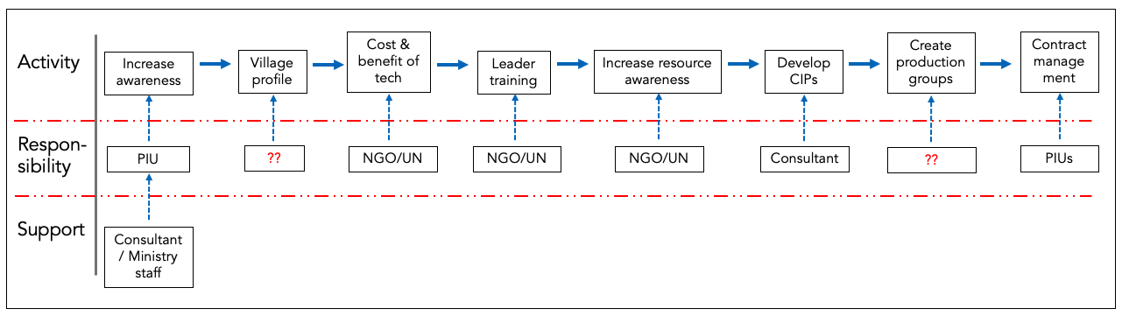
Figure 10. Subcomponent 4.2: Summary Flow Chart of Activities

Subcomponent 4.3: M&E, Knowledge Management, and Learning
The project would support continuous learning and adaptable knowledge management. The web-based management information system (MIS) developed under Biyoole will be expanded to track real-time performance of the Barwaaqo project and linked to an M&E system to focus on project results and outcomes.

Key Activities for Subcomponent 4.3
Table 24. Subcomponent 4.3: Key Activities
Key Activity | Activity Description
1 | Finance baseline, concurrent monitoring of inputs and outputs and monitoring of safeguards, conflict, and gender.
2 | Focus on developing and disseminating knowledge generated through various project activities. The activities will incorporate new modern technology.
3 | Support technical work such as flood mapping and support to information sharing To get more information and knowledge on the extent and period of floods
4 | This subcomponent will allow the FGS to engage a suitably qualified and experienced international independent firm to provide quality enhancement and implementation support to the project.
5 | Continuous monitoring of an MIS dashboard, by the NPCU and PIUs at each FMS, for functionality and accuracy of data, ensuring that project funds are utilized for the purposes specified in project grant agreements.

Subcomponent 4.4: Contingent Emergency Response
This subcomponent will support immediate and rapid response to an Eligible Crisis or Emergency, as needed. This zero-cost component will finance eligible expenditures under the Immediate Response Mechanism (IRM) in the case of natural or man-made crises or disasters, severe economic shocks or other crises and emergencies in Somalia (the emergency response would include mitigation, recovery, and reconstruction following crises and disasters, such as severe droughts, floods, disease outbreaks, and landslides, among others). It can be triggered through the formal declaration of a national emergency by the government authority and upon a formal request from the FGS to the World Bank through the Ministry of Finance. In the event that this component is triggered, interventions will be informed by the Emergency Operations Manual (EOM), which is attached as Annex 10.

Key Activities for Subcomponent 4.4
Table 25. Subcomponent 4.4: Key Activities
Key Activity | Activity Description
1 | funds from other project components will be reallocated to finance emergency response expenditures to meet agricultural crises and emergency needs.
2 | Implementation of this subcomponent will follow a detailed Contingent Emergency Response Implementation Plan (CERIP) satisfactory to the World Bank that will be prepared for each eligible emergency.

Project Management and
Institutional Arrangements

Project Locations
The project will be a fully national project implemented in all five Federal Member States (FMSs) of Puntland, Galmudug, Hirshabelle, South West State, and Jubbaland, and also in Somaliland. Systemized approaches will be followed to select project areas; prioritization criteria based on areas of extreme water scarcity, availability of sustainable water and drought susceptibility will be the driving factors. In Somaliland and all FMSs, the relevant disaster management agencies will be consulted regarding communities most in need, and these will be overlaid with the relevant national development plans to determine project locations..
To provide water, agriculture, and environment services to the people in the regions of Sool and Sanaag—where there is a lack of clarity regarding administrative responsibility—the Federal Government will contract third party implementers. Funds to the value of US$3 million (US$1.5 million from the Somaliland budget and US$1.5 million from the Puntland budget) for eight sites, covering all components (at an approximate budget of US$375,000 per site for all four components), has been ringfenced for these areas from project budgets. The map (Figure 11) shows the approximate area between Somaliland and Puntland that is in question. In cases where the location of a community is not clearly identifiable on the map the World Bank Cartography Unit has provided an interactive map to help the project to identify exact community locations using coordinates, this will assist the World Bank task team in the provision of clearances. No visibility by any Government or the use of World Bank logos is permitted in these areas in question.
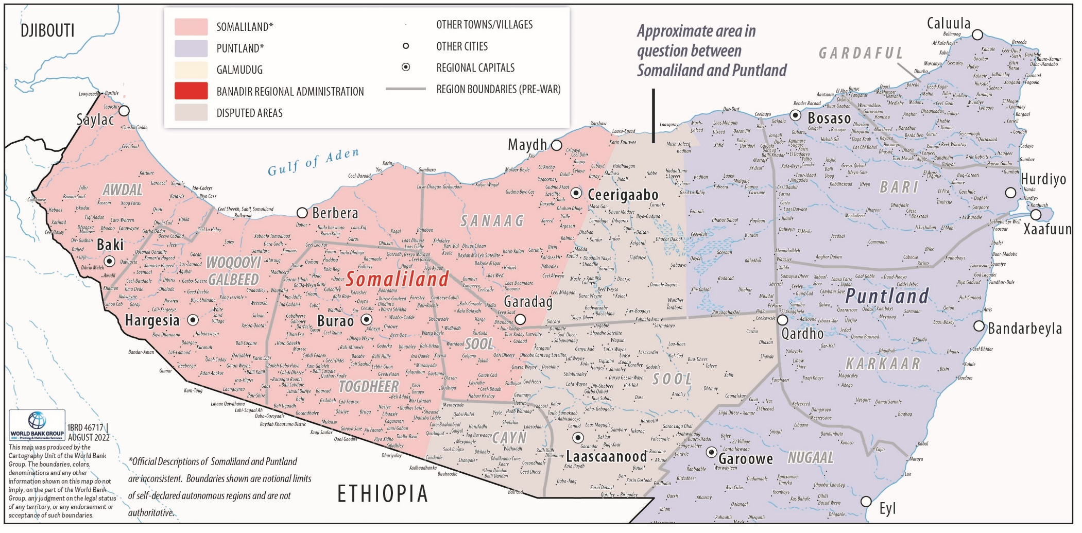
Figure 11. Approximated Area in Question

Roles and Responsibilities: Federal Level
Implementation arrangements, with the exception of community-driven development (CDD) which moves from the ministries of environments to the ministries of planning, will remain as per the Biyoole project. The existing and established Federal Inter-Ministerial Steering Committee, National Project Coordination Unit (NPCU), the state Project Implementation Units (PIUs), and the Somaliland model will continue to serve Barwaaqo.
The project will be implemented by the ministries of planning—lead coordinating ministry and responsible for Component 4; ministries of water/relevant agencies, for example, PWDA in Puntland—Component 1; ministries of agriculture and livestock—Component 2; and ministries of environment—Component 3. The NPCU will support Hirshabelle and Jubbaland to establish PIUs under their ministries of planning and lessons learned under the current project will be used to increase staff skills, build capacity, and mitigate risks. At the FGS level, the Ministry of Planning will have financial management (FM), procurement, monitoring and evaluation (M&E), social/community development, gender/gender-based violence (GBV) specialists, communication, environmental, security, and water specialists. State-level and Somaliland PIUs will replicate this structure; some roles, however, will be merged. Given the limited capacity at the municipal level, the project will support building the capacity of the districts and village development community management committees.
An External Assistance Fiduciary Section unit already exists in the Ministry of Finance based in Mogadishu and at FMS levels that manages the designated accounts and project accounts. A PIU with a project coordinator, supported by a specialists for monitoring and evaluation (M&E), procurement, and financial management, as well as specialists as needed with medium- and short-term input, will be appointed at the Ministry of Planning Investment and Economic Development (MoPIED) to maximize the flow of communications among the Federal Ministries, FMSs, and Somaliland. This will help the MoPIED oversee the M&E aspect of the project through its M&E Department. The project coordinator will be responsible for maintaining a unified Results Framework for the project. Funds for policy analysis and other relevant sector studies will be made available to each stakeholder ministry at the federal level.

Roles and Responsibilities: State Level
Each FMS and Somaliland will establish and maintain a PIU with representation from participating line ministries to ensure cross-sectoral collaboration in planning and implementation activities. The PIUs will be staffed by project management and the relevant fiduciary and safeguards specialists, in addition to the seconded sectoral specialists, to ensure high quality implementation. A specific indicator relating to gender has been included in the Results Framework under Component 4: Number of PIUs established under the project and functioning, and of which female are 30 percent. Drawing from experiences in the WALP pilot and Biyoole, it was found that having women playing key roles in PIUs greatly improved project implementation. The project will seek to replicate this good practice and ensure women’s participation by encouraging governments to establish PIUs that are gender balanced. This is particularly important in the south where initial indications, from preappraisal meeting attendance (where no women joined any of the meetings), are that women civil servants are marginalized and not included in water, livestock, and agriculture project implementation or decision making.
To inform key design elements of water interventions, the project will contract consultant engineers to (a) identify areas with potential for water development; (b) inform the mobilization discussions led by government with communities; and (c) provide detailed designs and supervision of the construction of water infrastructure.
Third party monitoring (TPM) will be contracted to provide monitoring support in South West State, Hirshabelle, and Jubbaland. Given the complexity of operating in these FMSs, the TPM will provide remote supervision, fiduciary compliance, and real-time risk and safeguards monitoring. The TPM will independently verify results on the ground and help ensure that funds are used for the intended purposes. It will also be able to provide technical guidance on the reliability of government M&E systems.

Figure 12. Organizational Flow of Services and Project Resources from Federal Government to Community Level
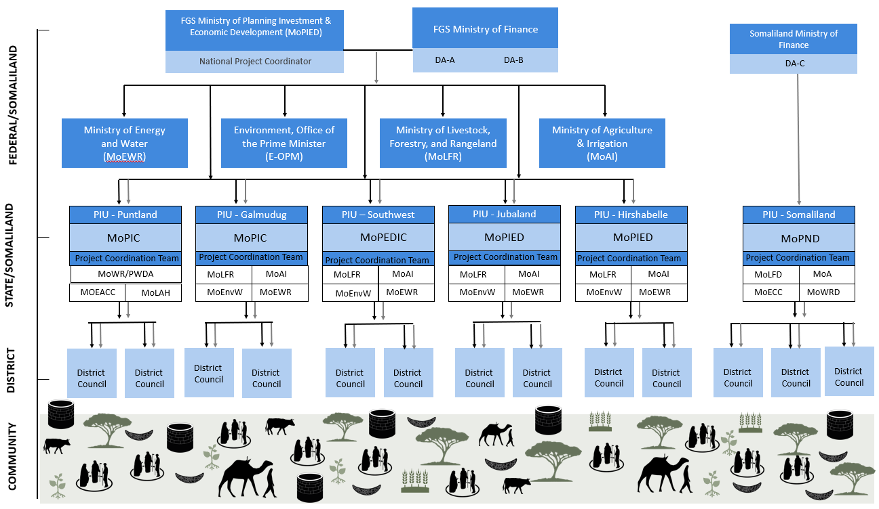

Roles and Responsibilities: Community Level
The role of districts and communities is critical in the management of rural resilience infrastructure projects. The Federal Government of Somalia (FGS) prepared community engagement operational guidelines as a comprehensive guide to the processes and procedures for engaging and working with the communities participating in the Biyoole project. These will be revisited and updated for Barwaaqo—this is particularly important given that the mandate for CDD has moved to the ministries of planning. Using these guidelines, this project will support building the capacity of the districts and community management committees. A project steering committee that tracks project implementation progress and provides support and guidance as required at the Federal level is established. State-level project steering committees will be established to provide oversight and guidance at the FMS level. The ministries of planning will play a coordination role in community engagement and development to ensure inter-agency linkages are enhanced. Operations and maintenance of water points is particularly critical and the local government, in this case the District Council, where the community is located, will be handed over the responsibility of the operation and maintenance (O&M) of the water point, and its related infrastructure developed under the project. Districts with council structures in Somaliland and Puntland will be started as pilot districts and the capacity of the districts will be developed for the O&M of the infrastructures in close collaboration with the target community. Lessons from these pilots will contribute to the O&M Guidelines to be developed under Component 1.
At the community level, while not part of the supply-side implementation structure, per se, the project will work through representative community institutions to provide leadership of the implementation process, including:
- Organizing the village for participation in the project;
- Identifying and agreeing on investment priorities; and
- Organizing the community to deliver those investments in collaboration with the government and other service providers.
The project calls this system of community institutions for problem identification, planning, and execution a community management system. In many communities, such an organization—the Village Development Committee (VDC)—has already been formed under other programs, and the project will work with them. In other communities, the project will facilitate the creation of such VDCs. The leadership of the VDCs will be elected from the village members and will include representatives from different stakeholder groups within the village. In particular, the project will require that 30 percent of the VDC leadership be women, to ensure that women’s voices are included in development investment decisions.
Figure 13. Flow of Community Engagement
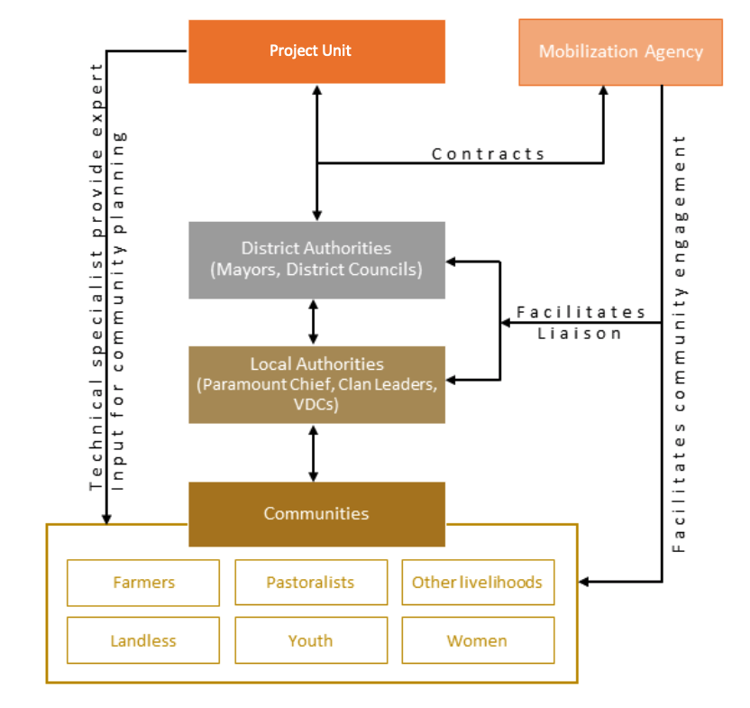
Table 26. Roles and Responsibilities of Project Implementing Entities
Entity | Duties and Responsibilities
Federal level
Inter-ministerial Steering Committee | - Chaired on a rotational basis by the ministries of water and energy resources, ministry of planning investment and economic development, ministry of agriculture and irrigation, ministry of livestock, forestry and range and the ministry of environment; and meeting quarterly  - Review and endorse the Annual Workplan and consolidated Annual budgets  - Review project quarterly reports and provide strategic guidance  - Facilitate inter-ministry and Federal Member State (FMS) dialogue and provide guidance on emerging implementation issues  - Oversee the proper monitoring and evaluation (M&E) functioning  - Ensure the establishment and functioning of project structures at all levels  - Ensure the project implementation framework is updated periodically  - Steering committee meetings are to be planned by the project coordinator, who is also responsible for ensuring that meeting minutes are recorded and archived
Ministry of Finance | - Manage project fund and oversee all project disbursements  - Generate system reports; review consolidated reports and submit reports to the World Bank
Ministry of Planning, Investment, and Economic Development | - Coordinate project implementation at all levels  - House the project coordinator  - Oversee M&E aspects of the project  - Development of Project Communication Strategy  - Maintain a robust communication with federal implementing agencies and states to collect project related information  - Update the project’s Results Framework regularly  - Liaise with External Assistance Fiduciary Section (EAFS)  - Produce quarterly, half-yearly, and annual project status reports (physical and financial)  - Oversee the implementation of the environment and social instruments, build capacity, and provide technical guidance to environmental and social (E&S) staff at FMS level.  - Coordinate implementation and build the capacity of implementing agencies on E&S risk management for the project.  - Oversee the grievance mechanism of the project, including a gender-based violence (GBV)–sensitive grievance mechanism, and contractor and direct workers’ complaints mechanisms.
Federal implementing agencies (Ministry of Agriculture and Irrigation, Ministry of Energy and Water Resources, Ministry of Livestock, Forestry and Rangeland, and Ministry of Environment) | - Provide technical backstopping in their respective areas to the implementing agencies at state level  - Provide training, coaching, and mentoring for state-level implementing agencies  - Update relevant policies, strategies, guidelines, and working manuals for their respective specialized areas
State level
State Project Implementation Units (PIU) | - Led by the selected line ministry in each state and represented by all  - Staffed by project management, fiduciary, safeguards and M&E specialists, and seconded technical sectoral experts  - Plan, budget, execute, supervise, monitor, and evaluate all project related activities in the state  - Procure all service contracts (community mobilization agencies, hydrological assessments, engineering surveys, and others)  - Procure all goods (office equipment, furniture, vehicles, improved seeds)  - Procure all works contracts (technical service agencies water infrastructure, demonstrational community garden and fruit groves, animal health treatment services, and others)  - Work closely with the community and village leaders  - Prepare and submit periodic budget requests to the ministry of finance  - Effects, payments to service providers, consultants, contractors, and others  - Liaise with line ministries at the federal level for technical support and guidance  - Collect project related information, compile and report periodically on project implementation status  - Coordinate implementation and build capacity of implementing agencies on E&S risk management at FMS level  - Manage the grievance mechanism at FMS level of the project, including a GBV-sensitive grievance mechanism and contractor and direct workers’ complaints mechanisms
Community level
Village Development Committee (VDC) | - Membership of the VDC should comprise all permanent residents of the community  - If there are internally displaced people in the community, it is recommended that they be included in the planning so that conflict over resources can be mitigated  - Led by the committee chair and consisting of at least seven members (minimum 30 percent women)  - Organize the community to participate fully in all aspects of the subproject at the community level  - Facilitate community level discussion, rapid rural appraisals, transect walks, and others  - Oversee the development of community development plans  - Facilitate community participation and contribution (labor, material, and others)  - Facilitate and organize community-level trainings (on community management, operation and maintenance, gender, natural resource management, conflict resolution, and others)  - Receive, own, manage, and operate community infrastructure  - Liaises with the state level PIU and line ministries to get technical backstopping and other relevant support  - Collect project-related information and report to the state PIU

Oversight Arrangements
PIUs at the state-level will be established within the respective ministry that is chosen to coordinate the project in Hirshabelle and Jubbaland, in the respective regions. They will have overall responsibility for project management, coordinating project implementation, M&E, and reporting of results to stakeholders, as well as for and developing environment and social safeguards frameworks and plans. Other FMS PIUs will continue to function with the set-up from Biyoole. The NPCU will also be maintained at the federal level, based within Ministry of Planning Investment and Economic Development (MoPIED), which will be responsible for the overall coordination of the project implementation and oversight.
Additionally, the World Bank will maintain an oversight role throughout the Barwaaqo project, as detailed in the following section.

Staffing of PIUs
The core staff of the Project Coordination Unit (PCU) and PIUs will include the coordinator, fiduciary (procurement and FM), environmental, social and GBV specialists, and M&E specialists. In addition, technical specialists on agriculture, livestock, and water will also be included in the line ministries implementing the project. Regular government staff are expected to be seconded to the PIUs.
Donor-financed projects in Somalia were following different mechanisms to retain key project staff. The lack of trained manpower and experienced specialists has also led Somalia to try to get some specialist support from the market in the form of advisors at a comparatively extremely high and unsustainable cost. While that may be the only option for the short term, in the long term it is unsustainable for any government that desires to establish an efficient civil service with a highly constrained resource environment. The Barwaaqo project is seconding civil servants to the PIUs to enhance knowledge transfer and capacity building.
The sources of financing for Barwaaqo is a standard International Development Association (IDA) grant that normally will not pay salaries for government regular staff. On the other hand, Biyoole understands the additional time and effort needed from seconded staff and would make reasonable compensation in recognition to this effort in the form of ‘Responsibility Allowances’. Annex 8 provides the Responsibility Allowance and harmonized consultant fees’ structure—it is drawn from the government’s civil service grade and payment scale, which will be used to compensate staff at all levels.

Implementation Support/ Supportive Supervisions
Twice yearly formal implementation support missions and additional interim implementation support missions every quarter will be carried out. Security permitting, all sites will be visited at least once in person by the project team. Where access is not possible, monitoring will be done using remote technology such as unstaffed aircraft systems. Ongoing support and dialogue will be maintained throughout to monitor progress and address pertinent issues. A supervision strategy has been articulated as an Implementation Support Plan (ISP), which is presented in Annex 11.
Regular dialogue will be maintained through direct contact, audio and/or video-conferences between the Bank team and the FGS and FMS officials to assure regular follow-up to agreed actions during project implementation. The procurement specialist will play a central role in supporting implementation of sound procurement practices, in accordance with the Bank’s fiduciary requirements. Bank Safeguards’ staff will provide needed support with respect to environmental and social safeguards as needed. They will conduct missions to project areas at least once a year and will remain available to support as needed on safeguards aspects. The Mid-Term Review (MTR) mission will require participation of the entire spectrum of specialists having participated in appraisal. The project will be reviewed at least once a year to ensure that it continues to meet the implementation support needs of the project.

Table 27. Implementation Support Plan and Resource Requirements
Time | Focus
First 12 months | Project start-up, preparation of safeguards instruments, training of fiduciary staff, establishment of Project Implementation Unit, development/maintenance of management information systems, and initiation of procurement
12–48 months | Implementation of support missions, leverage community-based platforms, facilitation of recruitment of local facilitators, support to formulation and implementation of plans, foster citizens’ engagement

Sustainability
Experience in the agricultural and water sectors has shown that the impact of multiple social, economic, technical, institutional, or environmental factors operating over a long period of time may influence sustainability of services in rural areas. Based on lessons learned from similar projects, project design will work towards strengthening and supporting sustainability of systems by activities aimed at, inter alia:
- Supporting the involvement of beneficiary communities and strengthening the participation and role of women in all cycles of project design and implementation.
- Strengthening the units responsible for postconstruction operations and maintenance (O&M) support at all levels.
- Supporting an enabling environment for the active participation of the private sector to support O&M.
- Supporting continuous and periodic refresher training sessions for user communities and directly related institutions at different levels.
- Supporting the choice of services and appropriate technologies, such as water technologies and agricultural services, during scheme design and implementation.

Operation and Maintenance of Water Points
To help ensure sustainability of investments, O&M guidelines have been prepared under Biyoole. The preparation of the guidelines initially drew on good practices from other contexts and was complemented by consultative workshops to review and validate the proposed guidelines. Whilst endeavors in this regard were initially acceptable, the guidelines will be strengthened under Barwaaqo. Introductory information is needed regarding what the purpose of the document is, key information on sites, such as year of construction, site characteristics, location, number of beneficiaries, and who the O&M guidelines will be used by. Of particular importance are the issues of who owns the infrastructure, who operates it, who manages it, and who has the right to use the water. Supported by the Bank’s technical assistance, standardized O&M guidelines will be finalized, based on experiences from Biyoole, and adopted nationally. This process will contribute to the development of national policies for O&M.

Project Procurement Arrangements

Guidelines and Regulations
Procurement will be carried out in accordance with the requirements in the Procurement Regulations for Borrowers under Investment Project Financing (IPF): Goods, Works, Nonconsulting Services and Consulting Services dated July 1, 2016 (revised in November 2017, August 2018, and November 2020); (“Regulations”), as well as “Guidelines on Preventing and Combating Fraud and Corruption in Projects Financed by the International Bank for Reconstruction and Development (IBRD) Loans and IDA Credits and Grants (revised as of July 1, 2016)”; and provisions stipulated in the Financing Agreement. Somalia being a fragility, conflict and violence (FCV) country, procurement under the projects will be processed under special procurement arrangements referred to in Paragraph 12 of the World Bank Policy IPF dated November 10, 2017.

Procurement Implementation Arrangements
The existing procurement implementation arrangement of the ongoing Biyoole project will be maintained and strengthened under the proposed Barwaaqo in the Federal Government of Somalia (FGS), Federal Member States (FMSs: Puntland, Galmudug, and South West State), and Somaliland. Also, the implementation timelines of Biyoole (stipulated to be closed on February 28, 2023) and Barwaaqo are overlapping and hence the expertise gained and institutional memory will be beneficial for implementation of Barwaaqo. The National Project Coordination Units/Project Implementation Units (NPCU/PIUs) are already staffed with project coordinators and procurement specialists, among other key staff. The new PIUs for the additional states of Hirshabelle and Jubbaland will be established during project implementation and will also recruit qualified procurement specialists. The procurement specialists shall be responsible for all procurement support at the NPCU/PIU level. The procurement specialists will initiate the procurement activities based on the approved procurement plan and do all procurement processing.

Project Procurement Strategy for Development and Procurement Plan
As per the requirement of the World Bank Procurement Regulations, the Recipient has developed a Project Procurement Strategy for Development (PPSD) as presented in Annex 9, based on which the Procurement Plan (PP) for the first 18 months has also been prepared. The PP sets out the selection methods to be followed by the Recipient during project implementation in the procurement of Goods, Works, Consulting and Nonconsulting services, cost estimates, time schedules, the Bank’s review requirements, brief description of the activities/contract, and so on. The PP will be updated at least every 12 months, or as required, to reflect the actual project implementation needs, but each update shall require World Bank Group (WBG) approval. All PPs will be publicly disclosed in accordance with the WBG’s disclosure policy.

Systematic Tracking of Exchanges in Procurement
The WBG’s Systematic Tracking of Exchanges in Procurement (STEP) system will be used to prepare, clear, and update PPs and conduct all procurement transactions for the project. The PIUs under Biyoole have been trained and are using STEP and the Bank STEP champion and the procurement specialist will continue working closely with PIUs for smooth use of STEP. Other procurement staff of the incoming implementing agencies not familiar with the STEP system will be trained on how to use it.

Main Procurement Activities
The project envisages procurement of the following main contracts:
- Works: Contracts under Works include construction of sand/subsurface dams, earth dams, boreholes/shallow wells, rehabilitation of office construction/rehabilitation. These being small Works, the market research shows that there are qualified local contractors, many of whom have participated in and completed projects of a similar nature, complexity, and value. Under the previous WALP, it has been observed that local construction companies have experience in similar works, financial capacity, and sufficient expertise. However, the major concern is that many bidders will need some training on how to avoid simple mistakes that could make bids to be rejected at a preliminary examination stage. It is, therefore, recommended that prebid conferences be held to brief bidders on what is required when submitting bids. The proposed procurement method is Request for Bids (RfB) and Request for Quotations (RfQ) based on the budget estimates. Therefore, a national approach will be considered.
- Nonconsulting services: Contracts under nonconsulting services include activities such as hiring conference facilities, transport or information technology (IT) services. Given the nature and size of the nonconsultancy services to be procured, most of the potential bidders are available locally. Such items will be procured through National Open Competitive market approach and RfQ.
- Office equipment, vehicles, and supplies: Somalia has available local traders for information and communication technology (ICT) equipment, scientific equipment, motor vehicles, and furniture and other office supplies. These items are available either locally or internationally. Such items will be procured using either Open National/International or RfQ methods as appropriate.
- Consulting services: The procurement activities under consultancy services for this project will be hiring consultants. These will include both individual and consultant firms from local and international markets and, where there is comparative advantage, nongovernmental organizations (NGOs) and United Nations (UN) specialized agencies as needed. There are qualified consulting firms and individuals mainly from the region who have participated in previous similar assignments funded by the Bank. In some instances, the foreign firms have partnered with local firms to enhance their experience. The preferred procurement methods for the recruitment of firms under consulting services would be Quality and Cost-Based Selection (QCBS). However, other methods including Consultant Qualification-based Selection (CQS) as well as direct selection would be used where necessary.

Forced Labor Risk in the Procurement of Solar Panels/Components
There is a significant risk of forced labor in the global supply chain for solar panels and components. To support forced labor risk mitigation, the Bank requires Borrowers to strengthen procurement documents that include solar panels/components for the “core functions of a project” as defined in the World Bank Environmental and Social Framework.
These strengthened measures include forced labor bidder declarations, qualification requirements, strengthened forced labor contractual provisions, and mandatory prior review/No Objection by the Bank. The new requirements apply to both international and national competitive procurement and any direct selection/direct contracting within the scope of application.

Service Delivery Contracts
Service delivery contracts will focus on operationalizing the livelihood plans created under subcomponent 2.2. Each PIU will have a budget envelope to support community-driven investments in watershed/landscape management, agriculture, and livestock activities, from which they can calculate a maximum investment envelope per community.
FMS ministries will have funds available to contract implementation support from qualified NGOs, firms or agencies to support community land and livelihood investments and to ensure the technical quality and sustainability of those investments. Implementing partners will engage directly with the community and livelihood groups formed through the mobilization process to implement their priority investments via training, civil works (for example, bunding, terracing, reforestation, pasture restoration, community service center, and so on), and asset provision (for example, seeds, farm tools, machinery, water-efficient irrigation equipment) needed to support the growth and development of livelihoods.
Technical staff from state-level ministries will work with, and provide oversight to, implementation service providers to ensure the technical quality of training and other activities.
Separately, construction companies will be contracted to carry out the construction works. The construction process, where requested by communities, will include labor-intensive methods.
Goods, Services, and Works will be packaged in economical packages to attract bidders who are qualified and can offer good prices, and can complete contracts within the stipulated period, resulting into value for money.

Selection Methods for Goods, Works, and Nonconsulting Services
The following selection methods for Goods, Works and Nonconsulting Services will be used.

Request for Proposals (RfP)
An RfP is a competitive method for the solicitation of proposals. It should be used when, because of the nature and complexity of the Goods, Works, or Nonconsulting services to be procured, the Borrower’s business needs are better met by allowing proposers to offer customized solutions or proposals that may vary in the manner in which they meet or exceed the requirement of the request for proposals documents. An RfP is normally conducted in a multistage process.
To allow an evaluation of the degree to which proposals meet the requirements of the RfP document, the evaluation normally includes rated type criteria and an evaluation methodology.

Request for Bids (RfB)
An RfB is a competitive method for the solicitation of bids. It should be used when, because of the nature of the Goods, Works, or Nonconsulting services to be provided, the Borrower is able to specify detailed requirements to which bidders respond in offering bids.
Procurement under this method is conducted in a single-stage process. Qualifying criteria (minimum requirements normally evaluated on a pass/fail basis) are normally used with RfB. Rated-type evaluation criteria are normally not used with RfB.

Request for Quotations (RfQ)/Shopping
A RfQ is a competitive method that is based on comparing price quotations from firms. This method may be more efficient than the more complex methods for procuring limited quantities of readily available off-the-shelf Goods or Nonconsulting Services, standard specification commodities, or simple civil Works of small value.
Small Works contracts estimated to cost equivalent or less than US$200,000 per contract or Goods/Nonconsulting Services to cost equivalent or less than US$100,000 per contract may be procured through Shopping procedures by comparing prices for quotations received from at least three reliable contractors or suppliers. In such cases, RfQ shall be made in writing and shall indicate the description, scope of the Works, the time required for completion of the Works, and the payment terms. All quotations received shall be opened at the same time.
In evaluating quotations submitted by bidders under Shopping method, the price and ability to meet required delivery requirements shall be the main selection considerations for these simple purchases. The terms of the accepted offer should be incorporated in the Local Purchase Order.

Direct Selection
Proportional, fit-for-purpose, and value for money considerations may require a direct selection approach: that is, approaching and negotiating with only one firm. This selection method may be appropriate when there is only one suitable firm or there is justification to use a preferred firm. Direct selection may be appropriate under the following circumstances:
- An existing contract, including a contract not originally financed by the Bank, for Goods, Works, or Nonconsulting Services, awarded in accordance with procedures acceptable to the Bank, may be extended for additional Goods, Works, or Nonconsulting Services of a similar nature, if:
- it is properly justified;
- no advantage could be obtained through competition; and
- the prices on the extended contract are reasonable.
- For tasks that represent a natural continuation of previous work carried out by a consultant within the last 12 months, where continuity in the technical approach, experience acquired, and continued professional liability of the same consultant may make continuation with the initial consultant preferable to a new competition, if performance has been satisfactory in the previous assignment(s).
- There is a justifiable requirement to reengage a firm that has previously completed a contract, within the last 12 months, with the Borrower to perform a similar type of contract. The justification shall show that:
- the firm performed satisfactorily in the previous contract;
- no advantage may be obtained by competition; and
- the prices for the direct contracting are reasonable.
- The procurement is of both very low value and low risk, as agreed in the Procurement Plan.
- The case is exceptional, for example, in response to emergency situations.
- The standardization of Goods that need to be compatible with existing Goods may justify additional purchases from the original firm, if the advantages and disadvantages of another brand or source of equipment have been considered on grounds acceptable to the Bank.
- The required equipment is proprietary and obtainable from only one source.
- The procurement of certain Goods from a particular firm is essential to achieve the required performance or functional guarantee of an equipment, plant or facility.
- The Goods, Works or Nonconsulting Services provided in the Borrower’s country by a state-owned enterprise, university, research center or institution of the Borrower’s country are of a unique and exceptional nature in accordance with the regulations.
- Direct selection of UN agencies must be in accordance with Paragraphs 6.47 and 6.48 of the World Bank procurement regulations.
In all instances of direct selection, the Borrower shall ensure that:
- the prices are reasonable and consistent with the market rates for items of a similar nature; and
- the required Goods, Works or Nonconsulting services are not split into smaller-sized procurement to avoid competitive processes.

Selection Methods for Consulting Services
The following approved selection methods for consulting services will be used.

Quality and Cost-Based Selection (QCBS)
The QCBS is a competitive process among shortlisted consulting firms under which the selection of the successful firm takes into account the quality of the proposal and the cost of the services. The RfP document shall specify the minimum score for the technical proposals. The relative weight to be given to the quality and cost depends on the nature of the assignment. Among the proposals that are responsive to the requirements of the RfP document and are technically qualified, the proposal with the highest combined (quality and cost) score is considered the most advantageous proposal.

Fixed Budget-Based Selection (FBS)
Like the QCBS, the FBS is a competitive process among shortlisted consulting firms under which the selection of the successful firm takes into account the quality of the proposal and the cost of the services. In the RfP document, the cost of services is specified as a fixed budget that shall not be exceeded. The FBS is appropriate when:
- the type of Consulting Service required is simple and can be precisely defined;
- the budget is reasonably estimated and set; and
- the budget is sufficient for the firm to perform the assignment.
The RfP document specifies the budget and the minimum score for the technical proposals. The proposal with the highest technical score that meets the fixed budget requirement is considered the most advantageous proposal.

Least Cost-Based Selection (LCS)
Similar to the QCBS, the LCS is a competitive process among shortlisted consulting firms under which the selection of the successful firm takes into account the quality of the proposal and the cost of the services. The LCS is generally appropriate for assignments of a standard or routine nature (such as engineering designs of noncomplex Works), for which well-established practices and standards exist.
The RfP document specifies the minimum score for the technical proposals. Among the proposals that score higher than the minimum technical score, the proposal with the lowest evaluated cost is considered the most advantageous proposal.

Quality-Based Selection (QBS)
Under the QBS, the proposal quality is evaluated without using cost as an evaluation criterion. If the RfP requests both technical and financial proposals, the financial proposal of only the highest technically qualified firm is opened and evaluated to determine the most advantageous proposal. However, if the RfP document requests only technical proposals, the firm with the highest-ranked technical Proposal is invited to submit its financial proposals for negotiations. The QBS is appropriate for the following types of assignments:
- Complex or highly specialized assignments for which it is difficult to define precise terms of reference (ToR) and the input required from the firm, and for which the Borrower expects the firm to demonstrate innovation in its proposals.
- Assignments that have a high downstream impact.
- Assignments that can be carried out in substantially different ways, so that proposals will not be comparable.

Consultant’s Qualification-Based Selection (CQS)
The Borrower shall request expressions of interest (REoI), by attaching the ToR to the REoI. At least three qualified firms shall be requested to provide information about their relevant experience and qualifications. From the firms that have submitted an Expression of Interest (EoI), the Borrower selects the firm with the best qualifications and relevant experience and invites it to submit its technical and financial proposals for negotiations. Advertisement of REoIs is not mandatory.
The CQS is appropriate for small assignments or emergency situations in which preparing and evaluating competitive proposals is not justified.

Direct Selection
Proportional, fit-for-purpose, and VfM considerations may require a direct selection (single-source or sole-source selection), approach, that is: approaching and negotiating with only one firm. This selection method may be appropriate when only one firm is qualified, a firm has experience of exceptional worth for the assignment, or there is justification to use a preferred firm.
Direct selection may be appropriate under the following circumstances:
- An existing contract for Consulting Services, including a contract not originally financed by the Bank but awarded in accordance with procedures acceptable to the Bank, may be extended for additional Consulting Services of a similar nature, if it is properly justified, no advantage may be obtained by competition, and the prices are reasonable.
- For tasks that represent a natural continuation of previous work carried out by a consultant within the last 12 months, where continuity in the technical approach, experience acquired, and continued professional liability of the same consultant may make continuation with the initial consultant preferable to a new competition, if performance has been satisfactory in the previous assignment(s).
- There is a justifiable requirement to reengage a firm that has previously completed a contract with the Borrower to perform a similar type of Consulting Service. The justification shows that the firm performed satisfactorily under the previous contract, no advantage may be obtained by competition, and the prices are reasonable.
- The procurement is of both very low value and low risk, as agreed in the PP.
- In exceptional cases, for example, in response to emergency situations.
- Only one firm is qualified, or one firm has experience of exceptional worth for the assignment.
- The Consulting Services provided in the Borrower’s country by a state-owned enterprise, university, research center or institution of the Borrower’s country are of a unique and exceptional nature, in accordance with Paragraph 3.23 c of the World Bank Procurement Regulations
- Direct selection of UN agencies in accordance with Paragraphs 7.27 and 7.28 of the World Bank Procurement Regulations.
In all instances of direct selection, the Borrower shall ensure fairness and equity, and shall have in place procedures to ensure that:
- the prices are reasonable and consistent with the market rates for services of a similar nature; and
- the required Consulting Services are not split into smaller-size procurements to avoid competitive process.

Selection Methods for Individual Consultants
Individual consultants will be selected for an assignment for which:
- A team of experts is not required;
- No additional home office professional support is required; and
- The experience and qualifications of the individual are of paramount requirement.

Selection Methods
- Open competitive selection of individual consultants: Advertisement through REoIs is encouraged, particularly when the PIU does not have knowledge of experienced and qualified individuals available or of their availability, the services are complex, and there is potential benefit from wider advertising. The REoIs shall include the complete ToR. Individual consultants will be selected from those that expressed interest in response to an REoI.
- Limited competitive selection of individual consultants: When the NPCU/PIU have knowledge of experienced and qualified individuals and their availability, instead of issuing an REoI, it may invite those individual consultants that it deems qualified to provide the required Consulting Services. The complete ToR shall be sent with the invitation. Individual consultants shall be selected from those that expressed interest in response to the invitation.
- Direct selection of individual consultants: Individual consultants may be selected on direct selection basis, with due justifications, under the following circumstances:
- tasks that are a continuation of previous work that the individual consultant has carried out after being selected competitively;
- assignments with a total expected duration of less than six months;
- urgent situations; or
- when an individual consultant has relevant experience and qualifications of exceptional worth to the assignment.

Complaint Handling
For procurement-related complaints, the project will follow the procedure prescribed in the Procurement Regulations (Paragraphs 3.27 to 3.32).

Thresholds
The World Bank (WB) exercises its procurement oversight through a risk-based approach comprising prior and post reviews, as appropriate. The WB sets mandatory thresholds for prior review based on the procurement risk rating of the project.
Based on the risk rating of the project, the Bank and Borrower will agree procurement above the applicable thresholds as provided in Table 28, which shall be subjected to prior or post review. The requirement for a prior or post review shall be specified in the PP.
During project implementation, the WB will monitor and reassess the risk and risk mitigation measures and, if determined by the Bank to be necessary and appropriate, the Bank may require the Borrower to revise the prior and/or post review requirements in the PP. The Bank will carry out post reviews of procurement activities undertaken by the Borrower to determine whether they comply with the requirements of the Financing Agreement.
Contractors’ and service providers’ skills remain weak and the NPCU and PIUs should plan to conduct training sessions for contractors and service providers. It is clear that there has been an improvement, particularly in Puntland, of contractor capacity to bid for and implement WB-financed projects; however, there is still a long way to go.
This was a lesson learned in the WALP pilot and Biyoole planned to address this problem. COVID-19, however, undermined plans to deepen contractor skills because Bank procurement staff were not able to travel and provide on-the-ground training. In Barwaaqo, efforts to strengthen the private sector by developing contractor skills to understand bidding documents and respond competently will be undertaken.
Table 28. Procurement Approaches and Thresholds (in US$ million)
Goods, Works, and Nonconsulting Services
Category | Open International | Open National | Request for Quotation (RfQ) | Direct Selection
Works | ≥5.0 | <5.0 | ≤0.2 | All values
Goods, IT, and Nonconsulting Services | ≥0.5 | <0.5 | ≤0.1 | All values
Consulting Services
Category | Shortlist of National Consultants
Category | Consulting Services |  | Engineering and Construction Supervision
Consultants (firms) | ≤0.1 |  | ≤0.2
Individual consultants | n.a. |  | n.a.
Direct Selection
Consultants (firms) | All values |  | All values
Individual consultants | All values |  | All values

Financial Management
External Assistance Fiduciary Section (EAFS) units are established under the Office of the Accountant General in the Federal Government of Somalia (FGS), Federal Member States (FMS), and Government of Somaliland, and they will be charged with overall financial management (FM) responsibility for all the Somali Multi-Partner Fund (SMPF)/International Development Association (IDA) funded projects. With overall guidance from the respective Accountant Generals, the EAFS units, in consultation with the respective Project Implementation Units (PIUs), will provide day-to-day financial management of the project. All project transactions will be recognized, captured, recorded, summarized, and reported through the governments’ financial management information systems (FMIS). The EAFS units with support of the Accountant General are responsible for ensuring that:
- All important business and financial processes are adhered to.
- Adequate internal controls and procedures are in place and adequately enforced.
- Interim unaudited Financial Reports (IFRs) are prepared on a timely basis.
- Project financial statements are prepared on a timely basis and in accordance with International Public-Sector Accounting Standards (IPSAS) cash-basis.
- External audit is completed on time and audit findings and recommendations/issues raised in the Management Letter are implemented expeditiously.
The EAFS is responsible for ensuring compliance with the External Assistance Fiduciary Section Fiduciary Manual. In case of conflict between provisions of the Project Operations Manual (POM) and the EAFS Manual, those of the POM shall prevail.
Figure 14. Project Financial Management Arrangements
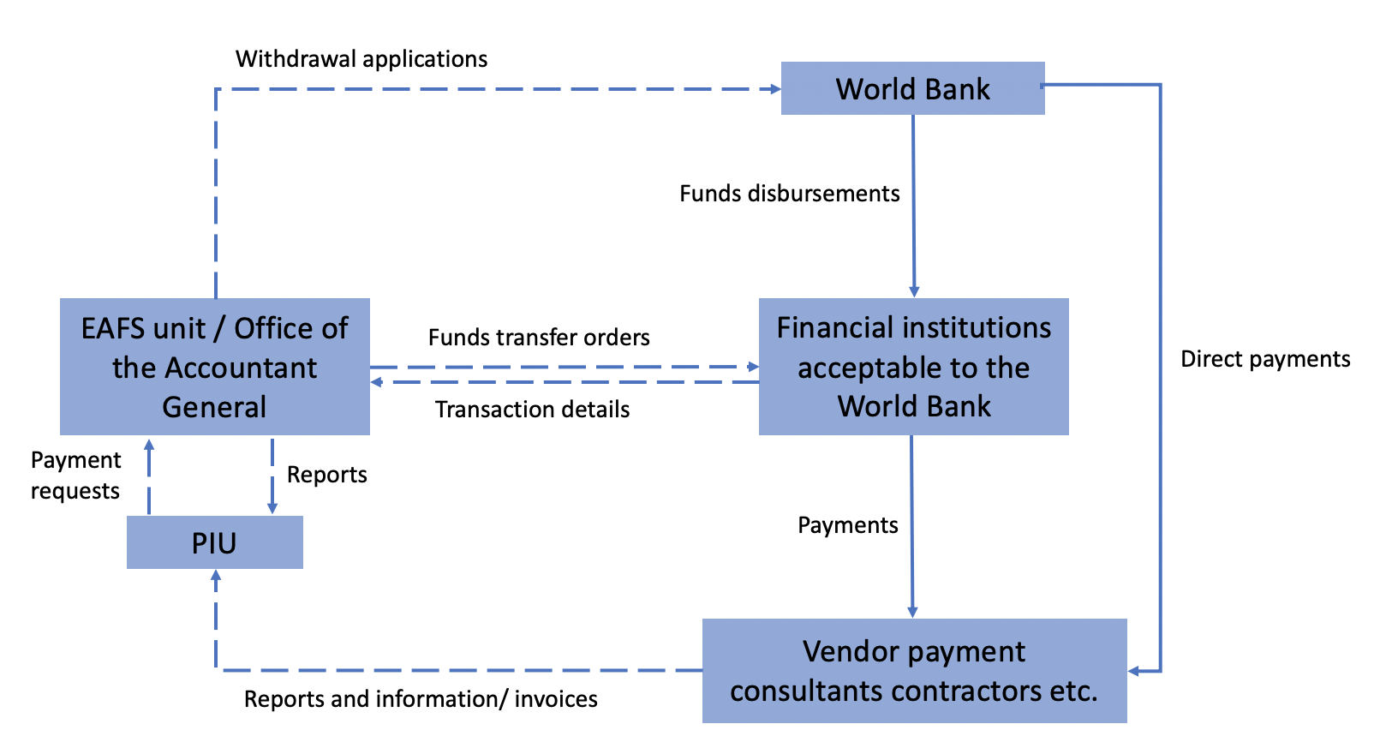

Project Planning and Budgeting Activities
The FGS Project Coordination Unit (PCU) and FMS PIUs closely working with the EAFs will prepare and submit the project’s annual workplans and budget and cash flow forecast for each project component for the necessary approvals by the task team leader (TTL) at the Bank. The workplans, cash flow projections, and budget will include the figures for the year analyzed by months and quarters. The cash budget for each month and quarter will reflect the detailed specifications for project activities, schedules (including Procurement Plan), and expenditure on project activities scheduled, respectively, for the quarter. All annual cash budgets will be sent to the TTL no later than two months before the beginning of the government fiscal year for review and approval. The project estimated annual disbursements for each component will be integrated and aligned to the implementing ministries’ budget calendar (‘on-budget’) and will form part of the appropriated budget by the Parliament. Budget utilization reports shall be prepared from the government FM systems (Puntland Financial Management Information System: PLFMIS; Somaliland Financial Information System: SLFMIS; and Somalia Financial Information System: SFMIS). Other FMSs, which currently do not have FMIS, shall prepare their budget utilization reports in MS Excel and forward them to FGS PCU as part of the internal government periodic reports as well as quarterly reports and submitted to the Bank.

Accounting Policies and Procedures
The project finances earmarked into the sector will be disbursed and accounted for on a cash basis. These will be supported with appropriate records and documentation to track commitments and to safeguard assets. Accounting records will be maintained in United States Dollars (USD). With respect to project support into the sector, the Office of the Accountant General and FMS Treasury Directorates will ensure:
- All important business and financial processes are adhered to.
- Adequate internal controls and procedures are in place.
- Timely and accurate accountability reports are prepared to inform the preparation of the project periodic reports.
- Comprehensive project financial statements covering all the components, including support to the sector, are prepared on a timely basis and in accordance with International Accounting Standards (IAS) or IPSAS.
- Cooperate fully with external auditors on all matters relating to the project external audit and ensure all matters raised by the auditors on the component are addressed adequately, on a timely basis, and audit findings and recommendations are implemented expeditiously.
- As far as practical, the project component budgets and expenditures shall be classified to facilitate the preparation of relevant reports and financial statements, including information on total project expenditures; total expenditure on each project component/activity; and analysis of that total expenditure into various categories of goods, training, consultants, and other procurement and disbursement categories.
- Approval, and the project’s financing shall be integrated into the respective FMS budget annual appropriations.
A project Fixed Assets Register will be prepared, regularly updated, and physical verification of assets routinely carried out. The Fixed Assets Register will reflect: details of suppliers; description and location of goods; original costs; disposal of assets; assets reference (identification) numbers; serial or registration numbers; dates of purchase; assets’ additions; condition of assets; and assets’ useful life and residual value. The respective Financial Management Specialist or Accountant in the FGS, FMSs or Somaliland will be responsible for fixed assets management. The EAFS units will ensure that there are adequate processes for contract administration and implementing ministries have systems in place to monitor all the FM related aspects of contract administration. In this respect, Contract Registers will be maintained with respect to all contracts with consultants, contractors and suppliers.

Internal Control Framework
Internal controls: The respective EAFS units, the ministries of finance, and implementing agencies will ensure that satisfactory arrangements to monitor, evaluate, and validate project results are in place throughout the project implementation period. The project internal controls procedures and processes are outlined in this POM and in the EAFS Manual. The project will ensure that all important business and financial processes are adhered to, and that adequate internal controls and procedures are in place. The possibility of circumventing the internal control systems with colluding practices such as bribes, abuse of administrative positions, misprocurement, and so on, is a critical issue and may include (a) late submission of supporting documents; (b) poor filing and records; (c) lack of system integration; (d) lack of budget discipline; (e) unauthorized commitment to suppliers, bypassing budget and expenses vetting procedures; (f) unsecured safekeeping and transportation of funds; (g) uncertainty over the banking arrangements supporting the project; (h) potential exposure to money laundering; and (i) insecurity and political instability.
These are mitigated as follows: (a) specific aspects on corruption auditing would be included in the external audit and monitoring arrangements terms of reference (ToR); (b) FM procedures (as part of EAFS Manual) have been approved and are in operation for the project; (c) strong FM arrangements (including qualified project accountants in the EAFS Units) exist; (d) there are periodic Interim Unaudited Financial Reports (IUFRs) including budget execution and monitoring; (e) measures to improve social accountability and transparency are built into the project design by ensuring that project reports are available to the public; and (f) annual public financial management (PFM) forums will be held. The respective ministries of finance are currently working on establishing an internal audit function with adequate capacity to enhance the internal control processes.
Fraud and corruption: The possibility of circumventing the internal control systems with colluding practices such as bribes, abuse of administrative positions, misprocurement and so on, is a critical issue and may include: (a) late submission of supporting documents; (b) poor filing and records; (c) lack of system integration; (d) lack of budget discipline; (e) unauthorized commitment to suppliers, bypassing budget and expenses vetting procedures; and (f) unsecured safekeeping and transportation of funds. These are mitigated as follows: (a) specific aspects on corruption auditing would be included in the external audit ToR; (b) FM procedures (as part of Operations Manual) have been approved and are in operation for the project; (c) strong FM arrangements (including qualified project accountants in the EAFS) exist; (d) there are periodic IUFRs including budget execution and monitoring; and (e) measures to improve social accountability and transparency are built into the project design.

Financial Reporting and Monitoring
The ministry prepares financial statements (reports) and submits them to the Accountant General for consolidation purposes. The reports are simplified, comprehensive, and standardized for purposes of comparability and for ease of understanding by the users. Presentation and disclosure of financial statements is done in accordance with the applicable laws and regulations stipulated in the Financial Procedures Manual. The FMSs will send individual reports to the FGS Accountant General who then consolidates them as governmentwide project level reports. The key monthly/quarterly reports produced are (a) trial balance for the month showing, in separate columns, the totals of debit and credit entries in the General Ledger; (b) cumulative Statement of Income and Expenditure; (c) Budget Execution report with comparison report; and (d) Statement of Financial Position. All the reports shall be generated from the core PFM system at the FGS, Puntland, Somaliland, and respective FMSs.
External audit of the project: The respective Offices of the Auditor General (FGS, Puntland, and Somaliland) with the support of technical assistance from an external audit firm, will carry out external audits for the project, including project activities into the water sector. As necessary, the project may be required to purpose adequate resources under the annual workplan to finance incremental costs related to the external audit exercise. The audit would be in conformity with the Bank’s audit requirements and in accordance with internationally recognized auditing standards. The auditor will express an opinion on the Financial Statements in compliance with International Standards on Auditing. The external auditors will also prepare a Management Letter giving observations and comments, and providing recommendations for improvements in accounting records, systems, controls, and compliance with financial covenants in the Grant Agreement. The audit report will be submitted to the Bank not later than six months after the end of the accounting period to which the audit relates. The respective ministries of water (FGS and FMS), as part of the implementing entities, shall work in close consultation with the EAFS units (and treasurers in the case of Jubbaland, South West State, Galmudug, and Hirshabelle) and the PIUs in liaising with the external auditors and responding to all the audit queries.
The external audit under the project will also be undertaken in line with the provisions laid out in the Grant Agreement.

Funds Flow Disbursement and Banking Arrangements
The project will open and maintain three Designated Accounts (DAs): two at the Central Bank of Somalia and one operated separately by Somaliland in a financial institution acceptable to the World Bank. DA-A in Mogadishu will be dedicated for the project activities implemented directly by the Federal Government, whereas DA-B will be ringfenced and dedicated for the project activities implemented by the FMSs (except Somaliland). DA-C will be dedicated for the project activities implemented by Somaliland. Each of the FMSs (Puntland, Galmudug, South West State, Hirshabelle, and Jubbaland) will open and operate a Project Account (PA) to which initial funds’ disbursements to the projects accounts will be based on cash forecast to allow the FMS adequate working capital to implement the project activities. Subsequent funds disbursement from the DA-B to the PAs will be supported by Statements of Expenditures (SOEs).
The United States Dollar (USD) denominated DA(s) will be opened in a financial institution acceptable to the World Bank. Payments from the DA will only be for eligible expenditure which will be justified and properly documented. The EAFS units will ensure that adequate and timely funds are available to finance project implementation as planned in all the implementing agencies, including the FMSs (Puntland, South West, Hirshabelle, Jubbaland and Galmudug), which will have PA. The EAFS will prepare and submit withdrawal applications for the DA. Funds will be transferred into the DAs against an approved Withdrawal Applications, as provided in the funds flow diagram (Figure 15). The first IDA fund release will be an advance payment based on an agreed ceiling and on the submission of a Withdrawal Application. Replenishment and Reimbursement of Withdrawal Applications will be accompanied by SOEs and direct payment will be accompanied by copies of records in accordance with the procedures established in the Disbursement Letter and the Bank’s Disbursement Guidelines.
Figure 15. Fund Flow through Project Accounts
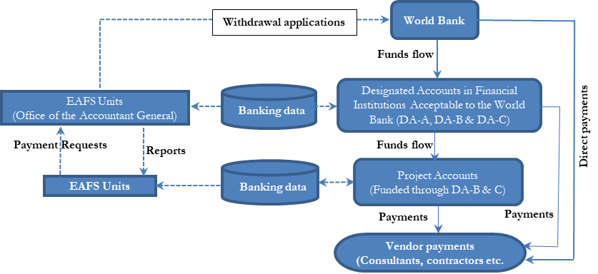
Disbursement procedures for the project are set forth in the Disbursement Guidelines. These procedures must be strictly followed in withdrawing funds for the purpose of project expenditures. The disbursement deadline is four months after the project closing date. For any changes to this date, the recipient will be notified by the World Bank. The disbursement methods to be utilized for the withdrawal of funds from the Grant will include: (a) Designated Account (Advance); (b) Reimbursement; (c) Designated Account (Replenishment); (d) Direct Payment; and (e) Special Commitment.
These methods are briefly described here.
Disbursement methods and supporting documentation requirements are detailed below:
- Designated Account (Advance): At the start of the project, the project may apply for an advance to be deposited in a Designated Account. Subsequent withdrawal applications will be based on SOEs reviewed and submitted information of withdrawal application to the World Bank through the Client Connection portal.
- Reimbursement: An example of this includes expenditures eligible for World Bank financing that will have been incurred by the recipient and not paid from advanced funds. These will be refunded on a reimbursement basis. Reimbursement requests shall include:
- Records providing evidence of eligible expenditures (for example, copies of receipts, supplier invoices).
- SOE in for all expenditures (with attached expenditure vouchers).
- List of payments against contracts that are subject to the World Bank's prior review (with attached payment vouchers).
- Designated Account bank statement and signed DARS.
- Designated Accounts (Replenishment): An example of this includes expenditures eligible for World Bank financing that will have been incurred by the recipient and not paid from advanced funds. These will be refunded on a replenishment basis. Replenishment requests shall include:
- Records providing evidence of eligible expenditures (for example, copies of receipts, supplier invoices).
- SOE in for all expenditures (with attached expenditure vouchers).
- List of payments against contracts that are subject to the World Bank's prior review (with attached payment vouchers).
- Designated Account bank statement and signed DARS.
- Direct Payment: Upon request of the project, through withdrawal application for Direct Payment, the World Bank may make payments directly to a third party (for example, supplier, contractor, and consultant) for eligible expenditures. Request for payment should include records providing evidence for eligible expenditures, for example, copies of the contract, receipts, supplier , and documentary evidence of delivery of contracted goods or services. The following are the steps for application:
- Assemble payment request and supporting documentation including invoices, receipts, payment certification, and shipping documents.
- Review the payment request for the following:
- Expenditure Eligibility;
- Expenditure Category;
- Sample contract; and
- World Bank 'No objection' for the expenditure.
- Raise Withdrawal Application.
- Raise Expenditure Summary Sheet for each category of expenditure (if multiple).
- Obtain authenticated signatories from the authorized persons.
- Special commitment: Upon request of the project, through a Withdrawal Application, for special commitment, the World Bank may pay amounts to a third party for eligible expenditures under special commitments. The following procedure may be adopted:
- Obtain Supply Contract/Award Letter and Suppliers invoice.
- Apply to a bank for opening Letter of Credit in favor of the payee's bank.
- Raise Special Commitment Application for payment to supplier on the terms stated in Contract or Award Letter and Letter of Credit.
- Submit Special Commitment Application, supporting documents including Supply Contract or Award Letter, a copy of the Letter of Credit to the payee's bank for onward transmission to the World Bank.
Each government other than the FGS will operate a separate USD PA. Funds may be transferred from DA-B and DA-C to PAs on a regular basis as and when funds are required.
Signatories to the DAs and PAs are to be:
- Federal Government: DA-A
  - Panel A (FGS): Director General of Ministry of Finance (MoF) with Director of Administration as alternate; and
  - Panel B (FGS): Accountant General (with Deputy Accountant General as alternate).
- Puntland, South West, Galmudug, Hirshabelle, and Jubbaland: DA-B
  - Panel A (FGS): Director General of MoF (with Director of Administration as alternate); and
  - Panel B (FGS): Accountant General (with Deputy Accountant General as alternate): All from FGS.
- Somaliland: DA-C
  - Panel A (SL): Director General of MoF (with Director of Finance as alternate); and
  - Panel B (SL): Accountant General (with Deputy Accountant General as alternate).
- FMS Projects Accounts: Puntland, South West, Galmudug, Hirshabelle, and Jubbaland
- Panel A: Director General of Ministry of Finance (with Deputy Director Administration); and
- Panel B: Director, Treasury (with Deputy Director Treasury as the alternate).
The Disbursement Letters provide for advances of project funds to each DA. The DA-A, DA-B, and DA-C advance ceilings are established, and can be modified, by the World Bank. At the time of writing, the advance ceilings are US$500,000, US$2,540,000, and US$500,000, respectively, and could change through Disbursement Letter amendment(s).
Funds may be transferred from DA-B to PAs on a regular basis as and when funds are required. The maximum advance to be held in each of the PAs is agreed between the FGS and the World Bank. FMSs may submit requests for increases to advances, supported by a cashflow forecast. These will be considered on a case-by-case, and approval will be evidenced by a No Objection letter from the TTL. The maximum project advances to be maintained in the PAs as agreed at the time of revision is:
- Galmudug State of Somalia: US$500,000;
- Hirshabelle State of Somalia: US $250,000;
- Puntland State of Somalia: US$1,000,000;
- Somaliland: US$500,000;
- South West State of Somalia: US$500,000; and
- Jubbaland State of Somalia: US$250,000.
Account maintenance and reconciliation procedures are described in Volume 2, the EAFS Manual.

Fraud and Corruption Risks
The possibility of circumventing the internal control systems with colluding practices such as bribes, abuse of administrative positions, misprocurement, and so on, is a critical issue and may include:
- Late submission of supporting documents, particularly documentation relating to decentralized payments in the regions, districts, and at community level.
- Poor filing and records.
- Delays in submission of accountability statements and supporting documents from the State Offices.
- Lack of budget fiscal discipline.
- Unauthorized commitment to suppliers, bypassing budget and expenses vetting procedures.
- Unsecured safekeeping and transportation of funds, particularly at the decentralized implementation levels at the communities.
These are mitigated as follows:
- Specific aspects on corruption auditing would be included in the internal and external audits.
- Specific FM arrangements relating to project support to the sector will be spelled out in the POM.
- Strong FM arrangements (including monthly/quarterly IFR including budget execution and monitoring).
- Measures to improve transparency, such as providing information on the project status to the public.
- The Bank fiduciary team will deploy pragmatic risk mitigation measures including targeted client support through the EAFS Units/Treasury Directorates as well as risk-based monitoring arrangements (including use of Risk Expertise), field-based implementation support including collaboration with internal auditors, third party monitoring/verification of outputs and use of technology.
- In consultation with the Accountant General(s) and EAFS Directors, consolidation and centralization of fiduciary risks through frequent joint FM/Procurement/INT (Integrity) training, targeted technical assistance support, and FM staff rotation.

Conclusion and Supervision Plan
Given the potential decentralized nature of the project components (distributed remote payments), the Bank team will undertake continuous extended FM reviews on all the project disbursements into this component. Third party monitoring arrangements and deployment of targeted risk management expertise will be an integral part of the FM supervision. Detailed reviews will be undertaken covering all FM aspects, including internal control systems, the overall fiduciary control environment, and end-to-end transactions tracing to disbursements all as SOE reviews. Supervision intensity will be based on the assessed and envisaged emerging risks.
The periodicity of FM supervisions will be based on risk emanating from the review of quarterly/monthly salary payments supporting documentation, quarterly IFRs reviews, review of audited Annual Financial Statements and Management Letter as well as timely follow up of issues arising. SOE/Withdrawal Application reviews will be undertaken with support from the Monitoring Agent(s), internal auditors, and the targeted Risk Expert(s). The FM risks will form the basis in the updating of the project Implementation Status Report (ISR). The Bank’s FM team will play a key role in monitoring the timely implementation of the action plan.
List of FM covenants: FM standard covenants include: (a) IFRs will be prepared on a quarterly basis and submitted to the World Bank 45 days after each quarter; (b) The AWPB, including disbursement forecasts, will be prepared each year; and (c) the overall FM system will be maintained operational during the project’s entire life in accordance with sound accounting practices.

Procedures for traveling and workshops
Travel expense policy and procedures are indicated in Annex 13.
The project will finance training and workshops. These costs should NOT be submitted on a case-by-case basis. If required, they should be based on an annual capacity-building plan and budget which shall be submitted to the Bank for its prior review and approval. The annual training plan will identify, inter alia (a) the training envisaged; (b) the justification for the training; (c) the personnel to be trained; (d) the duration for such training; and (e) the estimated cost of the training. At the time of the actual training, the quarterly travel budget request shall be submitted to the Bank for review and approval. Upon completion of the training, the trainees shall be required to prepare and submit a report on the training received.
Payment to travelers will be paid based on agreed financial rules and regulations set out in this POM and in consultation with the World Bank.

Adherence to the Agreed Environmental and Social Risk Management Arrangements
The project will be implemented following the World Bank’s Environmental and Social Framework (ESF). The existing institutional safeguards arrangement under the old operational policies for Biyoole will be enhanced and the capacity of the Project Implementation Units (PIUs) will be strengthened to be able to address the additional requirements of the ESF.
The NPIU will oversee and coordinate the implementation of the project and will guide and train the Federal Member States (FMSs), as well as provide templates for reporting. National Project Coordination Unit (NPCU) environmental and social (E&S) staff will include:
- National environmental specialist who will lead on the contractors’ Environmental and Social Management Plans (ESMP) or Environmental and Social Impact Assessment (ESIA).
- Full-time national social/community-driven development specialist who will lead on the community engagement process as well as the memorandum of understanding with the community, water sharing agreements and the summary social report and project GM.
- Full-time gender-based violence (GBV) /gender specialist who will be the main focal point for project and sexual exploitation, abuse, and harassment (SEAH) complaints.
- Security specialist who will oversee the security management system and review all site specific security risk assessments and management plans.
The NPIU will provide overall responsibility for safeguards’ due diligence and compliance monitoring, and be responsible for coordinating the identification, resolution, and monitoring the status of all E&S issues through the E&S focal points. The PIU will be responsible for:
      - Ensuring compliance with World Bank ESF and other relevant country laws as contained in this ESMF.
      - Ensuring that all service providers are informed of their responsibilities for the day-to-day compliance with the ESMF.
      - Supporting the smooth and efficient implementation of the project.
      - Undertaking effective preparation, review, approval, and implementation of the ESIA, and ESMP based on the ESMF.
      - Maintaining relevant records associated with management of E&S risks, impact assessments, evidence of consultations and a log of grievances together with documentation of management measures implemented.
      - Taking the lead in screening, scoping, and review of draft ESIA/ESMP for the government, receiving comments from stakeholders during public hearing of the project.
      - Convening a technical decision-making panel (if required), ensuring conformity with applicable standards, conduct environmental and social liability investigations, and perform monitoring and evaluation work.
      - Providing overall leadership during public consultation meetings with critical project stakeholders, to gain their support/cooperation/consensus in established policy direction.

The role of the E&S staff includes:
- Spearheading the development of, and updating, ESF instruments including this ESMF.
- Reviewing all ESIA and ESMP reports and documents prepared by E&S consultants to ensure compliance with the World Bank ESF/ESSs.
- Ensuring that Barwaaqo subproject design, specifications, and budget adequately reflect the recommendations of the ESIAs/ESMPs.
- Coordinating application, follow up processing and obtaining requisite clearances and approvals from the World Bank for the ESIA/ESMP submitted by the individual Barwaaqo project and subprojects’ contractors.
- Preparing regular monthly/quarterly/semi-annual annual progress reports with statutory requirements.
- Developing, organizing, and delivering appropriate E&S safeguards’ related training courses for the NPIU and FMS PIU staff, contractors, local government/community representatives and others involved in the project implementation.
- Reviewing and approving the contractors’ ESMP using the ESMF as a guide.
- Liaising with the contractors and the PIU/ Ministries, Departments and Agencies (MDAs) on implementation of the ESMPs and ensuring proper implementation of ESMP requirements through regular visits to project sites.
- Liaising with various government agencies on E&S, land, resettlement, and other regulatory matters.
- Continuously interacting with relevant NGOs and community groups working in the sector and project locations.
- Establishing dialogue with the affected communities and ensuring that E&S concerns and suggestions are incorporated and implemented in the project.
- Reviewing the performance of the project in terms of E&S safeguards, through an assessment of the periodic internal monthly and quarterly E&S monitoring reports; providing summaries of same and initiating necessary follow-up actions.
- Providing support and assistance to government MDAs and the World Bank during Project Review Missions.

The FMS SPIU level will have a full-time environmental specialist, social specialist, and GBV and gender specialists.

Government MDAs will be consulted and collaborated with on various matters including labor management, environmental, land, gender, and security, among others, during the implementing of the Barwaaqo project. Each agency will have a focal point for E&S issues who will ensure implementation of E&S requirements in conjunction with the FMS, environmental, social/CDD, and GBV/gender focal points.

ESMF Instruments
The project has a range of E&S risks which have been assessed and mitigation measures defined as per the World Bank’s Environment and Social Framework, in the following instruments, which have been disclosed on the Ministry website (including a summary in Somali):
- Stakeholder Engagement Plan (SEP).
- Environmental and Social Management Framework (ESMF) including a SEAH prevention and response action plan.
- Resettlement Planning Framework (RPF).
- Environmental and Social Commitment Plan (ESCP).
- Labor Management Procedure (LMP).
A projectwide security risk assessment and management plan will be prepared within three months of effectiveness and site specific comprehensive ESMPs—including social assessments, inclusivity plans, contractor LMPs, SEA/SH and Resettlement Action Plans/Livelihood Restoration Plans)—and Security Management Plans will be prepared and cleared before contracting, and in place before implementation. All contractors will have E&S requirements specified in their contracts as well as the need to develop ESMPs or E&S due diligence reports.
The ESMF checklists for screening proposed project activities will be utilized as general operational guidelines, and templates for preparing the ESMPs. The checklists will ensure that issues of social inclusion with regard to gender and disadvantaged community members are addressed within the project. In light of the type and scale of impact, most of the subprojects will not be subject to further environmental assessment requirements, but there may be some project activities for which it will be necessary for the PIU to prepare a project brief for further action. The PIU will prepare the relevant project brief for submission to the Environment Protection Department of relevant FMS or Somaliland. Upon receipt of the project brief, the Environment Protection Department will determine what additional environmental studies are necessary, if any. In case an Environmental and Social Impact Assessment (ESIA) is deemed necessary, the terms of reference (ToRs) for the study will be prepared by the responsible PIU and reviewed and approved by the respective ministry. The ESIA report will identify and assess the potential E&S impacts for the planned activities, assess the alternative solutions, and will design the mitigation, management, and monitoring measures to be implemented.
During project mobilization and the initial stages of implementation, the Biyoole example will be modified by PIUs and the Bank task team to create a bespoke Barwaaqo template. An indicative outline of an ESMP to guide preparation is presented in Annex 7.
Social and environmental risk management measures will be carried out throughout the project. Table 29 provides a summary of the types of activities that will be carried out at different stages of the project.
Table 29. Activities for Social and Environmental Risk Management
Stage | Activity | E&S Instrument
Project mobilization | Robust, transparent and inclusive staff recruitment/secondment  Establish grievance mechanisms (GM)  Develop, and submit for clearance:  - A projectwide Security Management Plan (SMP);  - Sexual Exploitation, Abuse and Harassment (SEAH) Prevention and Response Plan; and  - Labor Management Procedure (LMP) | LMP, SEAH action plan, SEP
Project launch | Stakeholder workshops at FMS levels to inform government and nongovernmental representatives about the project objectives and criteria and GM and get suggestions and good practices on implementation plan | SEP
Selection of subproject intervention areas | E&S eligibility criteria as per the exclusion list in the ESCP  Clear and transparent criteria including consideration of equity and need  Informed by projectwide SMP | SEP, ESMF
Screening of potential subproject sites | Community mapping and inclusive consultations including disadvantaged groups to ensure community input into design and siting and ensuring that there are no insurmountable risks—for example, major conflict or land contestation, and raising awareness raising about the GM and SEAH prevention  Subproject SMP | ESMF, RPF, SEAH
Subproject E&S instrument development | Environmental and Social Management Plans/Environmental and Social Impact Assessment (ESMP/ESIA) including requirements for voluntary land donation/government mediated land agreements/livelihood restoration plans/GBV service mapping and referral pathways/water sharing agreements | ESMF, RPF, SEAH, LMP, RPF, SMP
Contracting | RPFs specify E&S requirements and require contractors to submit costed ESMPs (including all E&S requirements) as part of bids  Contracts clearly specify E&S requirements and noncompliance | ESMF, RPF, SEAH, LMP, RPF, SMP
Monitoring and reporting | Monitor, and report on, implementation of all instruments and grievance management as well as emerging E&S risks and use it to enhance project implementation and revise processes and documents as necessary

Environmental Risks
The proposed project activities, if not properly implemented and managed, could result in environmental, health and safety (EHS) risks and associated impacts. There are impacts due to development of multiuse water sources under Component 1 (including small sand and subsurface dams in dry riverbeds [wadi]) and surface water storage infrastructure (for example, berkads and hafir dams) and potential impacts from use of water extracted in terms of contamination (for example, discharge of wastewater from community systems, discharges and waste from livestock, impacts from irrigation under Component 2). The project activities could also cause loss of vegetation due to construction/rehabilitation activities, occupational and community safety, and health risks, particularly from inefficient waste disposal and management, more focus for hazardous waste generation from damaged batteries, solar appliances, panels, and pesticide containers; aesthetic quality; air, and noise quality; loss of biodiversity localized as a result of construction and rehabilitation activities, water diversions, impact riverbeds and floodplain, limit access, or decrease water throughput to users downstream, and so on.
There are also positive environmental contributions of the project activities. Component 3 focuses on developing services for environmental protection and climate change adaptation. This component aims to maximize the benefits people and communities obtain from managing ecosystems sustainably. The project will invest in improving ecosystem services, focusing primarily on provisioning services and regulating services. This component will also enhance resilience to climate change risks such as floods and droughts. It will further strengthen the capacity of the different government and community institutions to develop and implement environmental plans and regulations. However, the ecosystem restoration intervention may bring about unintended impacts if not well designed or managed. Small-scale construction may lead to the introduction and spread of alien and invasive species which could negatively impact on biodiversity in the subproject area. This component will be led by the Directorate of Environment and Climate Change at federal level, and the ministries of environment at FMS levels.
The ESMF prepared for the Somalia–Water for Agro-Pastoral Productivity and Resilience (P167826) project will be adapted to cover ESF requirements for activities under Components 1, 2, and 3. The updated ESMF will include relevant measures from World Bank Group General Environmental, Health, and Safety Guidelines (EHSGs) as well as relevant global international industry practice (GIIP) to address environmental, social, health, and safety risks. The EHSGs on construction sites will ensure the safety and security of workers per ESS2 requirements. Based on the outcomes of the screening and national regulations, ‘High’ risk projects will be excluded from financing, ‘Low’ and ‘Moderate’ projects will apply ESMP, and ‘Substantial’ risk projects will apply ESIA and ESMP. ESIAs and ESMPs shall be developed for subprojects to identify potentially adverse environmental and social impacts and risks, and to provide input to the design of the subproject under the project at an early stage. The ESIA process will include analysis of alternatives so as to select the most feasible project option. Cumulative impacts associated with the project will also be evaluated as part of the ESIA process.
The project will follow the same methodology as the Biyoole project and will receive support and experience sharing from staff. E&S staff will be employed within the Federal Government and Member states including E&S, GBV, and security specialists. The capacity of the PCU will have to be strengthened with respect to the ESF approach, which is new to the project.
There are widespread security risks in Somalia to varying degrees for communities, contractors, and project staff. Implementation will not be possible in al-Shabab–controlled areas and security issues need to be carefully assessed and managed elsewhere. The use of security firms either during travel or to protect sites will need to be carried out in line with the World Bank’s Good Practice Note on Assessing and Managing the Risks and Impacts of the Use of Security Personnel. There are a range of contextual risks of operating in conflict zones with complex social contexts where effective and inclusive community consultations and meaningful stakeholder engagement is challenging.

Social Risk Management
The social risk rating is considered to be ‘Substantial’. Activities under Component 1, which focus on rainwater harvesting and groundwater infrastructure, both for people and to support livelihoods, could lead to a range of social risks and impacts. There is the potential to exclude disadvantaged and vulnerable groups from decision making and project benefits (particularly women and minority groups). In addition, the project will require land to develop water infrastructure in locations where land is unregistered or has been subject to land grabbing and has a range of claims. Lack of access to an adequate network of water structures that supply water for both livestock and domestic purposes has often been a cause of conflict between pastoralists and settled communities, which will need to be managed through consultations and agreements between communities and include women who also have critical domestic needs. There are many contextual risks of operating in remote, conflict-affected areas with complex social contexts where effective and inclusive community consultations and meaningful stakeholder engagement are challenging. Furthermore, developing effective grievance redress mechanisms will be complex due to rural locations, traditional decision-making structures, and existing social tensions. The extent of any labor influx will be determined during preparation. However, the presence of even relatively small numbers of external workers can result in social tensions, increased risk of transmission of diseases, and the risk of SEA/SH and other forms of GBV. The project will be subject to a range of labor risks, including OHS risks, safety and security risks, and the potential use of child labor. Local contracting arrangements may also mean that project workers do not have contracts or are subject to unfair conditions (lack of breaks, irregular pay, and so on). Female workers may be discriminated against in terms of employment but are also at higher risk of SEA/SH and other forms of GBV. COVID-19 may continue to play a role in influencing project implementation, notably around stakeholder engagement and face-to-face gatherings. Virtual options for meetings will be limited due to poor connectivity and a lack of familiarity with such forums.
Key social issues for the project include (a) land agreements and resettlement action plans/livelihood restoration plans for physical and economic displacement, the issues relating to inclusive in-depth consultations plus conflict sensitivity and mitigation measures, the careful assessment to avert conflicts, disputes or hostility between clan/ subclan/sub‐subclan or different interest groups as land is mostly communally owned; (b) low economic and social empowerment of women and of youth; (c) limited formal engagement with key stakeholders. In south and central Somalia, the ability to coordinate with local authorities, civil society, beneficiaries, and other stakeholders can be constrained by logistical and security restrictions; (d) potential exclusion of poor and vulnerable households, including female-headed households, minority groups, and internally displaced people (IDPs); and (e) GBV, in particular risks of SEA/SH.
The project will support social assessments and management plans as part or in preparation of the community development planning process during implementation. The mobilization process to establish community management systems will bring together the entire community for initial consultations, priority setting, and livelihood group formation. Depending on the cultural practices of the community, the project will form groups with both males and females or groups exclusively for females to ensure that they have a vehicle to implement their livelihood choices. Mobilization will be closely monitored to ensure that women (as well as youth and marginalized groups) are included in decision making and are able to avail the benefits of the project. Based on consultations with other agencies working with communities in Somalia, it is a practice requiring representation of women in leadership positions of Village Development Committees (VDCs) and other livelihood groups. To ensure women’s voices are being heard and reflected in decision making, leadership of VDCs must ensure that at least 20 percent of committee members are women. Moreover, in consultation with state PIUs, the project can decide if it is necessary to require that at least one investment per village under the project be the priority of women or other marginalized groups (for example, disadvantaged minority groups) in the community.

Involuntary Resettlement
The proposed project does not intend to undertake any subprojects that will displace people. However, individual subprojects are not yet identified. Therefore, as a precautionary measure, the project prepared an RPF. The RPF addresses any issues which might arise from economic displacement and/or restriction of access to communal natural resources under the project. During implementation, special attention will be given to community participation, grievance redress and benefit sharing mechanisms, and sociocultural systems/physical characteristics that are specific to the project sites and surroundings to ensure that those affected by implementation of the project, positively or negatively, have a voice and a mechanism for influencing project outcomes in line with the World Bank’s ESF. For projects on communally owned land, prior to project implementation, a community land agreement form will be signed, and it will have evidence of community consultation with at least two thirds of community representation. The RPF also provides guidelines for instances of voluntary land donation in subprojects.
The RPF report will be disclosed as a separate and stand-alone report in Somali and English at FGS level as well as by project implementation entities in the FMSs of Puntland, Somaliland, South West State, and Galmudug. The disclosure of the document will be in both project-visible locations where it can be accessed easily by public and at the World Bank info shop. Respective FMSs will disclose this RPF publicly through websites or other readily accessible public disclosure means available in their jurisdiction.

Gender
Women account for 45 percent of people involved in livestock management and crop and natural resource harvesting, and they provide more than 60 percent of the labor in subsistence farming. In agricultural and pastoralist communities, men are traditionally the protectors of family security, primary breadwinners, and central decision makers in both public and private, while women are responsible for bearing and raising children, all domestic tasks, and petty trading. In terms of productive activities, men and boys are responsible for buying, owning, grazing, milking, slaughtering, and trade of camels while women, children, and elders are responsible for rearing cattle and small ruminants. Men and women jointly trade small ruminants, with men handling exports and women handling local subsistence trade. Women also process and sell livestock by-products such as milk and ghee [clarified butter] from camels, as well as soap, and jewelry from bones. In fact, women control at least 80 percent of the country’s milk production and 100 percent of milk collection. Women also dominate small-scale poultry production, for which urban demand is growing, and their cooperatives dominate sesame production, which has growth potential for supplemental livestock feed. Drawing on lessons from other World Bank projects, the project will ensure that implementation of mobilization and livelihoods training/activities are timed to facilitate women’s participation, allowing them to balance the competing demands on their time from household work, child and elder care, and community obligations. Child care can also be provided to ensure that women are able to attend and focus on project events when needed.
The economic role of women has been changing in the face of recurrent crises. In the face of recurrent climate and security crises, pastoralists have become more sedentary and more reliant on satellite systems of livestock management, where families (women, children, elders) engage in agriculture in permanent or semi-permanent households while men migrate with herds for pasture and water. Women sometimes migrate to internally displaced persons’ camps for resources and security, or they travel to towns to engage in petty trade and work in the informal economy. Men also sometimes migrate to urban centers in search of economic opportunities. These shifts are steadily changing the nature of women’s work. A 2012 assessment in Baidoa by the Food and Agriculture Organization’s Food Security and Nutrition Analysis Unit showed that women provide 20 percent of unskilled labor in the construction sector and 70 percent in petty trade. A 2014 United Nations Development Programme study estimated that 60 percent of Somali business owners are women, although they are concentrated in the microsector. Labor intensive public works can also provide child care for participating women and will be monitored to ensure that women are selected to participate.
The GBV risk assessment of intended project activities indicates that GBV risks are anticipated to be ‘Moderate’ due to the small scale of anticipated infrastructure development and absence of labor influx. Given the challenging country context of instability and existing high rates of GBV, coupled with location of project activities in rural, often hard-to-supervise locations, and given project intentions to engage with women as key participants in decision-making bodies, the project will adopt a robust series of GBV risk mitigation measures to prevent incidences from occurring.
These measures, to be integrated into respective safeguard instruments, including the ESIAs and ESMPs, will include PIU sensitization and capacity building to improve understanding, management, and monitoring of GBV risks throughout the life of the project; ensuring regular community consultations to raise understanding of risk of SEA/SH/GBV and measures for reporting and response; community mapping activities (ideally as part of the Social Assessment) to identify potential GBV support services in project areas of influence; ensuring grievance redress measures include mechanisms for safe and confidential reporting of cases of GBV, and ensuring procurement provisions include measures to protect against incidence (for example, ensuring GBV requirements and expectations are integrated into any bidding documents and evaluation criteria, integrating Codes of Conduct with SEA/SH/GBV–related protections). The PIU will also be responsible for overseeing the implementation of the SEA/SH prevention and response plan, including articulation of an accountability and response framework, to be completed before construction activities commence. GBV risk screening will be conducted as water sites are selected and GBV risks will be monitored over the life of the project. The project will further ensure monitoring of GBV risks and associated mitigation measures will be integrated into responsibilities of an independent third-party monitoring to ensure proper oversight and GBV risk management. As indicated, GBV risk mitigation requirements will be integrated into all relevant safeguard instruments.
The project GBV/gender specialist will ensure women’s inclusion in the decision-making authority, such as PIUs, government institutions, and local committees. The GBV/gender specialist will also facilitate tailor-made training on gender awareness and the importance of women’s role in water management and conservation throughout the project cycle. Lastly, the project will adopt a grievance redress mechanism to ensure that women can submit feedback and grievances, and get responses, including on GBV-related complaints.

Disability
Experience in other World Bank projects has demonstrated that one issue that can consign a household to poverty is having a disabled household member. Often, the person with a disability does not have access to services that could help them participate more fully in community medication, OHS, assistive devices or training. Not only do such households have a member blocked from earning income, but often another member loses income opportunities by having to take care of the disabled family member. This project will work with the community to identify households affected by disability and will include the needs of those households’ accessibility issues in the design of infrastructure, livelihood opportunities that fit the abilities of the disabled persons, and link to additional resources by linking with government and other agencies in the investment plans.

Grievance Mechanism
The grievance mechanism (GM) aims to address project-related concerns in a timely and transparent manner, and effectively. As per WB standards, the GM will be operated alongside the GBV/SEAH Action Plan, which includes reporting and referral guidelines (included in the ESMF and SEP). The GM will also operate alongside a specific workers’ GMs, which are laid out in the LMP.

A multi-tiered, multi-options based GM will be designed for the project arranged by the Project Coordinator of the NPCU, in discussions with local communities. The mechanism will be such that the complaints launched at the local level will have a 360-degree monitoring and reporting process in place, to enable tracking of complaint resolution time, along with frequency of feedback to the complainant about the complaint status. Monitoring tiers will be defined from the local level to the NPCU.

Figure 16. Grievance Mechanism: E&S Staff and Focal Points
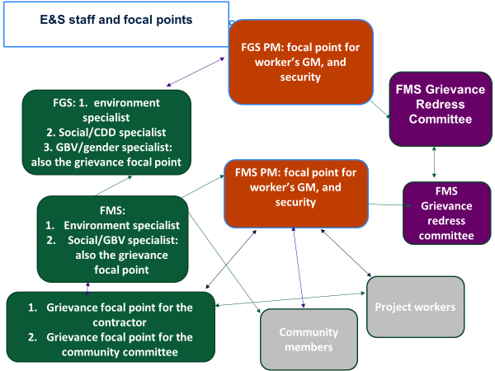

A Grievance Redress Committee (GRC) will be established at FMS and FGS levels chaired by the project coordinator. The relevant staff will be included as necessary depending on the complaint (procurement, finance, monitoring and evaluation, GBV advisor, and communications). At the community level, local committees with strong representation of disadvantaged groups will receive complaints directly from the community, contractors, and so on, and forward to the FMS social specialist to support resolution and follow up. All contractors and suppliers will be expected to sensitize their workers on the project GM and have a focal person to receive complaints regarding the construction and their workers and put in place complaints structures specific to the workers (as detailed in the LMP).
Local community groups will be involved in the setting up and functioning of the GM, with options of using free mobile technology and physical interface with a third party intermittently but regularly. This system will include identification and inclusion of key channels outside traditional dispute resolution or grievance redress mechanisms to enable safe and confidential reporting of incidences of SEA and other forms of GBV. Identified GM operators will also be trained on effective response to cases of GBV should they occur (see Figure 17).

Figure 17: Grievance Redress Mechanisms

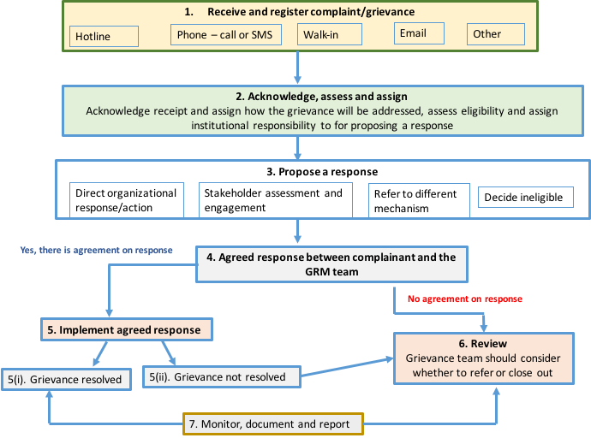

Other mechanisms: The communities and individuals who believe they are adversely affected by a WB-supported project may submit complaints through the WB’s Grievance Redress Service (GRS). The GRS ensures that complaints received are promptly reviewed to address project-related concerns.

Incident and Accident Reporting
Incident reporting will follow the management and reporting process depicted in Figure 18.

Figure 18. Incident Management and Reporting Process
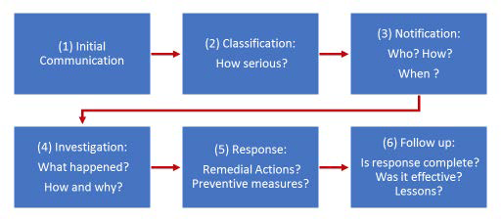

Incidents should be categorized into ‘indicative’, ‘serious’ and ‘severe’. Indicative incidents are minor, small or localized that negatively impact a small geographical area or a small number of people and do not result in irreparable harm to people or the environment. A ‘significant’ incident is one that causes significant harm to the environment, workers, communities or natural resources and is complex or costly to reverse. A ‘severe’ incident causes great harm to individuals or the environment, or presents significant reputational risks to the Bank.

Severe incidents (an incident that caused significant adverse effect on the environment, the affected communities, the public or workers—for example, a fatality, GBV, forced or child labor) will be reported within 48 hours to the PIU and the Bank.

Safeguard Documentation, Disclosure, and Reporting
This will be done as per the procedure in chapter 6 of the ESMF (Procedures For Preparation, Review, Clearance, and Implementation of ESF Instruments).
The identification of the subprojects to be supported will use the steps outlined below.
Step 1: Determination of subproject locations
- The identification of subproject location will be initially done in consideration of environmental consideration as part of the Analysis of Alternatives to avoid significant impacts and risks since the early phases and technical considerations for water points and combined with susceptibility to drought and essential water need and equity considerations. This will be based the WET tool combined with data and studies on drought need and then ensuring that subprojects include different clans and minority groups and avoid elite capture.
Step 2: Subproject identification
- This will be carried through an inclusive community consultation process involving women, and marginalised groups including minorities, with the aim of promoting resilient and sustainable community livelihoods for all. Local authorities in the beneficiary district will ensure that the activities fall with integrated land use plans and rationale use of resources. FMS PIUs will facilitate smooth communications between the project-affected communities and themselves during subproject identification and implementation.
Step 3: Screening/scoping
- The ESMF requires that all Barwaaqo subprojects shall be scoped/screened for social and environmental impacts. The FMS PIU E&S staff will initiate the scoping/screening process by completing the form contained in Annex 4. The aim of the screening/scoping form is to assist in identifying potential E&S impacts based on field investigations in the area of the subproject site. Assigning of appropriate E&S risk classification to a subproject shall be based on information provided in the E&S screening form (Annex 4) and discussions among the implementing teams at the FGS and FMS levels. The project E&S specialists shall undertake the E&S screening and assign the appropriate risk classifications for the subproject(s): Low, Moderate, Substantial or High. High risk projects will be excluded from financing. The classification should be assigned based on the criteria provided in ESF ESS1 Guidance Note and consensus reached by the various local teams engaged in this exercise.
- The completed scoping/screening report will be submitted to the FGS E&S team for internal checking and approval. The FGS E&S team will review the scoping/screening report and will accept the document either (a) with conditions relating to implementation; or (b) accept the documents with required and/or recommended amendments; or (c) reject the document with comments as to what is required to submit an acceptable screening report.
- Following the approval of the subproject environmental screening/ scoping report, the subproject will be fed into one of the following processes based on its approved categorization of High, Substantial, Moderate and Low risk. If the outcome of the E&S screening/scoping results in categorizing the subproject as Moderate or Low risk activities, no further actions to carry environmental assessment will be needed. However, for Moderate risk categorized subprojects, an ESMP shall be prepared and ESHS conditions shall be included in the subprojects’ procurement and contract documents.
Step 4: Preparing instruments/review
- The PCU will consult with the World Bank and, if the activity is considered to be High or Substantial risk, decide on the type of ESIA to be undertaken. Moderate and Low risk will use ESMP templates provided in the Annex (including the social summary report, evidence of consultations and community land agreements, and a site-specific security management plan/evacuation plan). High or Substantial risk will require ESIA and ESMP that will entail a systematic investigation of all risks and impact areas as identified in the screening report. For subprojects involving land acquisition, ESS5 requires the development of resettlement plans (RAP) proportionate to the scale and magnitude of the land acquisition impacts, regardless of the number of affected parties and livelihood restoration plans (LRPs) if livelihoods are affected as a result of the subprojects including impacts on downstream users. Following review by the FGS social and environmental specialists on the project, the ESIA/ESMP, RAP, LRP and SMP will be sent to the World Bank for review and clearance before project activities are initiated. The E&S instruments prepared for Moderate risk activities will be prepared by FMS E&S specialists and will be reviewed by FGS E&S specialists. Substantial risk activity ESIA will be prepared using external consultants. For quality assurance, it is then reviewed by the PCU and consultants that may be hired to support environmental and social teams. Thereafter it is submitted and cleared by the World Bank. ESMPs are to be available and cleared by the Bank prior to the contractors’ bidding phase.
Step 5: Implementation and supervision
- Once the ESF documents have been cleared, the ESMP and security management requirements will be included in the contractor’s contracts. E&S specialists and the supervisory engineer will be required to orient and closely monitor, through regular field visits, the implementation of the ESMPs and sign off on the ESMP completion reports before payment. Internal monitoring to ensure the compliance of Biyoole Components 1, 2, and 3 subproject implementation activities against the mitigation measures set out in its ESMP, RAP and LRP, will be carried out by the E&S risk management staff of the FMS PIU as well as the FGS E&S teams who are responsible for E&S management, and the supervisory engineer at the construction sites. Village development committees will also help monitor the contractor and raise any concerns with the FMS E&S specialists.
Step 6: E&S risk management and monitoring reports
- During the course of ESMF implementation, the FMS PIU as well as the FGS E&S teams will prepare and submit regular quarterly, biannual, and annual E&S monitoring and performance reports for all subprojects carried under Components 1, 2, and 3 including the identification and mitigation measures for unanticipated environmental and social risks and a summary of the grievances received and resolved. The E&S risk management monitoring reports should be submitted internally to the World Bank for review.
Step 7: Annual audits
- ESMF implementation will also be supported by conducting annual E&S performance audits that will be carried out by a third party (that is, registered and licensed independent consultancy firm). The third-party annual E&S performance audits will be conducted on Barwaaqo to evaluate the overall implementation of the ESMF.
The PIUs at the state level will have the overall responsibility for project management, including developing E&S instruments, and the reporting of results to stakeholders.

Reporting, Monitoring, and Evaluation
The project will support continuous learning and adaptable knowledge management. The project will finance baseline, concurrent monitoring of inputs and outputs and monitoring of safeguards, conflict and gender, and will focus on developing and disseminating knowledge generated through various project activities. Subcomponent activities will incorporate new modern technology such as geo-tagging of site investments, collection of field data with tablets/smart phones, and application of geo-spatial imaging for quantifying before-and-after comparisons for specific indicators. This subcomponent will be managed by the Ministry of Planning and budgeted for under the project Implementation Unit (PIU).
The existing monitoring and evaluation (M&E) framework from Biyoole will be reworked and updated. A baseline survey and end-line beneficiary survey will be carried out to measure who and to what extent people benefit from the infrastructure as well as how it affects their lives in both social and economic terms. The M&E system will document case studies capturing the impact of the project on communities, considering the gender dimension, impacts on vulnerable or marginalized groups, and how they may ultimately contribute to stronger rural resilience.
A web-based management information system (MIS) was developed under Biyoole to enable real time loading of data and monitoring. This MIS aims at providing the PIU staff and other stakeholders of the project with an indication of the project’s performance in terms of achievements made in the different time periods as well as the progress towards delivering the intended results. The PIU staff will be able to collect data, and clean and aggregate them before visualizing them in a dashboard, giving insights into the project progress against sets of indicators agreed upon in the M&E Framework. The dashboard will store photos of implementation and updated maps of locations.
Capacity needs assessment has been done with Biyoole project funds in collaboration with the World Bank task team and this will be further strengthened to learn from gaps and work on building institutional capacity.

Table 30. Monitoring and Evaluation Plan: PDO Indicators
Indicator Name | Definition/Description | Frequency | Data source | Methodology for Data Collection | Responsibility for Data Collection
Number of people provided with access to improved water sources (of which proportion of females) | This indicator measures the cumulative number of people who benefited from improved water supply services constructed under the project | Bi-annually | PIU reports | Periodical supervision | PIU
Farmers adopting improved agricultural technology (of which proportion of females) | The indicator evaluates the good agricultural practice transferred during technical assistance and number of the farmers who adopt it  NB: ‘Agriculture’ or ‘Agricultural’ includes: crops, livestock, capture fisheries, aquaculture, agroforestry, timber and nontimber forest products  ‘Adoption’ refers to a change of practice or change in use of a technology that was introduced or promoted by the project  Technology includes a change in practices compared with currently used practices or technologies (seed preparation, planting time, feeding schedule, feeding ingredients, postharvest storage/processing, and so on). If the project introduces or promotes a technology package in which the benefit depends on the application of the entire package (for example, a combination of inputs such as a new variety and advice on agronomic practices such as soil preparation, changes in seeding time, fertilizer schedule, plant protection, and so on), this counts as one technology | Bi-annually | PIU reports | Periodical supervision | PIU
Land area (hectare) under sustainable landscape management practices | The indicator measures, in hectares, the land area for which new and/or improved sustainable landscape management practices have been introduced. Land is the terrestrial biologically productive system comprising soil, vegetation, and the associated ecological and hydrological processes | Bi-annually | PIU reports | Periodical supervision | PIU
Table 31. Monitoring and Evaluation Plan: Intermediate Results Indicators
Indicator Name | Definition/Description | Frequency | Data source | Methodology for Data Collection | Responsibility for Data Collection
New water points constructed to reduce the risk of water shortages in drought-prone rural areas | This indicator measures the number of new water points constructed to reduce the risk of water shortages in drought-prone rural areas. | Bi-annually | PIU reports | Periodical supervision | PIU
Existing water points rehabilitated to reduce the risk of water shortages in drought-prone rural areas | This indicator measures existing number of water points rehabilitated to reduce the risk of water shortages in drought-prone rural areas | Bi-annually | PIU reports | Periodical supervision | PIU
Number of government staff gaining capacity to plan and design climate-resilient infrastructure | This indicator measures number of government staff that took training sessions on capacity to plan and design climate-resilient infrastructure | Bi-annually | PIU reports | Periodical supervision | PIU
Number of functional Farmer Field Schools established | This indicator measures the number of farmer schools established and that are functional | Bi-annually | PIU reports | Periodical supervision | PIUs
Number of animals that received veterinary services | This indicator measures the number of livestock (goats, camels, and others) that received treatment, vaccination, and veterinary support | Bi-annually | PIU reports | Periodical supervision | PIUs
Number of Community Animal Health workers (CAHWs) trained | This indicator measures number of CAHWs that received training (both theoretical and on the job) disaggregated by gender | Bi-annually | PIU Reports | Periodical supervision | PIUs
Female number of Community Animal Health workers (CAHWs) trained | This indicator measures the number of female CAHWs trained. It is estimated that 30 percent of the total trainees will be female | Bi-annually | PIU reports | Periodical supervision | PIU
Number of institutions providing veterinary services/certifications strengthened | This indicator measures the number of formal/government institutions that provide veterinary services that have been supported and strengthened through the project | Bi-annually | PIU reports | Periodical supervision | PIUs
Livestock managers with increased productivity | The intermediate indicator measures cumulative number of livestock managers with increased productivity (measured as number of livestock) | Bi-annually | PIU reports | Periodical supervision | PIUs
Female share of livestock managers with increased productivity | This indicator measures the female share of livestock managers with increased productivity (measured as number of livestock) with a female target of 30 percent from the total increase. | Bi-annually | PIU reports | Periodical supervision | PIU
Land area under invasive species management techniques | This indicator measures the land area (in hectares) that is under invasive species management techniques | Bi-annually | PIU reports | Periodical supervision | PIUs
Agricultural land area with soil and water conservation measures | This indicator measures the land area that has been restored with soil and water conservation interventions | Bi-annually | PIU reports | Periodical supervision | PIUs
Forest area restored | This indicator measures the land area that has been afforested (new or restored) | Bi-annually | PIU reports | Periodical supervision | PIUs
Efficient and functional web-based management information system (MIS) | This indicator measures having a functional web-based management information system that is efficient and gives real-time data across Federal Member States and Federal Government of Somalia | Bi-annually | PIU reports | Periodical supervision | PIUs
Beneficiaries that feel project investments reflected their needs | This indicator measures the level of beneficiary (client, community) satisfaction due to project intervention across Federal Member States | Bi-annually | PIU reports | Periodical supervision | PIUs + independent consultants
Project Implementation Units (PIUs) staffed | This indicator measures the number of PIUs established and staffed across Federal Member States | Bi-annually | PIU reports | Periodical supervision | PIUs
Female share of PIU staff, interns and seconded staff at line ministries and other water institutions | Female share of PIU staff and interns seconded as staff in line ministries and other water institutions (target: 30 percent) | Bi-annually | PIU reports | Periodical supervision | PIUs
Proportion of contracts awarded to female friendly contractors | This indicator measures the share of contracts awarded to female friendly contractors (in terms of staffing, equal pay for equal work, inclusive policies)—to be defined (for example, regarding hiring, advancement, share of technical and management of employees) | Bi-annually | PIU reports | Periodical supervision | PIUs
Women’s share of leadership positions in Village Development Committees (VDCs) | This indicator measures the percentage of women leading the VDCs, for example, chair or vice chair of the VDCs | Bi-annually | PIU reports | Periodical supervision | PIU Reports
Grievances registered related to delivery of project benefits that are addressed | This indicator measures the number of grievances received and addressed in relation to the delivery of the project. The timeline for addressing grievances will be about 10 days | Bi-annually | PIU reports | Periodical supervision | PIU
Community Investment Plans (CIPs) developed | This indicator measures the number of CIPs developed. These are reports derived from the Community Engagement Reports (CERs) and other technical assessments | Bi-annually | PIU reports | Periodical supervision | PIU reports
Number of line ministry buildings, laboratories, and offices constructed | This indicator measures the number of offices and/or buildings constructed for line ministries, diagnostic laboratories, and so on constructed using project funds | Bi-annually | PIU reports | Periodical supervision | PIU
Number of line ministry buildings, laboratories, and offices renovated | This indicator measures the number of line ministry buildings, offices, laboratories, and offices renovated by the project | Bi-annually | PIU reports | Periodical supervision | PIU

Annex 1. Readiness Criteria
The Project Implementation Units (PIU), together with the Task Team, are to lead the readiness assessment process.

Site Selection Criteria
The selection of appropriate sites for the construction of sand and subsurface dams and engagement with local communities represents a crucial phase in the project and needs to be based on clear, transparent, and objective criteria.
The Wadi Evaluation Tool (WET) developed during the preparation phase of the WALP project will be used for initial geospatial analysis of potential sites. The WET manual and WET decision makers manual, and the Lesson Learned and Recommendations from the Endline Survey are required to be systematically workshopped by the entire PIU before starting on site selection. Site selection workshops will be held in Month 1 of the projects and the list of proposed sites will need to be presented along with the No Objection Letter and PIU report on the site selection workshop. World Bank (WB) Task Team Leaders (TTLs) and Operations staff will participate in the site selection workshops.
The following are four important preconditions for a suitable sand/subsurface dam site:
Figure 19. Readiness Criteria Preconditions

The other criteria for consideration are briefly summarized and categorized here.

Socioeconomic Criteria
- Settlements (location/proximity of district capitals, location of and proximity to other settlements).
- Infrastructure (existence of nearby roads, presence of strategic water resources, existence of nearby livestock routes and markets).
- Construction costs (sand and rock/stone content of soil percent, presence of publicly available land at construction site).
- While the selection of the subproject sites will be based on technical considerations and needs, inclusivity should be considered given that there are likely to be many potential areas and that areas with internally displaced persons (IDPs) or minority clans may otherwise be overlooked due to clannism and elite capture. The project team will conduct a mapping of clans, and the presence of minority groups and IDPs will be carried out before the site selection.

Physical Criteria
- Climate and hydrology (precipitation levels and intensity, air temperature, vegetation cover and interception, existing retention storage volume).
- Geometric parameters (derived by elevation data in order to define flow accumulation lines, slope of the river, maximum flow length).
- Soil/geological properties (sand content of soil, stone/rock content of soil, subsurface permeability of geological formation, infiltration rate, electrical conductivity of soil).
- Site criteria (existence of a stream, river bank height, river width, channel slope, subsurface permeability of geological formation, groundwater/electrical conductivity).
While using the WET for optimum site location, two factors critically influence the decision of which criteria is best to use:
- Availability and reliability of data that feed into each criterion.
- Importance each PIU gives to each criterion within the site selection process.
More specifically, the selection criteria for the sites needs to consider the following factors:
- Proximity to the regional capital.
- Extent and diversity of water utilization for agriculture and livestock.
- Interest by the government to conduct future interventions.
- Presence of existing water infrastructure.
- Inclusive community participation and input in optimizing site selection.
- The potential of economic impact of the water work.
- Existing demand for water by the local community indicated by population number, level of agricultural activity, and presence of livestock.
- Accessibility of the potential site for surrounding population and pastoralists.
- Proximity of site vis-à-vis key livestock migration routes and major watering points.
- Technical and engineering capacity available for construction.

Readiness Criteria for National and State Agency Participation in the Project
The project will help build a strong foundation for a gradual transition to more integrated and sustainable agriculture and water development by strengthening local, state, and national institutions and capacities. The key readiness criteria for participation by national and state agencies include the following:
- The presence of a State Ministry of Finance with an External Assistance Fiduciary Section (EAFS).
- Each project implementing unit (at Federal Government of Somalia [FGS] and Federal Member State [FMS] level) must have staff in place who have successfully completed training in project and financial management, procurement, safeguards compliance, and so on.
- Ministries must be identified as participating parties to the project—for example, those ministries with portfolios that address water resources, agriculture, livestock/pastoralism, rural development, planning, and finance.
- Ministries should be actively participating in the Biyoole Project Steering Committee and/or the FMS PIUs.
- Strong experience with inter-ministerial collaboration, including with the FGS.
- Evidence of an appropriate level of institutional capacity (that is, human resources, office facilities) across line ministries.
- Before submitting a proposal for a study or training, an agency should complete an institutional needs assessment highlighting human resource capacity-building and staff training priorities.
- Proposals should be relevant to project activities—for example, reviewing rangeland management system effectiveness, studying the nutritional and market potential for crop options, and so on.
- Priority will be given to cross-ministerial proposals—for example, action plan to support sustainable agriculture and pastoral systems, and so on.
- Proposals should be agreed with the Project Steering Committee for financing.

Readiness Criteria for Community Participation in the Project
The project will support the mobilization of local/target communities to identify their needs/priorities via the development of Community Development Plans (CDPs) and the delivery of services that will enable communities to improve the health and sustainability of the natural resource base (that is, land, water, vegetative cover) and improve agriculture and livestock production. Readiness criteria for community eligibility to participate in project activities include:
- Evidence of strong community readiness to participate in the implementation of the water works.
- Supportive community leadership, land tenure, and water access rights.
- Communities within a specified (or fewer) kilometers to the new water point.
- Communities must accept the principles of engagement—that is, a transparent process, accountability of leadership to all villagers, and inclusion of women, youth, and minorities in the planning and development process.
- Community must be engaged in predominantly pastoral or agro-pastoral activities.
- Settlements where communities reside must be physically accessible to allow proper supervision.
- Communities should be expressly willing to provide in-kind resources such as time, labor, and land to support project implementation.
- Community Investment Plans developed and validated via broad-based community mobilization.
- Detailed list of community members who will benefit from cash-for-work activities validated by local authorities and PIUs.
- Common interest groups across livelihoods (that is, gardening, agroforestry) established.
- Clear land use arrangements/agreements in place and approved by local leaders and government officials.

Annex 2. Water Technology Options
Table 32. Water Technology Options
Measure | Description | Impact on Water Balance | Preselection of Areas in the WET | Approximate Cost (US$)
Balley/hafir | Earth dam at run-off concentrating flow path without clear stream bed, structures made of soil with a storing capacity of 3,000 m³ to 12,000 m³ | Point intervention, surface run-off storage | Run-off and slope | 140,000
Berkads | Water basin to store surface water (3–12 m³) Improved design that separates human and livestock offtake points, solar still design with glass, Perspex or semitransparent roof covers to catch evaporation, channel it to an internal gutter, and then outside into a storage tank | Point intervention, surface run-off storage | Run-off, small slope, and settlements | 50,000
Sand storage dam | Barrier in stream channel up to bank height depending on the site and other factors, with a storing capacity of 2,000 m3 to 5,000 m³ | Point intervention, streamflow storage | As implemented in the WET | 130,000
Semicircular bunds | Similar to soil bunds, but semicircular structures of 2.5 m diameter, placed as a regular pattern on hillsides to increase infiltration and prevent nearby farmlands from erosion | Area intervention increase infiltration | Slope, soil | 500  per hectare
Soil bunds | Earth banks, 1.5 m wide, thrown across the slope along the contour. They are suitable in low rainfall areas (up to 600 mm annual rainfall) having slopes 1–70 m and more permeable soils while not suitable in clay soils. The main function of these bunds is to reduce slope length which in turn reduces soil erosion and to store and retain water. ‘Indian type’—with 2x3x0.3 m excavations in front of the bund to save topsoil and increase infiltration. | Area intervention increase infiltration | Slope, soil | 500  per hectare
Subsurface dam | Subsurface dams are similar to sand storage dams except for the crest being under the surface of the riverbed. The inflowing water is stored in the riverbed sediments and can be used by means of shallow wells. The rise of the water level also promotes natural vegetation growth. There are two ways of implementing subsurface dams—as impermeable geo-membrane or as concrete dam in the riverbed, the latter being more sustainable. Depending on the site and other factors, with a storing capacity of 2,000 m3 to 7,000 m³ | Point intervention, streamflow storage | Similar to sand dams, but no distinct river channel needed | 140,000
Rock catchment | Utilization of concrete improved rocky slopes for water catchment | Point intervention | Surface geology (rock), slope, settlement, and rainfall | 20,000
Shallow wells/shallow boreholes | This is a hole dug, bored, driven or drilled into the ground for extracting water. The definition follows different depths in different places, but for the sake of this project a shallow borehole is up to 50 m depth and a borehole can go up to 200–300 m depth or beyond. The yield also can vary from as low as 0.8 liters per second to 5 liters per second and beyond to artisan free flow | Point source, groundwater extraction | Surface geology (rock), slope, settlement, and rainfall | 50,000

Annex 3. Lessons Learned and Recommendations from WALP and Biyoole
Table 33. Site Selection Phase
Lessons Learned | Recommendations
Finding the right location for the dam is difficult. Although small-scale sand or subsurface dams are generally considered ‘low-tech’, the correct siting presents challenges that are similar to those found in the design of larger, more complex water projects.  Additionally, WALP has shown that, due to a combination of less favorable climatic and hydrogeological conditions, Puntland is less suitable than Somaliland in the development of sand or subsurface dams. | - Prepare a prioritized list of candidate locations. Potential new sites should be identified and surveyed in advance to create prioritized lists of candidate locations from which the ministries can then choose. More broadly, the key outcome of such an investigative step should be an investment plan.  - The ministries should employ highly skilled water resources engineers and hydrogeologists to identify and assess potential new sites and develop the Investment Plan. More time and resources than those employed under WALP should be allocated on the site selection process and geophysical assessments. At each potential new site, multiple alternative locations should be considered.  - A prefeasibility-level report should be done, similar to the one crafted under WALP, for each potential new site and included in the Investment Plan.  - The criteria of site selection should be flexible to apply to all regions of Somaliland and Puntland and encompass a variety of water harvesting options besides sand and subsurface dams.  - Back-stopping support is needed for site selection, design, and monitoring. Experienced hydrogeologists and water resources engineers can provide the local ministries with the necessary technical support to help review and quality control the work being performed by local contractors.
Wadi Evaluation Tool (WET) is a useful tool to assist the site selection process. WET, developed under the WALP project, provides a valuable contribution to the process of finding potential areas for wadi water harvesting installations. However, ‘successful runs’ of the tool are highly dependent on: (a) the modeler’s knowledge of a variety of geospatial and geophysical concepts; and (b) the quality and resolution of the basic information the tool uses to runs its simulations.  WET alone does not provide the final location for siting sand and subsurface dams. The WET tool cannot be considered as a substitute for the field surveys and detailed analyses that are necessary for siting a sand or subsurface dam. At this stage, considering the limitations of the available data, WET’s primary contribution to the overall process is of assisting the rapid identification of general areas of the country where sand or subsurface dams might be a viable solution to water harvesting. | Invest in the collection of additional information. More specifically, it is recommended to:  - Develop/update a ‘well database’ by carrying out a field survey, gathering information on the location of existing wells (including some basic information on quality of water, water static levels inside the wells, and so on).  - Develop a more refined shallow water hydrogeological map based on advanced hydrogeological technologies.  - Once the general location of a number of candidate sites has been identified, some of the WET parameters, such as the width of the wadi and the infiltration rate (mm./hr.) need to be refined by combining remote sensing and field investigation techniques.
Data should drive the site selection. In Puntland, socioeconomic considerations and political priorities seemingly eclipsed environmental and hydrogeological data on where the pilot sites should be located. | Improve the site selection process.  - Develop an official, approved site selection process.  - The process must be transparent so that everyone knows how sites are selected; to prevent the perception of bias, criteria should be as objective as possible.  - Could be done in next phase-up of work, with WB help.
Cross-ministerial participation is key for proper site selection as well as rapidly identifying and addressing problems with the water points. Several ministries, covering cross-cutting areas such as water, environment, tourism, and agriculture were all involved. Ministries in Puntland and Somaliland coordinate some of the steps of the process and exchanged stories and lessons they learned individually. | Institutionalize a multiministry steering committee.  Next phase-up of the work must build on the institutional arrangements set up during WALP. Cross-ministerial participation, especially in Puntland, should be further developed. Possibly, a multiministerial steering committee should be institutionalized.
Sand and subsurface dams are not always ideal. Sand and subsurface dams are but one type of water harvesting technology that would be appropriate. Expanding the types of structures under consideration will help ensure that the ministries have multiple tools to address water scarcity and to fit the individual needs and priorities of local communities. | Alternate technologies should be studied and trained-on. More information is needed to determine which water harvesting technology is best suited for the various types of terrain in Somaliland and Puntland, and both communities and government staff should be trained on their operation and management. More specifically:  - Conduct hydrological and geophysical studies on rain water harvesting.  - Increase training of communities and governmental staff in the operation and management of rainwater harvesting systems.  - Develop policies, guidelines, and strategies for rainwater harvesting.  - Improve information management systems for rainwater harvesting.

Table 34. Design and Construction Phase
Lessons Learned | Recommendations
Limited capacity of local contractors. The type of water solutions utilized by WALP are ‘low-tech’ and yet, local contractors would have failed in performing their tasks without the substantial support provided by the World Bank and the ministries. | Improve the quality and accountability of local contractors.  - The ToR for geophysical consultancy should be revised in a way that it shows more accountability for the decisions and recommendations made.  - Geophysical consultants at a local level should be improved in terms of equipment and knowledge.  - Prequalification of companies for construction should be done, workshops and orientations regarding this field should be extended to ‘Puntland Construction Companies’.  - Backstopping support should help; a skilled engineer should be made available for real-time design changes during construction.  - A peer review learning process between Puntland and Somaliland contractors should be facilitated.
Rain caused construction problems. The construction of the dam began during the rainy season at a few sites. The influx of water caused significant damage and effectively undid the work that had been done. | The construction must be timed right. However long the process for site selection, design, tendering and awarding the construction of the water project might be, the construction itself should not be executed during the wet season.
Logistical challenges were underestimated. Moving the heavy equipment during excavation and construction turned out to be harder than originally anticipated, particularly in Puntland. The equipment needed to be moved from hundreds of kilometers away and to a terrain that is usually accessible only by 4x4 vehicles.  Access to water for construction turned out to be more challenging than expected and forced the contractor to import water to the site via trucks. This led to higher construction costs than originally anticipated.  Manual labor was not always available at site and sometimes had to be provided by villages that were located far away from the construction site. This also caused an increase in construction costs. | Budget time and money. Before bidding, construction companies should visit the sites and discuss potential issues and possible solutions with the ministries. The difficulty and distances should be budgeted for in terms of both money and time to complete the project.
Procurement of materials not readily available in the local market was challenging. Procuring materials such as HDPE and, in general, procuring material that was not available locally turned out to be more challenging than originally expected. This caused delays in project implementation (particularly at the second dam at Raydable). | Bulk supply material and equipment. Once a prefeasibility level investigation has been carried out of multiple sites, the implementing agencies might want to consider bulk procurement of the equipment and material that is difficult to find in the local market.
Table 35: General
Lessons Learned | Recommendations
Activities in the project budget prepared did not have budget notes to clarify the input with cost computation. This caused a lack of clarity for implementation initiation.  The project budget revision did not follow relevant procedures to maintain budget discipline, reallocation was done between components, and reviewing changes became challenging due to the numerous unnoticeable changes.  Differences in activity costs and costs in the procurement plans; the project budgets cost for activities and the ones submitted varied. Activity budgeting is to be done considering all the inputs and procurement plans to have amounts in the budget to avoid cost overruns. | As a result of lessons learned in Biyoole, Barwaaqo budget activities are to have detailed planning with detailed input and cost computation notes.  Activities under each component are to be placed correctly and allocation per component to be considered during budgeting.  The initial prepared and approved five-year budget is to be held at the Federal Government of Somalia (FGS) level.  Reallocations requests are to be submitted to the National Project Coordination Unit (NPCU) and approved at FGS level before making the budget changes during a revision.  Yearly budget plans from the five-year budget are to be prepared by each state and submitted to the FGS NPCU to align them to the five-year project budget before submission.
Since Bank projects are new to Somalia, the service providers were not able to submit complete bidding documents. | The PCU and PIUs should plan for conducting training sessions for contractors and service providers.
There is no framework for operation and maintenance (O&M) of rural water infrastructure. | The project should prepare a framework for O&M and provide for a longer-term presence, to leave behind a strong community management committees capable of maintaining water points, administering the water scheme in a financially responsible way, and handling routine O&M.
At the later stage of the project mobilization and establishment, there is a need to increase the collaboration between the federal and state ministries of the same sector for better coordination, monitoring, and exchange of knowledge and experiences. | The project initiated and implemented specific sectoral meetings and workshops which were held in the participating Federal Member States (FMSs) but led by the federal line ministries. This has increased the collaboration between the federal and state ministries within the project implementation and follow-up with the activities by the sectors. It would, therefore, be necessary to include sectoral meetings in Barwaaqo.
Depth to bedrock (sand/subsurface dams): Using geophysical instruments for the determination of depth to the bedrock or the impermeable layer doesn’t come up with accurate results, which results in design or budget differences as initially planned, as in the case of Rabable. These normally cause contract amendments since the need is to dig to a deeper depth. | Auguring tools should be used for digging test pits, especially for shallow water contained in wadis or remote areas, and in combination with advanced geotechnical tools.
Doing the Environmental and Social Management Plan (ESMP), the CES and Construction Investment Reports (CIR) will be problematic in terms of date conflicts (in separate manner) and time consuming. Furthermore, communities may raise issues after construction investment reports and hydrological surveys are completed. | Clear community awareness and mobilization should be conducted before any technical assessment is made. This can be done by the visibility assessment team, after the initial water site selection has been made and hydrological survey is under way. The CES and ESMP survey must be commenced to avoid delays and conflict of date; the Community Engagement Reports (CER)s date will be used for other reports, such as the CIR.
Site selection is one of the limiting factors for successful completions. Firstly, some sites are too remote and far to be reached when it comes to mobilization and monitoring challenges. Secondly, some of the communities may not have that much demand and water stress and this comes after hydrological survey was completed and sites are ready for construction, as in the case of Sinujiff, Sool, and Sanaag. | Standardized selection criteria must be agreed to. Within this criteria, political factors must be 100 percent free from initial selections—besides demand, the other factors to be considered are water demand, number of beneficiaries, accessibility, and geographical areas (in terms of reachability).
Strong coordination and collaboration among Federal Government, line and FMS about project, activities, and reporting. | Strengthen the relationship between the FGS and FMSs/line ministries.
Subsurface water technologies, such as sand dams and hafir dams, in South West State. | Improved accessibility for water availability for pastoral and agro-pastoral communities.
Sustainability and ownership for management and proper recourse utilization was improved. | Build the capacity of the community and continue support to, and strengthening communities.
Institutional building of Biyoole line ministries for office buildings. | The improved working environment for project staff and ministries’ staff.
Building the capacity of the community, such as Community Animal Health Workers (CAHWs), collaboration, and coordination between departments. | Improved livestock services at the field level and access to livestock treatment and response.
Active participation and collaboration between project implementing entities and beneficiaries enable community organizations to form strategic alliances with state institutions, increasing community ownership over the interventions, and effectiveness of the planning process. | Maintaining the support and momentum of planned activities, the Village Development Committee engaged early enough, comprehensively, and continued with the involvement of local authorities from different sectors. This is key to the success of the interventions.
Gender involvement and empowerment are fundamental added values to the project and have become better mainstreamed at all levels—from the implementing entity level to the beneficiaries. The Biyoole project benefited from having crosscutting and sectoral integration with gender. | Strengthen women’s participation in the project activities and decision making at all levels of the project.
Social and environmental factors such as drought, floods, climatic change, human activity like deforestation, and shortage of rainfall influence project implementation and response.
Proper engagement among stakeholders and communities. | Capacity building of public and private sector institutions, including policy formulation and review planning.
Capacity building for the Grievance Redress Mechanism (GRM) and ESMP to reach World Bank standard operating procedures on social and environmental management. | The team has already commenced mobilizing communities with the safeguarding regulations, procedures, and implementation at the site levels in South West State.
More knowledge and training from the previous WALP project, especially water technologies, benefit subsurface water.
The importance of storing the fodder in achieving production targets, for attributes such as growth or weight gain, and making up seasonal shortfalls between feed demand and supply. | Mitigation measures for drought and livestock migration and movement.
Build long-term resilience for sustainability include promoting and establishing farmer and rural field schools as an initiative to empower agro-pastoralists. | Continue support to, and provide capacity building for, Farmers’ Field Schools and Pastoral Field Schools.

Annex 4. Generic Environmental and Social Screening Checklist (from ESMF)
Introduction: The purpose of the checklist is to flag possible environmental and social risks and impacts to determine which E&S instruments to be developed, thus, issues further explored and included in the summary safeguard report and contractors ESMP and so on. It should be done as part of ground truthing based on visual observation and key informant interviews with people with different interests and needs regarding the proposed subprojects for example, elders, local government officials, women, youth, people with disabilities, minority groups, livestock keepers, crop farmers, seasonal users for example, pastoralists. Those people consulted should be mentioned at the end of the checklist.
Where to collect information: From focus group discuss or key informant interview with people with different interests and needs regarding the proposed investment for example, women, youth, people with disabilities, minority groups, livestock keepers, crop farmers, seasonal users for example, nomadic pastoralists.
Will the Project…? | Yes | No | Explanation
- Affect downstream water flows?
- Require clearing of trees, pasture/browse?
- Land ownership is clear (private, government, community)?
- Is on or near private land?
- Require demolition of existing structures?
- Require large volumes of construction materials (for example, gravel, stone, water, timber, firewood)?
- Use water during or after construction, which will reduce the local availability of groundwater and surface water?
- Affect the quantity or quality of surface waters (for example, rivers, streams, wetlands), or groundwater (for example, wells, reservoirs)?
- Be located within or nearby environmentally sensitive areas (for example, intact natural forests, mangroves, wetlands) or threatened species?
- Lead to soil degradation, soil erosion in the area?
- Create waste that could adversely affect local soils, vegetation, rivers, and streams or groundwater?
- Create pools of water that provide breeding grounds for disease vectors (for example, malaria or bilharzia)?
- Involve significant excavations, demolition, and movement of earth, flooding or other environmental changes?
- Be located in or near an area where there is an important historical, archaeological or cultural heritage site?
- Is an area where minority groups (0.5 groups) or IDPs reside or use the water point?
- Displace people or structures or restrict people’s access to crops, pasture, fisheries, forests or cultural resources, whether on a permanent or temporary basis?
- Result in human health or safety risks during construction or later?
- Involve inward migration of people from outside the area for use of services or other purposes?
- Is an area where there has been insecurity incidents in the past 12 months?
- Is an area where there has been conflict over water or land in the past?
- Require sharing or regulation of use between different groups or communities?
- Result in a significant change/loss in livelihood of individuals?
- Adversely affect the livelihoods and/or the rights of women?
- Cause increased settlement or degradation of surrounding areas?
- Disposal of bush clearance residue may cause spreading of invasive species?
- Introduce a non-native animal or plant species?
- Maintenance and management responsibilities have not been defined and accepted by users/local government?
- Any limitations for the livestock movement crossing gabions and rehabilitated rangelands?
- Boundaries of the water sources are clearly demarcated to a void creation of adjacent settlements
- Water source fenced/protected to avoid risks and contamination?
29. Result in transmission diseases from region to region or boundaries?
- Result in transmission of zoonotic diseases?
- Require use and application of inorganic fertilizers, pesticide, herbicide or fumigation?

Conclusion
Based on the above checklist and subproject exclusion criteria, what are the conclusions and recommendations?
Note the exclusion criteria:
  - Activities that may cause long term, permanent and/or irreversible (for example, loss of major natural habitat) impacts.
  - Activities that have a high probability of causing serious adverse effects to human health and/or the environment.
  - Activities that may have significant adverse social impacts and/ or may give rise to significant social conflict.
  - Activities that may involve extensive physical resettlement or extensive economic resettlement.
  - Activities that may impact on known cultural heritage sites, including sites that are important to local communities.
  - Activity that will compromise the sustainability of the aquifer.

1. Proposed project is eligible for financing under the project criteria.
…………………………………………………………………………………………………………………………………………………………………………………………………………………………………….……………………………………………………………………….……………………………………………………………………………………………………………………………………………………………………………………………………………………………………………………………………………………………………………………………………………………………………………………..

2. Proposed Environmental and Social Risk Ratings (High, Substantial, Moderate or Low). Provide justifications.
…………………………………………………………………………………………………………………………………………………………………………………………………………………………………….……………………………………………………………………….……………………………………………………………………………………………………………………………………………………………………………………………………………………………………………………………………………………………………………………………………………………………………………………..

3. Proposed E&S Management Plans/ Instruments—that is, ESMP, ESIA, Summary Safeguards Report (for social issues), Voluntary Land Donation Form
…………………………………………………………………………………………………………………………………………………………………………………………………………………………………….……………………………………………………………………….……………………………………………………………………………………………………………………………………………………………………………………………………………………………………………………………………………………………………………………………………………………………………………………..
4. Who was consulted in the completion of the checklist? Provide list.
…………………………………………………………………………………………………………………………………………………………………………………………………………………………………….……………………………………………………………………….……………………………………………………………………………………………………………………………………………………………………………………………………………………………………………………………………………………………………………………………………………………………………………………..

Prepared by
Name and role: |  | Name and role:
Date | Signature | Date | Signature
Reviewed and approved by
Environment Specialist  Name: |  | Social Specialist  Name:
Date | Signature | Date | Signature

Annex 5. Environmental And Social Commitment Plan
The Federal Republic of Somalia (the Recipient) will implement the "Barwaaqo” Second Water for Agro-Pastoral Productivity and Resilience II Project (the Project) with the involvement of Ministry of Planning Investment and Economic Development (MoPIED) at Federal level and the Ministry of Planning in each Federal Member State (FMS) and Somaliland, as set out in the Financing Agreement. The International Development Association (the Association) has agreed to provide financing (P177627) for the Project, as set out in the referred agreement(s).
The Recipient shall ensure that the Project is carried out in accordance with the Environmental and Social Standards (ESSs) and this Environmental and Social Commitment Plan (ESCP), in a manner acceptable to the Association. The ESCP is a part of the Financing Agreement. Unless otherwise defined in this ESCP, capitalized terms used in this ESCP have the meanings ascribed to them in the referred agreement(s).
Without limitation to the foregoing, this ESCP sets out material measures and actions that the Recipient shall carry out or cause to be carried out, including, as applicable, the timeframes of the actions and measures, institutional, staffing, training, monitoring and reporting arrangements, and grievance management. The ESCP also sets out the environmental and social (E&S) instruments that shall be adopted and implemented under the Project, all of which shall be subject to prior consultation and disclosure, consistent with the ESS, and in form and substance, and in a manner acceptable to the Association. Once adopted, said E&S instruments may be revised from time to time with prior written agreement by the Association.
As agreed by the Association and the Recipient, this ESCP will be revised from time to time if necessary, during Project implementation, to reflect adaptive management of project changes and unforeseen circumstances or in response to Project performance. In such circumstances, the Recipient through MoPIED, the Association agree to update the ESCP to reflect these changes through an exchange of letters signed between the Association and the Recipient’s MoPIED. The Recipient shall promptly disclose the updated ESCP.

Material Measures and Actions |  | Timeframe | Responsible Entity
Monitoring and Reporting
A | REGULAR REPORTING  Prepare and submit to the Association regular monitoring reports on the environmental, social, health and safety (ESHS) performance of the Project, including but not limited to the implementation of this ESCP; status of preparation and implementation of E&S documents required under the ESCP; stakeholder engagement activities; and functioning of the grievance mechanism(s).  Require focal points for the Federal Member States to report to the Project Management Unit within the MoPIED (NPCU). | Submit quarterly reports to the Association throughout Project implementation, commencing after the Effective Date. Submit each report to the Association no later than 15 days after the end of each reporting period.  On a monthly basis. | NPCU
B | INCIDENTS AND ACCIDENTS  Promptly notify the Association of any incident or accident related to the Project which has, or is likely to have, a significant adverse effect on the environment, the affected communities, the public or workers, including, inter alia, cases of sexual exploitation and abuse (SEA), sexual harassment (SH), and accidents that result in death, serious or multiple injury. Provide sufficient detail regarding the scope, severity, and possible causes of the incident or accident, indicating immediate measures taken or that are planned to be taken to address it, and any information provided by any contractor and/or supervising firm, as appropriate.  Subsequently, at the Association’s request, prepare a report on the incident or accident and propose any measures to address it and prevent its recurrence. | Notify the Association no later than 48 hours after learning of the incident or accident.  Provide subsequent report to the Association within a timeframe acceptable to the Association. | NPCU and State Project Implementing Units in each Federal Member State (FMS) housed in the Ministries of Planning (SPIUs)
C | CONTRACTORS’ MONTHLY REPORTS  Require contractors and supervising firms to provide monthly monitoring reports on ESHS performance in accordance with the metrics specified in the respective bidding documents and contracts and submit such reports to the Association. | Upon request submit the monthly reports to the Association as annexes to the reports to be submitted under action A above. | NPCU
ESS 1: Assessment and Management of Environmental and Social Risks And Impacts
1.1 | ORGANIZATIONAL STRUCTURE  Establish and maintain an organizational structure at Federal Government of Somalia (FGS) level with qualified staff and resources to support management of E&S risks including appointing within the NPCU, an Environmental Specialist, a Social Specialist, a GBV Specialist and a Security Specialist - each with more than eight (8) years of experience to be full time dedicated to the Project.  Establish and maintain an organizational structure at FMS level with qualified staff and resources to support management of E&S risks including appointing within the SPIU, a separate full-time environmental specialist, social specialist and GBV and gender specialist with more than five (5) years of relevant experience as per the terms of reference (ToRs) in the ESMF.  Mobilize additional staff as needed on short-term and long-term engagements in accordance with capacity building and ESMF institutional assessment/ needs; (land, OHS, community engagement, communications etc).  Contract a competent security risk management firm acceptable to the Association and maintain throughout Project implementation.  Procure service of a competent third-party agent acceptable to the Association to conduct annual E&S performance audit. | All FGS positions shall be engaged within 3 months of the Effective Date and thereafter maintained throughout Project implementation.  FMS positions shall be engaged within 90 days after the signing of the respective subsidiary agreement for each FMS, with the exception of the respective environmental specialists, social specialists and GBV and gender specialists for Jubbaland and Hirshabelle which shall be engaged within six months after the signing of the corresponding subsidiary agreements. All positions shall thereafter be maintained throughout Project implementation.  As required.  The security risk management firm shall be engaged after recruitment of security specialist within four months of the Effective Date.  Within one year of the Effective Date | NPCU  SPIUs  NPCU
1.2 | ENVIRONMENTAL AND SOCIAL INSTRUMENTS  - Prepare, adopt and implement an Environmental and Social Management Framework (ESMF) with management tools including, Sexual Exploitation, Abuse and Harassment (SEAH) Prevention and Response Plan, Chance-find procedures and Integrated Pest Management Plan (IPMP) for the Project, consistent with the relevant ESSs.  - Prepare adopt and implement a project wide security risk assessment and security management plan.  3. Adopt and implement an Environmental and Social Impact Assessment (ESIA), and corresponding Environmental and Social Assessment and Management Plan (ESMP) for all project activities in accordance with the ESMF, consistent with the relevant ESSs.  4. Cause implementing Ministries or entities and contractors to adopt and implement the subproject Environmental and Social Impact Assessment (ESIA) and/or the Environmental and Social Assessment and Management Plans (ESMPs), in accordance with the ESMF. | 1. Adopt the ESMF no later than effective date and implement throughout Project implementation.  2. Adopt a projectwide security risk assessment and security management plan within six months of project effectiveness  3&4. Adopt the ESIA/ESMP before launching the bidding process for relevant subprojects and implement the throughout sub-project implementation  Supervise implementing agencies and contractors throughout Project implementation. | NPCU

Material Measures and Actions |  | Timeframe | Responsible Entity
1.3 | MANAGEMENT OF CONTRACTORS  Incorporate the relevant aspects of the ESCP, including the relevant E&S documents and/or plans: the SEP, ESMF, RPF, LMP, SEAH Prevention and Response Plan and Project and site specific Security Risk Assessment (SRA) and Security Management Plan (SMP), into the ESHS specifications of the procurement documents with contractors. Thereafter ensure that the contractors comply with the ESHS specifications of their respective contracts.  Develop and implement procedures for managing contractors and subcontractors recruited to carry out civil works including inter alia:  - Ensure compliance with the national laws, for example, licenses to operate and excavate any sites for project purposes;  - Relevant environmental and social requirements will be included in the procurement and contracting process including bidding documents, contracts and subcontracts consistent with the requirements of ESSs;  - Where applicable ensure contractors prepare a detailed contractor-ESMP (C-ESMP) in line with ESMF/ESMPs requirements that is costed, with sufficient budget to mitigate E&S risks and demonstrates sufficient capacity to implement the required measures as part of the bidding process.  - Codes of conduct (CoCs) included in construction contracts for contractors, subcontractors, primary suppliers and their workers covering conditions of service, OHS, GBV and security requirements.  - Monitor contractor commitment and compliance with ESSs;  - Ensure that contractors and subcontractors have GM focal points for project and workers grievances and all grievances are logged and resolved and feedback provided to the complainant on the resolution.  - Ensure contractors and primary suppliers provide details on their oversight on environmental, social, health and safety (ESHS) performance and adequate mechanisms for serious incident reporting; and  Monitor the performance of the contractors and primary suppliers to ensure that they comply with the ESHS specifications of their respective contracts in accordance with the ESMF (including SEAH Prevention and Response Plan), SEP, LMP, and Project-wide Security Risk Assessment and Management Plan and site-specific assessments and plans. | Prior to the preparation of procurement documents and included the final contracts  SPIU shall ensure all relevant ESS clauses are included and budgeted for before signing of contracts.  Develop procedures prior to engaging contractors and thereafter implement procedures to manage contractors and subcontractors throughout Project implementation.  Throughout Project implementation. | SPIU
1.4 | TECHNICAL ASSISTANCE  Ensure that the consultancies, studies (including feasibility studies, if applicable), capacity building, training, and any other technical assistance activities under the Project are carried out in accordance with the terms of reference acceptable to the Association, that are consistent with the ESSs. Thereafter ensure that the outputs of such activities comply with the terms of reference. | Throughout Project implementation. | NPCU
1.5 | IMPLEMENTATION OF PROJECT ACTIVITIES IN SOMALILAND  The Recipient shall ensure that, in accordance with the ESS:  (a) The E&S instruments are adapted for Somaliland and consulted upon.  (b) Adapted Somaliland Project Operations Manual which includes, among other things: (i) institutional arrangements and responsibilities for assessing and managing E&S risks and impacts, with a description of the ESHS assessment and management arrangements; and (ii) the E&S instruments and plans referred to in paragraph 1.2 above (or a reference thereto).  (c) Institutional arrangements, satisfactory to the Association, are established and maintained for carrying out the Project in Somaliland—including managing the Project’s E&S risks—are in place. | (a, b, and c) Before signing of subsidiary agreement or initiation of implementation of any Project activities in Somaliland. | NPCU shall cause the Ministry of Planning in Somaliland
1.6 | CONTINGENT EMERGENCY RESPONSE FINANCING  - Ensure that the CERC Emergency Response Manual (ERM) and the CERC-ESMF include a description of the E&S risk management arrangements for the implementation of the CERC activities, in accordance with the ESSs.  - Incorporate the relevant aspects of the CERC-ESMF and the ESSs into the subsidiary agreements  - Cause all implementing partners (Somaliland and FMS) and contractors/subcontractors to comply with the ESHS specifications of their respective agreements and contracts, as per the CERC-ESMF and any E&S instruments which may be required for activities under the CERC.  - Prepare and submit to the Association regular monitoring reports on the CERC activities, including on the E&S risk management, as part of quarterly reporting under Section A of this ESCP. | - The adoption of the CERC-ERM and CERC-ESMF in form and substance acceptable to the Association is a withdrawal condition for the CERC under the financing agreement for the Project.  - The Output Agreement with relevant E&S provisions shall be concluded in form and substance acceptable to the Association before the start of project activities under the CERC.  - Any required E&S instrument shall be adopted and included as part of the respective bidding process, if applicable | NPCU
1.7 | EXCLUSION CRITERIA  The following types of activities are ineligible for financing under the Project:  - Activities that may cause long term, permanent and/or irreversible environmental or social impacts (for example, loss of major natural habitat, significant influx, food insecurity, water scarcity, indirect physical displacement.  - Activities that have a high probability of causing serious adverse effects to human health and/or the environment such as risk of violence, significant resource restrictions, elite capture and discriminatory exclusion.  - Activities that may have significant adverse social impacts and/ or may give rise to significant social conflict such as disputes over land or access to water.  - Activities that may involve significant physical resettlement or extensive economic displacement or loss of livelihoods –more than 10 vulnerable HH)  - Activities that may impact on known cultural heritage sites including sites that are important to local communities.  - Activities that will compromise the sustainability of the aquifer for projects entailing groundwater extraction.  - large dams and small dams with significant safety risks  - Small dams that (i) could cause safety risks, such as an unusually large flood-handling requirement, location in a zone of high seismicity, foundations that are complex and difficult to prepare, retention of toxic materials, or potential for significant downstream impacts or  (ii) are expected to become large dams during their operating life will be excluded from financing  Any other excluded activities as set out in the ESMF for the Project and informed by consultations with Stakeholders. | Throughout the Project implementation | NPCU
ESS 2: Labor and Working Conditions
2.1 | LABOR MANAGEMENT PROCEDURES (LMP)  Adopt and implement LMP consistent with ESS2/national regulations satisfactory to the Association to address labor risks, including (but not limited to):  - conditions of service;  - code of conduct;  - occupational, health and safety (OHS) measures;  - Covid-19 prevention measures;  - prevention of child and forced labor;  - emergency preparedness and response;  - grievance redress mechanism for project workers;  - training of project workers on key issues including OHS and GBV prevention; and  - management of labor influx. | Adopt not later than effective date . Thereafter implement throughout Project implementation. | NPCU
2.2 | GRIEVANCE MECHANISM FOR PROJECT WORKERS  Establish, maintain, and operate a grievance mechanism for Project workers, as described in the LMP and consistent with ESS2.  Ensure that each contractor shall establishes Grievance Mechanisms during the execution of the works under its contract, for Project and workers’ complaints | Establish a worker grievance mechanism within 90 days from engaging Project workers and thereafter maintain and operate it throughout Project implementation.  Prior to the execution of any works under the respective contract. | NPCU and SPIUs
2.3 | OCCUPATIONAL HEALTH AND SAFETY (OHS) MEASURES  Develop and implement occupational, health and safety (OHS) measures, based on World Bank EHS Guidelines, as part of the sub-project LMP including through, inter alia, implementing adequate OHS measures and incorporating SMP, SEAH Prevention and Response Plan requirements into the ESHS specifications of the procurement documents and contracts with contractors. | Develop prior to the relevant Contractors’ bidding phase and thereafter implement throughout Project implementation. | NPCU and SPIUs

Material Measures and Actions |  | Timeframe | Responsible Entity
ESS 3: Resource Efficiency and Pollution Prevention and Management
3.1 | RESOURCE EFFICIENCY AND POLLUTION PREVENTION AND MANAGEMENT  Resource efficiency and pollution prevention and management measures shall be included under the ESMPs to be prepared under Section 1.2 above. | Same timeframe as in Section 1.2 above. | NPCU
3.2 | DEPLETION OF GROUND WATER RESOURCES  Carry out hydrological assessments as part of the project specific ESIA/ESMPs under Section 1.2 above.  Install a water discharge meter for the boreholes at the point of water abstraction to record the daily volume of water abstracted and install the dip tube for the boreholes to monitor the ground water level for the drilled boreholes periodically. | Same timeframe as in Section 1.2 above.  As per ESMF under Section 1.2, prior to handing over of the boreholes to the communities for use and throughout Project implementation. | NPCU
3.3 | ENSURING POTABLE WATER  All water sources developed by the Project shall be subjected to the water quality tests for the physio-chemical and microbiology parameters to ensure all parameters meet the WHO Potable water drinking standards before handing over to the community.  Undertake periodic water quality tests for the physio-chemical and microbiology parameters. ensure proper maintenance and cleaning of equipment and tanks | Prior to handing over of the boreholes to the communities for use.  As needed in accordance with WHO guidelines | NPCU, SPIUs

Material Measures and Actions |  | Timeframe | Responsible Entity
3.4 | AQUIFER SUSTAINABILITY  Potential interventions (boreholes and wells) shall be subject to prior knowledge corresponding aquifer sustainability assessment approved by the Association, to ensure that the proposed investment will not compromise the sustainability of the resource or have negative externalities or have transboundary negative externalities or impacts on watersheds beyond the assessed impacts described in the OP7.50 memo as notified to the riparian countries. | A prerequisite or part of the site specific ESIA/ESMAP in accordance with Section 1.2 above. | NPCU
3.5 | PESTICIDE MANAGEMENT  For Component 2:  - adopt the integrated pest management plan (IPMP);  - provide supervision and training on acceptable and unacceptable pesticides (banned lists of pesticides that are restricted under applicable international conventions and/or any products that pose at serious risk the human health); and  - require farmers to comply with good practices and standards of use and storage. | (a) Adopt the IPMP prior to carrying out any activities under Component 2, and thereafter implement throughout Project implementation;  (b) and (c) throughout implementation of Component 2 activities and throughout project implementation | NPCU
ESS 4: Community Health and Safety
4.1 | TRAFFIC AND ROAD SAFETY  Incorporate measures to manage traffic and road safety risks as required in the ESMP to be prepared under action 1.2 above. | Same timeframe as for the adoption and implementation of the ESMP under Section 1.2 above. | NPCU
4.2 | COMMUNITY HEALTH AND SAFETY  Assess and manage specific risks and impacts to the community arising from Project activities, including, inter alia behavior of Project workers, risks of labor influx, response to emergency situations, and include mitigation measures in the ESMPs to be prepared in accordance with the ESMF. | Same timeframe as for the adoption and implementation of the ESMPs under Section 1.2 above. | NPCU
4.3 | SEA AND SH RISKS  Adopt and implement the SEA/SH prevention and response plan as part of the ESMF, to assess and manage the risks of SEA and SH. | Adopt per the time frame in Section 1.2 above, and implement throughout Project implementation. | NPCU
4.4 | SECURITY MANAGEMENT  Assess and implement measures to manage the security risks of the Project, including the risks of engaging security personnel to safeguard project workers, sites, assets, and activities as set out in the Security Management Plan, guided by the principles of proportionality and GIIP, and by applicable law, in relation to hiring, rules of conduct, training, equipping, and monitoring of such personnel. | Develop site specific security risk assessments and management plans once the specific Project sites are known, implement plans throughout Project implementation. | NPCU?
4.5 | INVOLVEMENT OF MILITARY/SECURITY PERSONNEL  Ensure the following measures are carried out before deploying the Recipient’s military/security personnel for the provision of security to Project workers, sites and/or assets, consistent with the ESSs:  - Assess and implement measures to manage the security risks of engaging the military as set out in the Security Management Plan, guided by the principles of proportionality and GIIP, and by applicable law, in relation to screening, hiring, rules of conduct, training, equipping, and monitoring of security forces;  - Adopt and implement standards, protocols, and codes of conduct for the selection and assignment of security personnel to the Project, and screen such security personnel to verify that they have not engaged in past unlawful or abusive behavior, including sexual exploitation and abuse (SEA), sexual harassment (SH) or excessive use of force;  - Enter into a memorandum of understanding (MoU), with the police commissioner at regional level, setting out the arrangements for the engagement of the security personnel in the Project, including the relevant actions and measures set out in this ESCP;  - Provide adequate instruction and training to the military, prior to deployment and on a regular basis, on the use of force and appropriate conduct (including in relation to civilian-military engagement, SEA and SH, and other relevant areas) as set out in the Security Management Plan;  - Ensure that the stakeholder engagement activities under the Stakeholder Engagement Plan (SEP) include communication on the involvement of the military in the Project;  - Ensure that any concerns or grievances regarding the conduct of military are received, monitored, and documented (taking into account the need to protect confidentiality) by the Project’s grievance mechanism (see action 10.2 below), which shall facilitate its resolution, in accordance with ESS4 and ESS10. Notify the Association after receiving the concern or grievance, as set out under action B above; and  - Where the Association so request in writing, after consultation with the Recipient: (i) promptly appoint a third- party monitor consultant, with terms of reference, qualifications and experience acceptable to the Association, to visit and monitor the Project area where the military are deployed, collect relevant data and communicate with Project stakeholders and beneficiaries; (ii) require the third-party monitor consultant to prepare and submit monitoring reports, which shall be promptly made available to and discussed with the Association; and (iii) promptly take any actions, as may be requested by the Association upon its review of the third-party monitor consultant reports. | Carry out (a), (b), (c), and (d) before deploying military under the Project and implement throughout Project implementation.  (e) and (f) as set out under actions 10.1 and 10.2 respectively. Notify the Association after receiving the concern or grievance in the timeframe specified in action b above.  (g) within the timeframes requested by the Association. | NPCU?
4.6 | Safety of Dams  Adopt and implement dam safety measures in accordance with Good International Industry Practice (GIIP) as part of the ESMF.  - Ensure that the engineering design for dams allows for sufficient water flow downstream even in the months of the dry season and implementation of best monitoring practices of the downstream effects of the dam particularly along the channel of the riverbeds. Ensure all dams in excess of 10 meters in height or impounding more than 3mn. cu. m. are eliminated during the ESMF Screening procedure.  - environmental expert to personally inspect the site and design of all dams before countersigning the ESMF Screening form and ensuring through the ESMF procedure that all small dams are designed by a qualified engineer, constructed under the supervision of a qualified contractor, and follow the Guide on Safety of Small Dams in the ESMF as well as Good International Industry Practice.  Ensure through the environmental and social assessment/plan that there will be no or negligible risk of significant adverse impacts due to potential failure of the dam structure to local communities and assets, including assets to be financed as part of the Project. | Same timeframe as Section 1.2 above. | NPCU
ESS 5: Land Acquisition, Restrictions on Land Use and Involuntary Resettlement [the relevance of ESS5 is established during the ESA process. If resettlement instruments need to be prepared (for example, resettlement process frameworks, resettlement action plans, process frameworks) this should be reflected in the ESCP. See examples below]
5.1 | RESETTLEMENT POLICY FRAMEWORK  Adopt and implement a Resettlement Policy Framework (RPF) for the Project, consistent with ESS5. | Adopt not later than effective date and implement throughout Project implementation. | NPCU
5.2 | RESETTLEMENT PLANS  Adopt and implement a resettlement action plan (RAP) for each activity under the Project for which the RPF requires such RAP as set out in the RPF and consistent with ESS5. | Adopt and implement the respective RAP, including ensuring that before taking possession of the land and related assets, full compensation has been provided and as applicable displaced people have been resettled and moving allowances have been provided. | NPCU
5.3 | LAND ACQUISITION PRIOR TO PROJECT APPROVAL  All land acquisition for the Project shall be carried out as outlined in Sections 5.1 and 5.2 above. In the event that any land acquisition has occurred prior to signing of the Financing Agreement, such acquisition must be determined by the Association to have been consistent with the ESSs before the site or subproject may be included in the Project. Remedial measures regarding this earlier land acquisition, if necessary and deemed acceptable to the Association, shall be included in the RAP. | Screening and census survey during the RAP process for subprojects to verify whether any prior resettlement occurred in a manner consistent with ESS5 and acceptable to the Association. | NPCU

Material Measures and Actions |  | Timeframe | Responsible Entity
ESS 6: Biodiversity Conservation and Sustainable Management of Living Natural Resources
6.1 | BIODIVERSITY RISKS AND IMPACTS  Consistent with the ESMF, include in relevant ESMPs provisions for screening of sensitive ecosystems and potential impact on biodiversity downstream and ecosystem services during sub-project level site selection and exclude these areas for any development under the Project particularly Components 1 and 3. Assess all the risks and impacts relevant to ESS6 as part of the ESIA and as per the procedures laid down in the ESMF of the Project. Apply mitigation hierarchy to manage E&S risks. Such measures shall be adopted and implemented in a manner acceptable to the Association.  Ensure adequate provision for the prevention and management of alien and invasive species for activities supported under Component 3 and include this measure in the E&S instrument. | Same timeframe as Section 1.2 above. | NPCU
ESS 7: Indigenous Peoples/Sub-Saharan African Historically Underserved Traditional Local Communities
7.1 | The MoPIED shall carry out sub-project level assessments that identify the presence of indigenous peoples/sub-Saharan African historically underserved traditional local communities in the project intervention areas and where found will prepare indigenous people’s plans in a manner acceptable to the Association. | In each area before the implementation of the respective subprojects. | NPCU
7.2 | INDIGENOUS PEOPLES PLAN  Adopt and implement an Indigenous Peoples Plan (IPP) for each activity under the Project consistent with ESS7. | Adopt the IPP prior to the carrying out of any activity that requires the preparation of such IPP. Once adopted, implement the respective IPP throughout Project implementation. | NPCU
ESS 8: Cultural Heritage
8.1 | CULTURAL HERITAGE AND CHANCE FINDS  Consistent with the ESMF ensure that ESS8 related measures are included in the ESMPs for subprojects and that such measures are adopted and implemented in a manner acceptable to the Association.  Implement—if applicable—the chance finds procedure described in the ESMF which will be included in site-specific ESMPs including requirements for a cultural heritage assessment to be conducted by a specialized expert in case of relevant findings during excavation activities. | Same timeframe as Section 1.2 above. | NPCU
ESS 9: Financial Intermediaries
9.1 | Not relevant to the Project.
ESS 10: Stakeholder Engagement and Information Disclosure
10.1 | STAKEHOLDER ENGAGEMENT PLAN PREPARATION AND IMPLEMENTATION  Adopt and implement a Stakeholder Engagement Plan (SEP) for the Project, consistent with ESS10, which shall include measures to, inter alia, provide stakeholders with timely, relevant, understandable and accessible information, and consult with them in a culturally appropriate manner, which is free of manipulation, interference, coercion, discrimination and intimidation, and an inclusion plan for vulnerable and marginalized groups (VMGs). | SEP was disclosed on 5th September 2022. It shall be adopted not later than the Effective Date and updated regularly throughout Project implementation. | NPCU
10.2 | PROJECT GRIEVANCE MECHANISM  Establish, publicize, maintain, and operate an accessible grievance mechanism, to receive and facilitate resolution of concerns and grievances in relation to the Project, promptly and effectively, in a transparent manner that is culturally appropriate and readily accessible to all Project-affected parties, at no cost and without retribution, including concerns and grievances filed anonymously, in a manner consistent with ESS10.  The grievance mechanism shall be equipped to receive, register, and facilitate the resolution of SEA/SH complaints, including through the referral of survivors to relevant gender-based violence service providers, all in a safe, confidential, and survivor-centered manner. | Establish the grievance mechanism within one month of Effective Date and thereafter maintain and operate the mechanism throughout Project implementation. | NPCU and SPIU
Capacity Support
CS1 | A preliminary capacity assessment for the implementation of the E&S requirements has been carried out as part of the ESMF preparation and will be updated as necessary following the recruitment and induction of new E&S specialists. The capacity assessment includes terms of reference, an action plan and timeline for capacity building activities, including training and mentorship, in the following areas:  - The World Bank’s ESF in general;  - Stakeholder mapping engagement and management;  - Occupational and Community Health and Safety issues (such as OHS measures in rehabilitation, construction and maintenance);  - Labor Management;  - Specific aspects of environmental and social assessment including preparation of E&S instruments such as ESIAs, ESMPs, RAPs and LRPs, Sexual Exploitation, Abuse and Harassment (SEAH) Prevention and Response Plans, Security Management Plans;  - Gender Based Violence (GBV); and sexual exploitation and harassment;  - Grievance Management;  - Security and water management;  - Climate change adaptation and nature based solutions;  - Natural resources management (range management, water resources management, biodiversity management), etc;  - Dam safety and management of natural disasters;  - Land and Resettlement (land acquisition, displacement and compensations);  - Occupational and Community Health and Safety;  - Emergency Preparedness and Response; and  - Code of Conduct.  Targeted groups will include the following:  - NPCU in the MoPIED;  - State level SPIU;  - Line ministry staff E&S focal person  - Contractors/subcontractors/primary suppliers and their project workers;  - Village Development committees (VDCs);  - Quality Enhancement and Institutional Strengthening firm;  - Beneficiary communities; and  - Key stakeholders. | A detailed capacity building plan shall be prepared along with budget and timelines within 6 months of Effective Date, and thereafter be implemented and regularly updated as needed throughout Project implementation | NPCU
CS2 | Organize training for Project workers on occupational health and safety including on emergency prevention and preparedness and response arrangements to emergency situations. | As needed throughout Project implementation. | NPCU

Annex 6. Voluntary Land Donation Consent Form Template
Item | Description
Project name
Project location
Subproject name
Subproject description
GPS coordinates of land area
Date
Please attach the community minutes and summary safeguards report explaining how the requirements for voluntary land donation for this subproject have been met.
TERMS OF THE AGREEMENT
As discussed in our community minute on ……………………………………, to which all residents and regular users of the project site (specify) ……………………………………………………………………………………………….. were invited.
We, the nominated representatives at that meeting, confirm that the following issues were discussed and the residents and regular users of this land are in unanimous agreement.
- That ……………………………………………………………………………………….. shall be the site of the proposed ……………………………………………………………………………………….. and that:
- We all are aware that the land set aside for the subproject is community land and no one is claiming individual ownership because it belongs to all of us, and no alternative claims will be made later on the land.
- We have all agreed unanimously that the project implementation should continue.
- We will all allow other neighboring and cross-border communities access to the project site as agreed in the water management plan.
- We all shall strive to peacefully resolve any conflicts with other communities concerning the project.
- We will all strive to peacefully co-exist and resolve any conflict arising out of the subproject facility following due process provided by local laws.
- The land to be donated was identified in consultation with all residents and users of the land.
- We all understand the likely impacts of proposed activities on donated land.
- We all understand that the community has agreed the investment of this land for public use only.
- We all understand that the community could have refused this subproject.
- We all agreed to this subproject and donation of the land without coercion, manipulation or any form of pressure on the part of public or traditional authorities.
- We all agreed that we do not require any monetary or nonmonetary benefits or incentives as a condition for the donation.
- Donation of land will not adversely affect the livelihoods of occupiers and users of the land.
- If any structure will be moved or any access to land be limited as a result of the subproject, support will be provided to the individual, so their livelihoods are not adversely affected.
- The land is free of encumbrances or encroachment and is not claimed by any individual and its ownership is not contested.
We have been designated by the community of ……………………………………………………………………………………….. ………………………………………………………………………………………..…………………………………………………………………..………………………..………………………………………………………………………………………..…………………………………………………… and represent all groups using this land (include elders, women, youth, other users, minority groups), and
Confirm the above information to be true and that we have resolved to abide by ALL terms of this agreement. (Please attach minutes of the community meeting including the signed attendance sheet and photos of the meeting).
No. | Name | Village/Location | ID/No. | Phone number | Role | Date | Signature

Agreed/Witnessed on this ………………….. Day of ………………….. in the Year………………….. by:
- Area elder
Name | ID/No. | Phone Number | Date | Signature

- Women’s group leader/representative
Name | ID/No. | Phone Number | Date | Signature

- District Administrator
Name | ID/No. | Phone Number | Date | Signature

- Mayor
Name | ID/No. | Phone Number | Date | Signature

- Department of Land District Representative
Name | ID/No. | Phone Number | Date | Signature

- District Representative Ministry of Public Land/Water/Other (please specify)
Name | ID/No. | Phone Number | Date | Signature

- Project Representative
Name | ID/No. | Phone Number | Date | Signature

- Project Manager
Name | ID/no. | Phone number | Date | Signature and R/Stamp

For Puntland
- Regional Coordinator for Water
Name | ID/No. | Phone Number | Date | Signature and R/Stamp Signature

- District Representative of Ministry of Interior
Name | ID/no. | Phone number | Date | Signature and R/Stamp

- District Representative of Ministry of Local Government
Name | ID/no. | Phone number | Date | Signature and R/Stamp

Annex 6.1: Land Agreement Template (Land Agreement Form)
Date: __________________
Subject: Donating Land for Public Use

After consideration of the letter dated: __________________ and titled __________________________ from the ______________________________________________ as the owners of the land located in GPS: _________________________________________________ in the village of __________________, we hereby testify that we are donating our land to the __________________ village of __________________ District for public use only (that is, construction of __________________).

The measurements of land that we are donating is as follows:

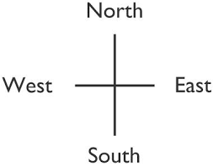

Hence, this notary serves as a legal document affirming that we have donated the above stated land for public use, which will be used for _________________________________________________ for the __________________ project being implemented by __________________ government and funded by the World Bank.
Undersigned are names of deed owners in sound mind.
Name: ____________________
ID. No.: ___________________
Sign: ______________________
Tel. No.: ___________________

Name: ____________________
ID. No.: ___________________
Sign: ______________________
Tel. No.: ___________________

Acknowledgment
I, _____________________________________________, chairperson of the ___________________ Village Development Committee affirm in this legal document that we accept the land donated for public use from the above signed owner(s) of the land located in ________________________________________________ with the measurements stated above.
Undersigned is the name of the chairperson of the village in sound mind.

Name: ____________________
ID. No.: ___________________
Sign: ______________________
Tel. No.: ___________________
Date: _____________________

Witnesses
Name: ____________________
ID. No.: ___________________
Sign: ______________________
Tel. No.: ___________________
Date: _____________________

Name: ____________________
ID. No.: ___________________
Sign: ______________________
Tel. No.: ___________________
Date: _____________________

The notary office _______________________________________ is testimony that we have witnessed this agreement for which all parties were present and have the legal enforcement that will take effect as of date _______________.

Undersigned is the name of the notary officer in sound mind.

Name: ____________________
ID. No.: ___________________
Sign: ______________________
Tel. No.: ___________________
Date: _____________________

Requirements for voluntary land donation:
- The owner(s) of the land to be donated should not be forced if they do not agree with the donation.
- The impacts must be minor, that is, involve no more than 10 percent of the area of any holding and require no physical relocation.
- The land should meet technical project criteria as identified by the project engineers.
- The land in question must be free of squatters, encroachers or other claims or encumbrances.
- Verification of the voluntary nature of land donations must be obtained from each person donating land.
- Grievance mechanisms must be available.
- If land donated is not used for the agreed purpose, it must be returned. Otherwise, the donor cannot reclaim land donated and sign an official letter regarding that matter.

Annex 7. Indicative Outline
of the Environmental and Social Management Plan
An Environmental and Social Management Plan (ESMP) consists of the set of mitigation, monitoring, and institutional measures to be taken during implementation and operation of a project to eliminate adverse environmental and social risks and impacts, offset them, or reduce them to acceptable levels. The ESMP also includes the measures and actions needed to implement these measures. The Borrower will
(a) identify the set of responses to potentially adverse impacts; (b) determine requirements for ensuring that those responses are made effectively and in a timely manner; and (c) describe the means for meeting those requirements.
Depending on the project, an ESMP may be prepared as a stand-alone document or the content may be incorporated directly into the ESCP. The content of the ESMP will include the following:

Mitigation
The ESMP identifies measures and actions in accordance with the mitigation hierarchy that reduce potentially adverse environmental and social impacts to acceptable levels. The plan will include compensatory measures, if applicable. Specifically, the ESMP:
- Identifies and summarizes all anticipated adverse environmental and social impacts (including those involving indigenous people or involuntary resettlement).
- Describes—with technical details—each mitigation measure, including the type of impact to which it relates and the conditions under which it is required (for example, continuously or in the event of contingencies), together with designs, equipment descriptions, and operating procedures, as appropriate.
- Estimates any potential environmental and social impacts of these measures.
- Considers, and is consistent with, other mitigation plans required for the project (for example, for involuntary resettlement, indigenous peoples, or cultural heritage).

Monitoring
The ESMP identifies monitoring objectives and specifies the type of monitoring, with linkages to the impacts assessed in the environmental and social assessment and the mitigation measures described in the ESMP. Specifically, the monitoring section of the ESMP provides (a) a specific description, and technical details, of monitoring measures, including the parameters to be measured, methods to be used, sampling locations, frequency of measurements, detection limits (where appropriate), and definition of thresholds that will signal the need for corrective actions; and (b) monitoring and reporting procedures to (i) ensure early detection of conditions that necessitate particular mitigation measures, and (ii) furnish information on the progress and results of mitigation.

Capacity Development and Training
  - To support timely and effective implementation of environmental and social project components and mitigation measures, the ESMP draws on the environmental and social assessment of the existence, role, and capability of responsible parties on site or at the agency and ministry level.
  - Specifically, the ESMP provides a specific description of institutional arrangements, identifying which party is responsible for carrying out the mitigation and monitoring measures (for example, for operation, supervision, enforcement, monitoring of implementation, remedial action, financing, reporting, and staff training).
  - To strengthen environmental and social management capability in the agencies responsible for implementation, the ESMP recommends the establishment or expansion of the parties responsible, the training of staff and any additional measures that may be necessary to support implementation of mitigation measures and any other recommendations of the environmental and social assessment.

Implementation Schedule and Cost estimates
For all three aspects (mitigation, monitoring, and capacity development), the ESMP provides (a) an implementation schedule for measures that must be carried out as part of the project, showing phasing and coordination with overall project implementation plans; and (b) the capital and recurrent cost estimates and sources of funds for implementing the ESMP. These figures are also integrated into the total project cost tables.

Integration of ESMP with Project
The Borrower's decision to proceed with a project, and the Bank's decision to support it, are predicated in part on the expectation that the ESMP (either stand-alone or as incorporated into the ESCP) will be executed effectively. Consequently, each of the measures and actions to be implemented will be clearly specified, including the individual mitigation and monitoring measures and actions and the institutional responsibilities relating to each, and the costs of so doing will be integrated into the project's overall planning, design, budget, and implementation

Annex 8. Project Implementation Unit: Staffing and Responsibility Allowances
Table 36. Biyoole Project: Responsibility Allowance Structure
CIM Level | Type of Job | Examples of Job Titles | Responsibility Allowance (US$)
A1 | Senior Director | - Director General  - Permanent Secretary  - Chief of Staff | 1,100
A2 | Director | - Director | 900
A3 | Sub-Director | - Deputy Director  - Team Leader  - Head of Administration  - Head of Finance | 500
A4 | Senior Specialist | - Senior Public Finance Management Specialist  - Chief Statistician  - Senior Water Engineer | 400
A5 | Specialist | - Agricultural specialist  - Economist  - Engineer  - Statistician  - E&S specialist | 200

Table 37. Salary Standardization Scale for Biyoole Project (FMS)
Title | Basic Consultant Fees (US$) | Allowance  (If Provided) (US$) | Total Consultant Fees per Month (US$)
Coordinator | B2/Step 3: 4,990 | 440 (Housing and Communications) | 4,990
Procurement Specialist | B3/Step 2: 3,510 | 440 (Housing and Communications) | 3,950
Finance Specialist | B3/Step 1: 3320 | 440 (Housing and Communications)  + 210 ( if female) | 3,970 (F)  and  3,760 (M)
M&E Safeguard, Environmental, and Safeguards | B4/Step 1: 2,385 | 440 (Housing and Communications) | 2,825
Consultant Entry Fees (Jubbaland and Hirshabelle)
Coordinator | B3 Step 1: 3,320 | 440 (Housing and Communications) | 3,760
Procurement Specialist | B4/Step 4: 2,780 | 440 (Housing and Communications) | 3,220
Finance Specialist | A1/Step 1: 1,835 | 440 (Housing and Communications)  + 210 (if female) | 2,485 (F)  and  2,275 (M)
M&E Specialist | A2/Step 1: 1,635 | 440 (Housing and Communications) | 2,075
Safeguard Specialist | A2/Step 1: 1,635 | 440 (Housing and Communications) | 2,075

Annex 9. Project Procurement Strategy for Development (PPSD)
Short Form Project Procurement Strategy for Developments (PPSD) for ‘Barwaaqo’ Somalia Water For Rural Resilience Project
Project Overview
Country(s) | Somalia
Full project name | ‘Barwaaqo’ Somalia Water for Rural Resilience Project (P177627)
Total finance (US$) | 70 million
Project number | P177627
- Summary of Project Development Objective
The Project Development Objective (PDO) is to develop water, agriculture, and environmental services for rural communities in Somalia’s drylands.
PDO Level Indicators
Achievement of the PDO will be measured by the following outcome-level indicators:
- Number of people provided with access to improved water sources (of which proportion of females).
- Number of farmers/clients adopting improved technology (of which proportion of females).
- Land area (hectares) under sustainable landscape management practices.
- Project Components and Costs
The project is framed around four components, as shown in Table 38.
Table 38. Project Components and Allocated Spend Details
Project Components | Subtotal (in US$) | % Split Per Component
Component 1. Support the Development of Multiuse Water Sources | 26,300,000 | 38%
Component 2. Development of Agriculture and Livestock Services around Water Points | 15,500,000 | 22%
Component 3. Development of Environmental Catchment Services in Project Areas | 10,000,000 | 14%
Component 4. Project Management, Community Development, and Enhancing Livelihoods Planning | 17,500,000 | 25%
Subtotal of the components | 69,300,000 | 99%
Contingency | 700,000 | 1%
TOTAL | 70,000,000 | 100%

Procurement
Project procurement will be carried out in accordance with the World Bank Procurement Regulations for IPF Borrowers [Procurement Regulations] dated July 1, 2016, and updated November 2020; World Bank’s Anticorruption Guidelines, dated October 15, 2006 (revised in January 2011 and July 2016), and provisions stipulated in the Financing Agreement. Somalia being a fragility, conflict, and violence (FCV) context country, procurement under the projects will be processed under special procurement arrangements referred to in Paragraph 12 of the World Bank Policy IPF dated November 10, 2017.

Summary of the Proposed Procurement Contracts
The project envisages procurement of the following main contracts:
- Works: Contracts under Works include construction of sand/subface dams, earth dams, boreholes/shallow wells, rehabilitation of previous Biyoole water structures and office construction/rehabilitation.
- Goods and Nonconsulting services: The contracts under Goods include information and communication technology (ICT) equipment, vehicles, office furniture, hydrological water tools, and office supplies. The contracts under nonconsulting services include activities such as hiring of conference facilities, transport or information technology (IT) services, among others. The type and budget for such activities will be defined and agreed to between the Borrower and the World Bank during the project implementation period.
- Consulting services: Recruitment of individual consultants, consulting firms, nongovernmental organizations (NGOs) and United Nations (UN) specialized agencies, as the need arises for technical support and assistance.
- Nonconsulting services: The contracts under this will include internet services, photography, house rents, among others.

Operating Context
- Governance Aspects
The political and governance risks are considered ‘Substantial’, creating a difficult operating environment for the Barwaaqo project. Somalia is classified as an FCV situation by the World Bank Group. Further, the current uncertainty regarding Federal Government of Somalia (FGS) elections could heighten existing tensions in Somalia and shift development priorities. The political instability can quickly result in insecurity. Fighting in Somalia tends to be isolated and, in the event of the security situation suddenly deteriorating, project activities and funds can be reallocated to more secure states. The political process, including the relationship between the Federal Member States (FMSs) and the central FGS, therefore, remains fragile.
Somalia is situated in the Horn of Africa and lies along the Gulf of Aden and the Indian Ocean covering an area of 637, 657 square kilometers. Somalia has land borders with only two countries: Kenya to the southwest and Ethiopia to the west. The Gulf of Aden forms Somalia's northern borders and the Somali Sea and Guardafui Channel bound it to the east. Mogadishu is the capital of Somalia and is located in the Benadir Region of the country.
The Somalia region comprises the FMSs (Puntland, Galmudug, Hirshabelle, Jubbaland, and South West) and Somaliland. The FMSs have a degree of autonomy over regional affairs but are constitutionally subject to the authority of the Federal Government of the Republic of Somalia. Somaliland, on the other hand has declared self-independence from Somalia and is independently managing its own state affairs. Somaliland has experienced relative security stability compared to the FMSs of the FGS. Somalia has a population of about 15 million, of which roughly 60 percent are nomadic and semi-nomadic pastoralists, and 60 percent live in rural areas.
- Economic Aspects
Macroeconomic risks are ‘Substantial’. The economic recovery has been timid and fragile. The slow pace of vaccination continues to expose the region to emerging strains of coronavirus, holding back economic performance. Inflation has picked up due to rising food prices. The fiscal space is constrained: Somalia is in debt distress. Somalia became eligible for interim debt relief under the Heavily Indebted Poor Countries initiative in March 2020, which set the country on a course to sharply reduce its debt levels. The International Monetary Fund’s 2020 debt sustainability analysis indicates that even with the interim debt relief, Somalia will remain in debt distress, as its debt will still be about 43.3 percent of the gross domestic product (GDP) in 2024, above the 30 percent sustainability threshold.
The GDP in Somalia was worth US$4.92 billion in 2020, according to official data from the World Bank. Growth in GDP is expected to recover to 3.2 percent in 2022, which is still below pre-COVID–19 projections. Annual inflation was estimated to decrease to 4 percent in 2020 from 4.7 percent in 2019, due to tax relief on food essentials and improved food supply. The Somali shilling (SoS) remained relatively stable, depreciating by less than 1 percent between January and November 2020 as widespread dollarization reduced the supply of counterfeit currency. The SoS is stable, however, it is not convertible. (April 6, 2016–April 8, 2021: USD/SOS close: 575.756 low: 565 high: 617.5.) The Banking sector is still establishing itself in Somalia, and international providers preferred to quote in US$ or other currencies.
- Sustainability Aspects
The present project does not envisage any use of Sustainable Procurement conditions in the procurement process.
- Technological Aspects
Somalia is increasingly being connected to the outside world through digital technology: rapid urbanization means that getting urban spaces right can transform prospects for many; rapid integration of ICT technologies and financial services, with opportunities to leapfrog towards financial inclusion, e-government, a safety net based on mobile money transfers and digital entrepreneurship; a vibrant private sector connected to an informal global network; and economic integration, through infrastructure and trade, with the broader Horn of Africa region.
Market Research and Analysis
Works: Contracts under Works include the construction of sand/subface dams, earth dams, boreholes/shallow wells, rehabilitation of previous WALP water structures and office construction/rehabilitation. These being small Works, the market research shows that there are several qualified local contractors, many of whom have participated and completed projects of similar nature, complexity, and value. Under the previous WALP, it has been observed that local construction companies have experience in similar works, financial capacity and sufficient expertise. However, the major concern is that many bidders will need some training on how to avoid simple mistakes that could make bids to be rejected at the preliminary examination stage. It is, therefore, recommended that a prebid conferences be held to brief bidders on what is required when submitting bids. The proposed procurement method is Request for Bids (RfB) and Request for Quotations (RfQ) based on the budget estimates. Therefore, a national approach will be considered.
Consultancy services: The procurement activities under consultancy services for this project will be hiring consultants. These will include both individual and consultant firms, NGOs, and UN specialized agencies from local and international markets, as appropriate. There are qualified consulting firms and individuals available in Somalia, many of whom have participated in previous similar assignments funded by the Bank.
Procurement of nonconsulting services: Contracts under nonconsulting services include activities such as hiring conference facilities, transport or IT services. Given the nature and size of the nonconsultancy services to be procured, most of the potential bidders are available locally. Such items will be procured through National Open Competitive market approach and RfQs.
Office Equipment, vehicles, and supplies: Somalia has local traders for ICT equipment, scientific equipment, motor vehicles, furniture, and other office supplies. These items are available either locally or internationally. Such items will be procured using either Open National/International or RFQ methods, as appropriate.
Systematic Tracking of Exchanges in Procurement (STEP): The World Bank’s STEP system will be used to prepare, clear, and update Procurement Plans (PPs) and conduct all procurement transactions for the project. The staff will be trained on using STEP.
Procurement templates: The Bank’s Standard Procurement Documents (SPDs) shall be used for procurement of Goods, Works, consulting and nonconsulting services under International Competitive Procurement. However, International Competitive procurement is not anticipated. As there are no National Bidding documents, the Bank’s SPDs may be used under National Procurement Procedures (NPP). Similarly, selection of consultant firms shall use the Bank’s SPDs, in line with procedures described in the Procurement Regulations.
Publication (advertising): The Borrower is required to prepare and submit to the Bank a General Procurement Notice. The Bank will arrange for its publication in United Nation Development Business online (UNDB online) and on the Bank’s external website. Specific Procurement Notices for all procurement under ICB and Requests for Expressions of Interest for all consultancies shall be published in at least one newspaper of national circulation in the Borrower’s country, or in the official gazette, or on a widely used website or electronic portal with free national and international access, and in UNDB online.
Training and workshops: The project will finance training and workshops. These costs should not be on the Procurement Plan. If required, based on an annual training plan and budget which shall be submitted to the Bank for its prior review and approval. The annual training plan will identify, inter alia: (a) the training envisaged; (b) the justification for the training; (c) the personnel to be trained; (d) the duration for such training; and (e) the estimated cost of the training. At the time of the actual training, the request shall be submitted to the Bank for review and approval. Upon completion of the training, the trainees shall be required to prepare and submit a report on the training received.
Procurement implementation arrangements: The existing procurement implementation arrangement of the ongoing Biyoole project will be maintained and strengthened under the proposed Barwaaqo in FGS and FMSs (Puntland, Galmudug, and South West states), and Somaliland. In addition, the implementation timelines of Biyoole (stipulated to be closed on February 28, 2023) and Barwaaqo are overlapping; hence the expertise gained and institutional memory will be beneficial for implementation of Barwaaqo. The Project Coordination Units/Project Implementation Units (PCU/PIUs) are already staffed with project coordinators and procurement specialists, among other key staff. An adequate number of officials dealing with procurement in the PCU/PIUs either directly or indirectly have undergone procurement training with focus on the World Bank's procurement regulations. However, they are not yet fully conversant with the new World Bank Procurement Regulations and are still learning. Under the new project, the Bank will continue to provide support by conducting training aimed towards addressing procurement capacity issues for the PCU/PIU staff and technical departments/stakeholders. The new PIUs for the additional states of Hirshabelle and Jubbaland will be established during project implementation. The assessment of the new PIUs reviewed lack of adequate previous experience in World Bank Procurement Regulations. To mitigate the risk, the PIUs will recruit qualified procurement specialists with experience acceptable to the World Bank, among other staff. Also, during project implementation, the capacities of the PIUs will be strengthened. In this regard, the procurement capacity will be enhanced through on-the-job training, hands-on support and mentoring by the World Bank Procurement team during project implementation. Also, additional staffing will be considered as needed.
Procurement assessment: A capacity assessment of the four PIUs in the FMSs (Galmudug, Puntland, and South West State) to implement the project procurement was conducted in April 2021. The objectives of the assessment were (a) to evaluate the capability of the PIUs to undertake procurement and the adequacy of the systems that are in place to administer procurement; (b) to assess the ability of the PIUs to effectively carry out the procurement processes; (c) to develop an action plan to be implemented as part of the project to address the deficiencies detected by the assessment, aimed at minimizing the risks identified; and (d) to propose procurement supervision plans for the Bank considering the relative strengths and weaknesses and risks revealed by the assessment.
The assessment reviewed that the implementing agencies have previous procurement experience, but they lack adequate capacity and previous experience in the World Bank Procurement procedures (World Bank’s New Procurement Framework [NPF]) and hence will require support to undertake the necessary procurements satisfactorily according to Bank procedures. Due to anticipated procurement workload, it is proposed that each PIU will recruit a procurement specialist with knowledge and experience of World Bank procurement procedures to support the procurement activities of the project. The procurement specialists will work alongside the procurement personnel in the ministries for knowledge transfer, to enable them gradually to take over the procurement activities of the project. The Bank will also provide procurement training/hands-on support to build the capacity of the client’s local procurement staff during the project implementation. The major procurement challenges of the PIUs include (a) inadequate experience in undertaking procurement in accordance with the requirements in the Procurement Regulations for Borrowers under IPF: Goods, Works, Nonconsulting Services and Consulting Services dated July 1, 2016 (revised November 2017); (b) inadequate experience in contract management; and (iii) record keeping system.
Risk Assessment: In view of the challenges outlined above, the risk for procurement was considered ‘High’. The risk is reduced to a residual rating of ‘Substantial’ in view of the mitigation measures proposed in Table 39.
Table 39. Procurement Risks and Mitigation Measures
Risk Description | Mitigation Measures | Timeframe | Responsibility
Inadequate knowledge and experience of World Bank Procurement Regulations for Borrowers under IPF: Goods, Works, Nonconsulting Services and Consulting Services dated July 1, 2016 (revised November 2017) | Recruit a procurement specialist with knowledge and experience of World Bank procurement  Conduct training for Client on WB Procurement Regulations for Borrowers under IPF: Goods, Works, Nonconsulting Services and Consulting Services dated July 1, 2016 (revised November 2017 and 2018)  Prior review of all contracts regardless of the value | During project implementation | FGS and FMSs (Galmudug, Hirshabelle, Jubbaland, Puntland, and South West), and Somaliland/WB
Inadequate knowledge and skills in contract management by the implementing agencies | Conduct training tailored towards addressing the weaknesses in contract management for PIU staff and technical departments  Recruitment of senior procurement and contracts management specialist at FGS level | During project implementation | FGS and FMSs (Galmudug, Hirshabelle, Jubbaland, Puntland, and South West), and Somaliland/WB
Inadequate skills of the end users in developing specifications and terms of reference (ToR) | Need for TAs/consultants in the respective technical areas to extend hands-on support and the support of HEIS | During project implementation | FGS and FMSs (Galmudug, Hirshabelle, Jubbaland, Puntland, and South West), and Somaliland/WB
Need for systematic filing system to have complete records of the procurement processes | Establishment of a satisfactory filing system | During project implementation | FGS and FMSs (Galmudug, Hirshabelle, Jubbaland, Puntland, and South West), and Somaliland/WB
Due to security challenges and weak public sector functionality, private sector participation and efficiency would be limited, and this affects the supply market functionality | All biding opportunities will be advertised on the available websites and posted on widely circulated national gazette | During project implementation | FGS and FMSs (Galmudug, Hirshabelle, Jubbaland, Puntland, and South West), and Somaliland/WB
Fraud and corruption risks (including collusion and outside interference) in contracting process | Disclosure of procurement plans, disclosure of contract awards, and creating awareness about effects of fraud and corruption | During project implementation | FGS and FMSs (Galmudug, Hirshabelle, Jubbaland, Puntland, and South West), and Somaliland/WB
Use of unqualified and inexperienced evaluation members and varying of the evaluation criteria through elimination or skewed subcriteria | Use of a qualified and experienced sector relevant evaluation panel, which has the time to undertake the evaluation within the possible shortest time and ensure confidentiality  Use of clearly defined evaluation criteria established in the bidding documents without variations or skewing  Training for the evaluation members on carrying out bid evaluations | During project implementation | FGS and FMSs (Galmudug, Hirshabelle, Jubbaland, Puntland, and South West), and Somaliland/WB
Low awareness of procurement risks | Creating awareness among the government, private sector, and other stakeholders about the key issues regarding integrity in procurement and financial management | During project implementation | FGS and FMSs (Galmudug, Hirshabelle, Jubbaland, Puntland, and South West), and Somaliland/WB
Procurement Oversight and Monitoring Arrangements
The Bank exercises its procurement oversight through a risk-based approach comprising prior and post reviews, as appropriate. The Bank sets mandatory thresholds for prior review based on the procurement risk rating of the project. Based on the risk rating of the project, the Bank and Borrower will agree to procurement above the applicable thresholds, as provided in Table 40, which shall be subjected to prior or post review. The requirement for a prior or post review shall be specified in the PP. During project implementation the Bank will monitor and reassess the risk and risk mitigation measures and, if determined by the Bank to be necessary and appropriate, the Bank may require the Borrower to revise the prior and/or post review requirements in the PP. The Bank will carry out post reviews of procurement activities undertaken by the Borrower to determine whether they comply with the requirements of the Financing Agreement. The FGS will also hire a Third Party Monitoring Firm to make sure that funds are used for the intended purposes.

Table 40. Thresholds for Goods, Works, and Nonconsulting Services
Category | Prior Review  (US$ million) | Open International | Open National | Request for Quotation  (RfQ)
Works | ≥0.2 | ≥5.0 | <5.0 | ≤0.2
Goods, IT, and nonconsulting services | ≥0.1 | ≥0.5 | <0.5 | ≤0.1
Table 41. Thresholds for Consulting Services
Category | Prior Review  (US$, million) | Shortlist of National Consultants
Category | Prior Review  (US$, million) | Consulting Services | Engineering and Construction Supervision
Consultants (firms) | ≥0.1 | ≤ .1 | ≤ .2
Individual consultants | ≥0.05 | n.a. | n.a.
Selection method: For Goods and Nonconsulting services, RfB and RfQ will be used as appropriate. Where there is justification, direct selection may be used. For Consulting Services, the preferred method would be QCBS. However, other methods including Consultant Qualification-based Selection (CQS) and direct selection would be used as stipulated in the Procurement Plan.
Contract strategy: Goods, Services, and Works will be packaged in economical packages to attract bidders who are qualified and can offer good prices and complete contracts within the stipulated period, thus resulting into value for money.

Annex 10. Contingency Emergency Response Component (CERC)

Emergency Operations Manual
(Updated: November 22, 2017)

Table of Contents

Executive Summary 3
Background 3
Mechanism for Triggering CERC 4
Coordination and Implementation Arrangements 5
Procurement 6
Fraud and Corruption 13
Disbursement and Financial Management 13
Safeguard Compliance 14
Monitoring and Evaluation 14

Executive Summary
This Annex was prepared pursuant to the Financing Agreement for the Agro-Pastoral Productivity and Resilience, or ‘Biyoole’ Project (P167826). The Financing Agreement stipulates the preparation and submission of an Emergency Response Operations Manual (hereafter referred to as the Emergency Operations Manual, or EOM) for the Contingency Emergency Response Component (CERC) as one of the two conditions for implementation of said Component.
This Annex serves as the Government of Somalia’s (GoS) EOM and details (a) the proposed emergency activities to be financed by the proceeds allocated to the Project’s CERC and its Disbursement Category 3; and (b) the coordination and implementation arrangements related to the programing and execution of said activities.
Upon No Objection by the World Bank, the EOM will be annexed to the Biyoole project’s Operations Manual and will be used by the implementing agency through its Project Implementation Unit (PIU), as it relates to:
  - Triggering the CERC.
  - Coordination and implementation of the emergency activities.
  - Procurement, financial management, and disbursement functions.
  - Compliance with the project’s safeguard policies.
  - Monitoring and evaluation of the emergency activities.
The specific activities to be financed by the proceeds reallocated to CERC are event- and demand driven. The contents of this EOM represent the framework by which this component will be triggered and by which the approved activities will be coordinated and implemented in accordance with World Bank and national policies and procedures as agreed with the World Bank.

Background
The GoS received financing from the World Bank/International Development Association for the purposes of implementing the Biyoole project, the development objective of which is to develop water and agricultural services among agro-pastoralist communities in dryland areas of Somalia. The project’s loan amount is US$42 million, of which US$0 is allocated to CERC.
Consistent with the project’s development objective, the CERC funds will finance postdisaster emergency recovery eligible expenditures in support of the government’s rapid emergency response efforts.
In the event or imminence of a major crisis or emergency, the GoS may submit a request to reallocate funding within the Biyoole project vis-à-vis the allocation of uncommitted financial resources to CERC to address emergency response needs. The use of such resources will be subject to Bank No Objection.

Mechanism for Triggering the CERC
The Biyoole project’s Financing Agreement establishes that two conditions should take place for requesting the CERC activation. These are:
  - Establishment of a causal relationship between the eligible emergency and the need to trigger the CERC.
  - Preparation of, and furnishing to, the World Bank a request for financing through CERC, indicating the project’s funding to be reallocated.
The causal relationship between the eligible emergency and the need to activate the CERC to withdraw proceeds will be established by an official government declaration of emergency in accordance with a Statement of Facts acceptable to the Bank, based on a preliminary assessment of damages and needs.
The Statement of Facts can be a third-party declaration of emergency, such as the United Nations (UN) Flash Appeal. In case of health emergencies, third-party declarations will be considered for triggering, such as the World Health Organization (WHO) Risk Assessment Level 2 grade and greater, as described by the WHO Emergency Response Framework; or an equivalent grading by other international agencies such as World Organization for Animal Health (OIE), United Nations Environment Program (UNEP) or the Food and Agriculture Organization (FAO).
An eligible crisis or emergency is defined by the World Bank as an event that has caused or is likely to imminently cause a major adverse economic and/or social impact associated with natural or man-made crises or disasters.
The government will seek support from the World Bank to select a list of activities for financing under the CERC based on the positive list presented in the Procurement Section of this Annex (Table 43) and priorities identified at the preliminary assessment of the emergency’s impact (damage, needs, or both). Likewise, the government may seek advice from the World Bank in the selection of which component of the project will reallocate funds to the CERC, if necessary.
The government will officially notify the Bank of the interest to activate the CERC, summarizing the nature of the emergency. As a second step, an official letter requesting to trigger CERC shall be sent to the World Bank’s Somalia Country Director by the Minister of Finance (MoF), indicating the following information:
- Nature of emergency, its impacts (preliminary assessment of damage and/or needs) and confirmation of causal relationship, as supported by the official declaration of emergency, between the event and the need to access the funding through the CERC.
- Indication of the project’s funding to be reallocated to the CERC and the distribution of reallocation across components and disbursement categories.
- List of emergency activities to be carried out with estimated cost (brief description).
- Implementation modalities with respect to decentralized activities if needed.

Coordination and Implementation Arrangements
The Biyoole project’s implementing agency through its Project Implementation Unit (PIU) is the lead agency within the GoS responsible for the implementation of emergency activities, including all aspects related to procurement, financial management, monitoring and evaluation, and safeguard compliance.
Other relevant governmental agencies may provide technical assistance to the PIU as related to the finalization of procurement bidding documents and the technical supervision of the emergency recovery and reconstruction activities.
The government may bolster its supervision capacity through the engagement of technical consultants to support the governmental agencies in the finalization of bidding documents and site supervision of works. The technical consultants shall work closely with the governmental agencies but report to the PIU.
The Ministry of Finance, with the support of the sectorial ministries, will be responsible for:
- Ensuring the delivery of the emergency activities outputs and the attainments of outcomes by facilitating coordination amongst the governmental agencies and institutions participating in the implementation and by addressing coordination issues as they arise.
- Reviewing progress reports as submitted by the PIU coordinator and take action thereon if needed.
- Providing guidance as needed.
Table 42 summarizes the specific implementation steps associated with the emergency activities and the assigned responsibilities.
Table 42. Steps for Implementation
Step | Actions | Responsibility
1 | Decision to trigger CERC: In the event of an official declaration of emergency, based on preliminary damage and needs assessment, the Ministry of Finance (MoF) will inform the World Bank (WB) about its interest in triggering CERC | MoF
2 | Identification of emergency activities: Following the MoF’s decision to trigger CERC, it will seek support from the Bank through the Project Implementation Unit (PIU) in the selection of a list of emergency response activities within the Positive List based on results of the preliminary damage and needs assessment. Summary information will be prepared on proposed activities, including the nature and amount of goods, the location and type of the proposed emergency services/works and their preliminary technical specifications, estimated costs and safeguard implications | MoF, WB, PIU, and governmental agencies
3 | Request of activation: The MoF will send a letter requesting the activation of the CERC to the WB. This letter shall include the description of the event, the needs, indication of funding source and amount to be reallocated, and list of activities to be carried out in response to the emergency | MoF and PIU
4 | WB review and No Objection: The WB, upon positive review of activation request, grants No Objection. | WB
5 | Reallocation: The WB processes the reallocation of funds from Project components to the CERC | WB
6 | Implementation of emergency activities: The PIU starts the implementation of approved emergency activities  Procurement: The major activities under this step include, inter alia, (a) analysis of procurement implementation capacity and methods; (b) preparation of technical specifications and bills of quantities for critical Goods, Works, and Nonconsulting services; (c) recruitment of a consultant/consulting firm for design/supervision of emergency subprojects; and (d) procurement of Goods, Works, and Nonconsulting services for implementation of emergency activities.  Financial management (FM) and progress reporting: The PIU will follow the project’s FM and reporting procedures as defined in the Financing Agreement and detailed in the project’s Operations Manual.  Monitoring and evaluation: The oversight and reporting mechanisms established for the project will also be applied. An annually contracted external financial audit firm will audit the annual financial statements of the whole Project, including those financed through Disbursement Categories 1 & 2. | PIU
7 | Final reporting: A final report will be prepared by the PIU once all emergency activities are finished and submitted to the WB | PIU

Procurement
The PIU is responsible for ensuring that the procurement policies and procedures governing the CERC are fully and successfully applied to the contracting of Goods, Works, and Services related to the emergency activities.
In addition to ensuring that the procurement policies and procedures are applied, the PIU is also responsible for ensuring that all proposed emergency activities are eligible for financing.
Procurement will be carried out in accordance with the World Bank Procurement Regulations for IPF Borrowers and other provisions stipulated in the Financing Agreement.
All procuring entities as well as bidders and service providers shall be expected to observe the highest standard of ethics during the procurement and execution of contracts financed under the project in accordance with Section III of the World Bank Procurement Regulations for IPF Borrowers of July 2016.
The CERC will finance a combination of Goods, Works, and Services for emergency response. There shall be no prior review by the Bank for procurement during the immediate response and recovery phase of the emergency situation.
The thresholds for selection methods, and prior review to be applied to procurement under CERC during the reconstruction phase based on the World Bank’s emergency procurement procedures, will be agreed with the Bank and included in the Project Procurement Strategy for Development (PPSD) and the Procurement Plan.
Contracts not subject to prior review will be subject to post review based on a 20 percent sample.
Bidding Documents: International procurement for Goods, Works, and Nonconsulting services will be carried out using the Bank’s Standard Procurement Documents (SPD). The Standard Request for Proposal (RfP) shall be used for the selection of consultants through competitive procedures.
In the case of national procurement, the National Standard Bidding Documents (SBD) as agreed with the Bank can be used. For shopping, a simple Invitation to Quote shall be used.
In accordance with paragraphs 2.1 and 2.2 (e) of Annex 4 of the Procurement Regulations, each bidding document and contract financed out of the proceeds of the credit shall provide the provisions on fraud and corruption, and the provision that the bidders, suppliers, contractors, and subcontractors shall permit the World Bank to inspect their accounts, records, and other documents relating to the bid submission and performance of the contract, and to have them audited by auditors appointed by the World Bank.
Table 43 presents a positive list that should be used for the procurement or reimbursement of already procured goods that might be required for the government’s emergency recovery effort, as well as Works Services, and operational costs.
The GoS and the Bank may reach agreement on the conditions for the release of the financial tranches and the required documentation and certifications, such as customs and tax certificates or invoices.
The acceptable procedures as well as addressing of any associated risks and mitigation measures should be agreed.

Table 43. Positive List of Goods, Works, and Services
Item
Goods
- Medical equipment and supplies
- Nonperishable foods, bottled water, and containers
- Tents for advanced medical posts, temporary housing, and classroom/daycare substitution
- Equipment and supplies for temporary housing/living (gas stoves, utensils, tents, beds, sleeping bags, mattresses, blankets, hammocks, mosquito nets, kit of personal and family hygiene, and so on) and schools
- Gasoline and diesel (for air, land, and sea transport) and engine lubricants
- Spare parts, equipment and supplies for engines, transport, construction vehicles
- Vehicles (vans, trucks, and SUVs): Only eligible for import reimbursement
- Equipment, tools, materials and supplies for search and rescue (including light motor boats and engines for transport and rescue)
- Tools and construction supplies (roofing, cement, iron, stone, blocks, and so on)
- Equipment and supplies for communications and broadcasting (radios, antennas, batteries)
- Water pumps and tanks for water storage
- Equipment, materials and supplies for disinfection of drinking water and repair/rehabilitation of black water collection systems
- Equipment, tools, and supplies for agricultural, forestry, and fisheries
- Feed and veterinary inputs (vaccines, vitamin tablets, and so on)
Services
- Consulting services related to emergency response including but not limited to: urgent studies necessary to determine the impact of the disaster and to serve as a baseline for the recovery and reconstruction process, and support to the implementation of emergency response activities
- Nonconsultant services including but not limited to: drilling, aerial photographs, satellite images, maps and other similar operations, information and awareness campaigns
Works
- Repair of damaged infrastructure including but not limited to: water supply systems, dams, reservoirs, canals, transportation systems, energy and power supply, telecommunications
- Repair of damaged public buildings, including schools, hospitals, and administrative buildings
Emergency Operating Costs
- Incremental expenses by the government for a defined period related to early recovery efforts arising as a result of the impact of an emergency. This includes but is not limited to: costs of staff attending emergency response, operational costs, and rental of equipment

(a) Project Procurement Strategy for Development and Procurement Plan
The procurement arrangements under the CERC shall be designed and included in the PPSD. The PPSD should be simplified and fit for purpose. Selection methods, selection arrangements, and market approach options including security considerations, using streamlined procedures (for example, use of Direct Selection or Request for Quotations for large contracts) should be adopted when it is appropriate.
To streamline the market approach, ensure better outcomes and efficiency when facing emergency, the PIU will conduct periodic supply market assessments as a base source of information for procurement of items that can be required in case of such emergency (see the positive list in Table 43). A good understanding of the reality of the prevailing market conditions in the country, its competitiveness, and the country’s logistical infrastructure is essential for determining an appropriate delivery strategy for the project.
If the situation of the immediate response and recovery does not allow time and resources during preparation, the completion of the PPSD can be deferred to the implementation phase. Streamlined procurement arrangements, especially those that limit competition such as Direct Selection, shall be documented in the PPSD.
A Procurement Plan (PP) will be prepared based on the approved list of emergency activities and the PPSD as soon as it is feasible for the PIU. This plan will also be used for monitoring and reporting purposes.

(b) Selection Methods
Consultants
Direct selection: Direct selection of consulting firms and individuals should be used if it presents a clear advantage over competition for the required consulting services. Firms that are already working in the country and that have a proven track record in similar assignments may be the most suitable option for the start-up activities. Consultants selected on a single-source basis may be given the right to participate in future assignments under the same project provided that there is no conflict of interest with the tasks performed under the initial contract. However, for future or downstream assignments, any available information must be shared with all participating firms to ensure a level playing field.
Selection of consulting firms through Consultants’ Qualification-based Selection (CQS): CQS is often the appropriate method for small assignments. When justified, the Bank may agree to the use of CQS for contracts estimated to cost more than $300,000.
Consultant shortlists: On an exceptional basis, the Bank may clear shortlists of consultants where fewer than six firms have expressed an interest to submit requests for proposals and where a wide geographic spread of shortlisted consultants cannot be achieved. If advertising at an international or national level would impede a rapid selection, advertisement for expressions of interest may be forgone or limited to the local/state level for assignments with estimated cost of less than US$300,000. The selected firm is then requested to submit simplified technical and financial proposals.
Other streamlined approaches: Using a ‘pool of experts’ or a list of ‘preselected’ consulting firms may also be considered as an appropriate method at various steps of project execution, including the procurement process and the preparation of ToR, shortlists, RfPs, and bidding documents. Remuneration and fees may be resolved at the time of preselection and prescribed in a framework agreement.
Civil Works, Goods, and Nonconsulting Services
Direct selection: Direct selection for the procurement of civil works, goods, and nonconsulting services may be used to extend an existing contract or award new contracts in response to disasters. For such contracting to be justified, the Bank should be satisfied that the price is reasonable and that no advantage could be obtained by further competition. The direct contracting may be from the private sector, UN agencies/programs, contractors or NGOs that are already mobilized and working in the emergency areas.
Request for Quotations (RfQs): RFQs may be an appropriate competitive method for procuring readily available off-the-shelf goods, or simple civil works or nonconsulting services. The RfQ selection method can be used even for large contracts and the justification noted in the PPSD or procurement records as appropriate. Normally at least three price quotations should be obtained. In case that less than three suppliers or contractors are available (or less than three quotations are received), such a situation shall be noted in the procurement records and the process shall be continued.
National procurement procedures: Simplified national procedures and documentation agreed with the Bank can be used where international procedures are considered to be inappropriate or too complex due implementation capacity issues, and where there is clearly no international market appetite to participate in bidding.
The procurement procedure to be followed for the National Procurement Procedure shall be the open competitive bidding procedure or other procurement arrangements set forth in the PPSD that meet the requirements specified in paragraphs 5.3–5.6 of the Regulations and are consistent with the Bank’s Core Procurement Principles.
Simplification of pre- and postqualification criteria: The pre- and postqualification criteria requirements of the Bank’s SBDs for both Large Works and Small Works can be amended to optimize the participation of available local or regional contractors, in particular, adapting the qualification requirements to match the qualifications of available and competent local and regional contractors.
Prequalified suppliers and contractors: Using lists of prequalified suppliers and contractors, to whom periodic invitations are issued, may also help accelerate the procurement process. Such an approach could be used for a large number of similar simple contracts of any size, as well as for procurement of commodities. Prequalification documents may use a simplified format that is acceptable to the Bank. Suppliers and contractors would be asked to provide quotations for simple unit prices, as for commodities. Contracts should be awarded on a competitive basis, and may be for up to two years, with a price escalation clause and the possibility of extension upon mutual agreement between the client and the supplier.
Accelerated Bid times: Under the international and national procurement, accelerated bid times might be envisaged, but bidding periods shorter than 15 business days for international and seven business days for national should be cleared with the Bank, taking into consideration the capacity of firms (local and international) to prepare responsive bids in a short period.
Waiving bid and performance security requirements: For small contracts for Goods or Works, the preparation of bids by small and medium-size suppliers or contractors can be accelerated by taking the option, set out in paragraph 5.35, Section V of the Procurement Regulations, of not requiring a bid security. Similarly, in the case of small contracts for Works or supply of Goods, the Borrower may decide not to require a performance security. However, in Works contracts, retention money may be required during the liability period; for Goods contracts, manufacture warranties will be requested.
Advance payment: Where it is not easy for contractors and suppliers to obtain lines of credit from banks, the government may consider increasing the amount of advance payment under Works and supply contracts to up to 40 percent of the contract value, provided that the contractor/supplier provides a bank guarantee for the same amount and the World Bank clears this increased value of advance payment.

(c) Special Procurement Arrangements
Commodities
Procurement of commodities, such as grain and fuel, must be in accordance with paragraph 6.51, Section VI of the Procurement Regulations. Priority commodities must be determined in response to the basic needs resulting from the emergency situation, in particular, the needs of the poorest people.
Force Account
In emergencies, when construction firms are unlikely to bid at reasonable prices because of the location of, and risks associated with, the project or a certain government agency has a sole right in certain type of work (for example, railway track work, high tension transmission cables), Force Account for repair/reconstruction using the government agency’s own personnel and equipment or a government-owned construction unit may be the only practical method (see paragraphs 6.54 and 6.55, Section VI of the Procurement Regulations).
Use of Standby Arrangements
There is no need to wait for an emergency for making arrangements for procurement of emergency Works, Goods, and Services. The Government may carry out advanced procurement procedures according to those established in this Manual and WB Procurement Regulations under Framework Agreements (FAs). This long-term agreement with suppliers, contractors, and providers of nonconsulting services sets out terms and conditions under which specific procurements (call-offs) can be made throughout its term. FAs are generally based on prices that are either preagreed or determined at the call-off stage through competition or a process allowing their revision without further competition. Prior arrangements allow the offering and signing of contracts, whose execution is only triggered when disaster strikes.
Use of Procurement Agents
The government may hire a procurement agent (PA) or project management agent (PMA) if it is considered the most efficient option. The PA/PMA should be selected in accordance with paragraph 7.31 of Section VII of the Procurement Regulations for IPF Borrowers. Where large numbers of small contracts are involved, the Borrower may also employ a management contractor. One main criterion for selecting a PA/PMA is the firm’s ability to deploy its staff for the Borrower in a timely manner.
Use of United Nations Agencies
UN agencies may be hired on sole-source basis for contracts for which they offer their unique roles and qualifications in responding to emergency situations. Standard forms of agreement for UN agencies as acceptable to the Bank will be adopted. For those UN agencies where such forms have not been agreed with the Bank, the Bank’s team will provide acceptable sample forms.
The UN agencies may participate in activities financed by the World Bank or WB-administered trust funds in one of the following ways:
- The UN implements all or part of project activities on behalf of the country.
- The UN acts as a supplier of critical goods (for example, vaccines) under a WB-financed project.
- The UN acts as a provider of technical services under a WB-financed project.
Alternative Procurement Arrangements
The government may consider using other multilateral or bilateral agencies or organizations in project design in accordance with Section III.F of the Procurement Policy. if agreed with the Bank. In such case, the Bank may agree to rely on, and apply, the procurement rules and procedures of the agency or organization, and may agree to such party taking a leading role in providing implementation support and monitoring of procurement activities.

(d) Links to Standard Procurement Documents
National Procurement Document
Bank SPD:
SPD for Goods:
Request for Bids—Goods (1 Envelope Process):
http://pubdocs.worldbank.org/en/483691488554783284/SPD-Request-for-Bids-GOODS-1-envelopeprocess-January2017.docx
Request for Bids—Goods (2 Envelope Process):
http://pubdocs.worldbank.org/en/468681488554784631/SPD-Request-for-Bids-GOODS-2-envelopeprocess-January2017.docx
SPD Works
Prequalification Document—Works
http://pubdocs.worldbank.org/en/548921488913575648/SPDPrequalificationDocumentWORKSJanuary2017.docx
Request for Bids—Works (After Prequalification)
http://pubdocs.worldbank.org/en/121881487953110913/SPDRequestforBidsWORKSafterprequalificationJanuary2017.docx
Request for Bids—Works (Without Prequalification)
http://pubdocs.worldbank.org/en/714331487953112744/SPDRequestforBidsWORKSwithoutprequalificationJanuary2017.docx
Request for Bids—Works: Roads (Output and Performance-Based Road Contracts)
http://pubdocs.worldbank.org/en/171191487887148073/SPDRequestForBidsROADSOutputandPerformanceBasedContractsJanuary2017.docx
Request for Bids—Small Works (1 Envelope Process)
http://pubdocs.worldbank.org/en/345371487887149754/SPDRequestforBidsSMALLWORKSOneEnvelopeJanuary2017.docx
Request for Bids—Small Works (2 Envelope Process)
http://pubdocs.worldbank.org/en/953971487887151207/SPDRequestforBidsSMALLWORKSTwoEnvelopeJanuary2017.docx
Bid Evaluation Form (Goods, Works, and Nonconsulting Services)
http://web.worldbank.org/WBSITE/EXTERNAL/PROJECTS/PROCUREMENT/0,,contentMDK:20062543~isCURL:Y~menuPK:84284~pagePK:84269~piPK:60001558~theSitePK:84266,00.html
Request for Proposals—Consulting Services
http://pubdocs.worldbank.org/en/696341487953115547/SPDRequestForProposalsConsultantsJanuary2017.docx
Consultant—Sample Evaluation Report
http://web.worldbank.org/WBSITE/EXTERNAL/PROJECTS/PROCUREMENT/0,,contentMDK:20062010~menuPK:84284~pagePK:84269~piPK:60001558~theSitePK:84266~isCURL:Y,00.html

Fraud and Corruption
All procurement entities as well as bidders and service providers (that is, suppliers, contractors, and consultants) shall observe the highest standard of ethics during the procurement and execution of contracts financed under the project in accordance with Annex IV of the Procurement Regulations.

Disbursement and Financial Management
The PIU is responsible for ensuring that the financial management and disbursement policies and procedures governing the project are fully and successfully applied to the management of the financial resources mobilized through Disbursement Categories 1 & 2 in support of the identified emergency activities. These policies and procedures are detailed in COAP.
Incurred expenditures under Disbursement Category 3 for Emergency Expenditures under the CERC will be audited by the external auditor alongside other project activities as indicated in the external audit ToR. The project’s internal auditor will carry out target review of incurred expenditures under Disbursement Category 3, including reviewing inventory and output of Goods, Works, and Services.

Safeguard Compliance
An Environmental and Social Management Framework (ESMF) for contingent emergency response financing is required to align with the EOM and to supplement the existing environmental and social safeguards instruments of the project, where needed. This ‘CERC-ESMF’ will outline a screening process built around the positive list for key environmental and social issues and risks. This will be linked to identifying institutional arrangements for oversight of any required additional environmental and social (E&S) due diligence and monitoring. In addition, the CERC-ESMF will include generic emergency small-scale civil works ‘sector’ guidance identifying key E&S issues with practical Environmental and Social Management Plan (ESMP) type checklists. (See Annex 4 for details.)
Activities financed under the contingent component will be limited to provision of critical Goods and Services, as well as repair or reconstruction of damaged infrastructure outlined in a positive list in this EOM (Table 43). Land acquisition leading to involuntary resettlement and/or restrictions of access to resources and livelihoods is not anticipated. It is also unlikely that changes to the existing safeguards instruments of the project will be required. However, if necessary, the safeguards instruments will be updated if the emergency activities do not fall within the scope of the existing instruments. It is unlikely that emergency works will trigger new safeguards policies. However, if required, new instruments will be prepared, consulted upon and disclosed; per the requirements of the Bank’s Investment Financing Policy, a restructuring would be prepared.

Monitoring and Evaluation
The GoS recognizes the particular importance of monitoring and evaluation of the CERC given that it represents a novel approach to disaster recovery financing and will require particularly strong oversight to ensure appropriate emergency activity implementation. In case of activation, additional indicators related to the CERC will be added to the project’s Result Framework during restructuring. The CERC activities will be part of regular project monitoring and will be assessed as part of the final project evaluation.
Given the large number of postdisaster activities that may be initiated shortly after the approval of the use of the contingent funding—in addition to those already under implementation—the PIU may hire additional technical consultants to support supervision and procedural compliance efforts, particularly as they pertain to fiduciary and safeguards.

Annex 11. Implementation Support Plan
Table 44. Implementation Support Plan
Phase | Focus | Implementation Support Missions
Initiation phase | - Project start-up  - Signing of advanced procurement contracts  - Preparing safeguards instruments  - Training fiduciary staff  - Establishing Project Implementation Units in Hirshabelle and Jubbaland  - Enhancing management information systems  - Initiating procurement | As part of the mobilization and then annual workplans
Project life span | - Implementing support missions  - Leveraging community-based platforms  - Facilitating recruitment of local facilitators  - Supporting formulation  - Implementing plans  - Fostering citizen engagement | Twice yearly and additional interim implementation support missions every quarter

Annex 12. Action Plan
Table 45. Action Plan
Action | Responsibility | Start Date | End Date | Status/Updated End Date at XX
Component 1: Support the development of multiuse water sources
- Initiate the establishment of Project Implementation Unit (PIU) capabilities
a. Bring the PIUs onboard, especially in Hirshabelle and Jubbaland
b. Establish office space and procure equipment for Hirshabelle and Jubbaland
- Procure and mobilize an engineering consulting firm
a. Centralized procurement of the backstopping engineering firm; each participating FMS to conduct site feasibility studies and investment plans
b. Procure in accordance with the Project Procurement Strategy for Development (PPSD)
- Site selection
a. Initial selection using Wadi Evaluation Tool (WET)
b. Define parameters including land issues for final dam sites
c. Field visits by project team to selected dam sites
d. Ground truthing feasibility studies for appropriate technologies
e. Discussions with communities to finalize agreements on exact locations
- Estimate water availability to inform community mobilization and planning process and community identification of water resource use, and so on
- Surveys and design of dams and associated structures
a. Consulting firm to carry out individual site feasibility studies for each participating government
b. Consulting firm to prepare investments plans for each participating government
- Specifications, tenders, and contract awards
a. Each PIU to manage procurement pursuant to the project procurement and workplans and in accordance with the procurement arrangements in the Project Operations Manual (POM) for Works at selected sites
- Develop a contract management plan
a. To be guided by the World Bank Procurement Guidance: Contract Management (September 2018)
- Construct dams/water infrastructure
a. Respective PIUs to contract construction firm(s)
b. Construction to be undertaken in the selected sites by the selected construction firm(s)
i. Dams/sand dams
ii. Gabions/trees for river embankments
iii. Shallow wells
iv. Animal troughs
v. Standpipes/kiosks
vi. Storage tanks – 25 CUM
vii. Solar pump systems
viii. Pipes and fittings
ix. Construct ancillary works (pit latrines)
- Site supervisions
a. Regular site supervisions until the end of the project
10. Contract management undertaken by each PIU, guided by World Bank Procurement Guidance
- Commission dams/water infrastructure, undertaken by responsible Ministries, Departments, and Agencies (MDAs) in the various regions
Component 2. Development of Agriculture and Livestock Services around Water Points
2.1 Increased sustainable farming production and development
      - Mobilization of farmers into CIGs/VMGs
      - Establish demonstration plots for community gardening and agroforestry activities
      - Establish Farmer Field Schools
      - Microproject investments at CIG level (FLID, SLM, VMGs, and Nutrition)
      - Procurement and distribution of seeds and tools
      - a. Mode can vary depending on the implementation support provided
      - b. Priority is to procure certified or quality declared seeds from local suppliers whenever possible.
      - Delivery of climate smart agriculture training and training for specific crops
a. Including:
i. Soil micronutrient assessments
ii. Soil rehabilitation/management and needed training
iii. Soil moisture management
2.2 Increased sustainable livestock production and development
- Procurement process for mobilization of pastoralists into CIGs/VMGs; training of CHWs
- Procurement process for microproject investments at CIG level (breed improvement, animal health, rangeland and fodder management)
- Procurement process for establishment of Pastoralists' Field School and demo plots
- Veterinary clinics services, veterinary clinics centers, and operation management
- Provide livestock supplies, medicine, and operation and maintenance
- Mobilize pastoralists into CIGs/VMGs; training of CHWs
- Microproject investments at CIG level (breed improvement, animal health, rangeland and fodder management)
- Establish Pastoralists' Field School and Demo Plots
2.3 Institutional and capacity development
    - FGS sharing harmonized agricultural and Livestock manuals, policies and guidelines
    - Create sectoral committees chaired by FGS Agricultural and Livestock Ministry for close coordination of sector works
    - Procure agricultural, livestock specialist and focal points to manage activities
    - Operation support for office and veterinary clinics
    - Capacity building of lead Community Animal Health Workers
    - Capacity building of FPOs and linkages with CIG/VMGs
    - Community Animal Health Workers’ training and veterinary clinics centers’ development
Component 3. Development of Environmental Catchment Services in Project Areas

3.1 Environmental restoration
FGS Leading Forums and Creation of Sectoral Team Committee and sharing SLM Guidelines
Develop Village Profiles and Community Investment Groups
4. Implement Cash for work schemes to mobilize community labor for SLM and Rangeland interventions Monitor activities for quality control and evaluate and document impacts
Implement community-based Rangeland management activities based on guidelines developed under component
Procure inputs, machinery and equipment for SLM and rangeland activities
Land terracing, gully rehabilitation, Prosopis control and reforestation and/or natural regeneration.
Procure Tools and equipment for SLM activities
3.2 Institutional and capacity development
• Support community committees to establish resource mobilization mechanisms
• Regional/national conferences on environment and climate change
- Regional/national conferences on environment and climate change
Capacity building, office buildings, equipment and specialist and Focal point staffing
Community committees training on climate change, adaptation
- Develop a community operations manual (COM)
- Prepare information, education, and communication (IEC) materials about the project
- Develop community-based SLM guidelines – individual consultant
7. Develop community-based rangeland management guidelines – individual consultant
8. Prepare guidelines for agriculture support in project communities
9. Prepare proposals for targeted exposure visits
Component 4.2: Community-driven development planning
1. Sensitize communities on roles and responsibilities for participating in the project
- PIU staff, civil servants and contracted service providers to meet with local leaders around 2-3 weeks before mobilization process starts
- First meeting to introduce the “rules of the game” for participation in the project
- Mobilizers to engage with the community at least ion a weekly basis for the first two months
- Should include all the steps outlines below:
6. Develop a village profile
a. Including number of households, livelihood profiles and constraints to livelihoods; estimated wealth rankings; number and size of different stakeholder groups
7. Including a mapping exercise of community assets, and so on.
8. Sensitize communities on the costs (construction and maintenance) and benefits of different technologies
11. Enhance the capacity for community governance by training leaders
12. Develop Community Investment Plans (CIPs)
13. Identify and/or establish committee to oversee labor-intensive public works within the community
14. Establish Common Interest Groups (CIGs) for Component 3 activities.
15. Contract management will be undertaken by PIUs, guided by the WB Procurement Guidance: Contract Management

Annex 13. Procedures for Travel-Related Payments
Planning of trips shall be undertaken to minimize the cost of travel and, where appropriate, allow for sufficient time to process travel advances.

Request and Approval of Travel
- Employee travel must be approved in advance by the Project Implementation Unit (PIU) Head and individual holding spending authority for the relevant Ministry, Department, and Agency (MDA). The request must include the itinerary, a budget, and the reason for the proposed travel.
- If approved in (1) above, then the PIU Head submits a letter requesting a ‘No Objection’ to the Task Team Leader (TTL) via email, including the:
- Traveler’s name and position.
- Itinerary.
- Purpose of the travel.
- Project subcomponent under which the travel is to be funded.
- Budget, including:
- Flight costs for economy class travel, supported by cost quotation(s);
- Daily Subsistence Allowance (DSA), which covers hotel, food and incidentals (tips, laundry, toiletries, and so on). The DSA is available to travelers to a maximum of the applicable daily rate multiplied by the number of accommodation nights;
- Visa fees;
- Local transportation; and
- Other.
- Approval of PIU Head and individual holding spending authority for the relevant MDA.

Requesting Travel Advances
- Requests for travel advances may be submitted by the traveler to the PIU Head, when possible 21 days prior to travel. Advances may be provided up to 100 percent of the traveler’s approved budget per the NOL not including flight costs.
- Once approved by the PIU Head, travel advance request will be submitted to the individual holding spending authority for the relevant MDA and forwarded to the respective Ministry of Finance for processing. Advances are to be paid to traveler’s individual bank account.
- Flights are to be booked by the PIU and paid directly to the vendor through the Ministry of finance. Flights must be purchased from authorized government vendors.

Acquittal of Travel Advances
Barwaaqo project travelers’ expense claims when no advance provided:
- Within 10 days of the end of the travel, the traveler must submit a travel expense claim package including a schedule of the amount spent, supported by original receipts.
- The PIU Finance Officer will prepare an expense voucher for the amount owed to the traveler, which will be processed via the Ministry of Finance.

Travel Payment Guidelines, Rates and NOL Processes
- Quarterly travel plans and budgets are to be developed and reviewed by the National Project Coordination Unit (NPCU) before submitting to the Bank team one week prior the start of the quarter.
- Travel authorization form along with a Statement of Mission Objective (SMO) is to be submitted to the Authorizing officer for signature before the travel date.
- The project will provide per diem and DSA for authorized travel time on the first day of travel and subsequent complete days.
- No per diem and accommodation is provided on the day of return.
- 20 percent of the total per diem rate is for breakfast and 40 percent each is for lunch and dinner.
- Accommodation amount should be accounted for with original receipts from a recognized hotel
- Official notice through email is to be sent by coordinators to the visiting state PIUs and Director Generals prior to officially traveling to the sites.
Table 46. Project Travel Allowance Rates: Visits outside Federal Member States
Travel Destination | Accommodation Rate Per Day (US$) | Per Diem Rate Per Day (US$) | Total Rate Per Day (US$)
Mogadishu | 84 | 36 | 120
Hargeisa | 84 | 36 | 120
Garowe | 84 | 36 | 120
Dhusamareb | 84 | 36 | 120
Baidoa | 84 | 36 | 120
Kismayo | 84 | 36 | 120
Jowhar | 84 | 36 | 120
Other cities | 84 | 36 | 120

Table 47. Travel Allowance Rates: Site Visits inside Federal Member States
Travel Destination | Accommodation Rate Per Day (US$) | Per Diem Rate Per Day (US$) | Total Rate Per Day (US$)
Inside state: site visits | 18 | 36 | 54

Table 48. Project-Related Travel Payments’ Procedures
Advances against expenditure | - Advances are to be requested by PIUs and made two to three weeks before travel date  - Prior advances are to be accounted for before any advances are requested  - Travel expense forms are to be completed within two weeks after return date and all supporting documents (invoices, boarding passes, signed travel form, travel authorization letter, tickets, and so on) are to be attached before processing payment  - Any unsupported expenses or the advance balances are to be paid back to project Accounts within four weeks after return date  - Any outstanding advances beyond 30 days after return from travel will be recovered from the advance-holder’s salary during the next payroll processing
Personal reimbursements | - Travel expensed are claimed with travel payment claim form  - All supporting documents (invoices, boarding passes, signed travel form, travel authorization letter, tickets, and so on) are to be attached

Annex 14. Examples of Agricultural and Irrigation Technologies
Figure 20. Examples of Agricultural and Irrigation Technologies
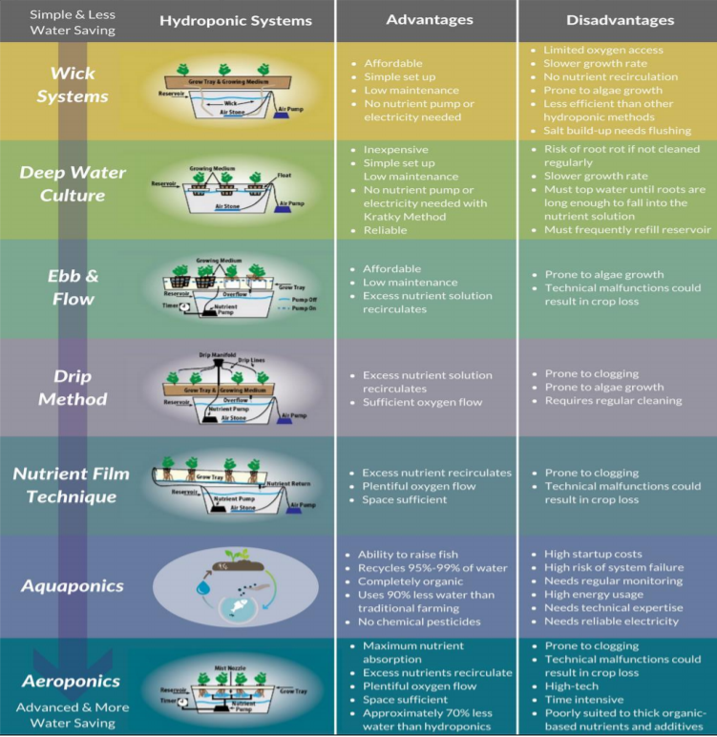

Annex 15. Map of Somalia
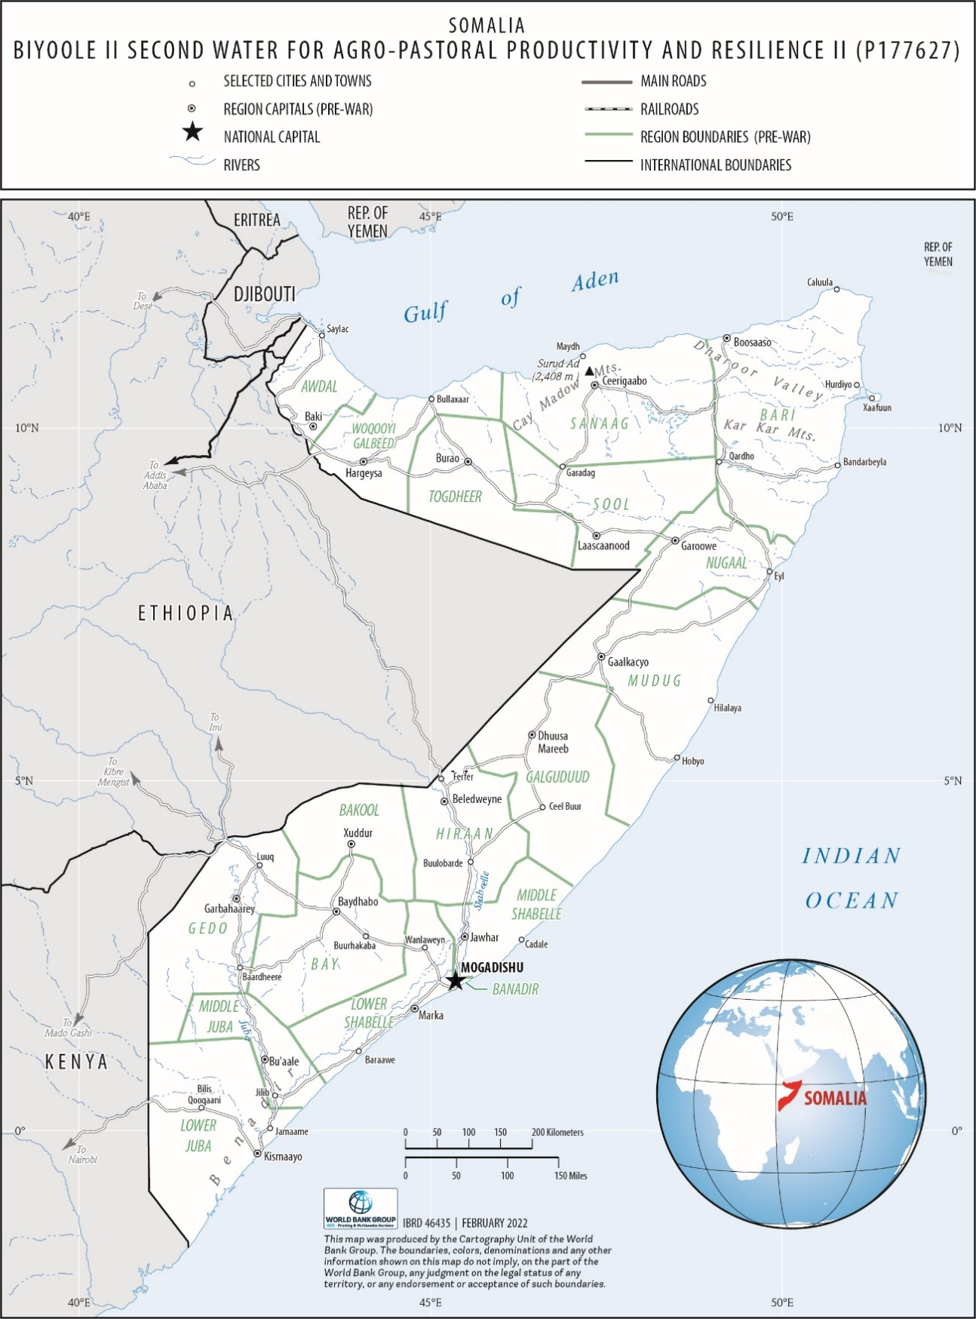

Barwaaqo in the Somali language means ‘Prosperity’. Biyoole, which means ‘water fetcher’, was disproportionally emphasizing the water sector only. However, the real nature of the project is greening the drylands of Somalia, bringing prosperity and better economic well-being to the targeted rural communities.
Financing Agreement for Somalia Water for Rural Resilience Project, the ‘Barwaaqo’ project, between the Federal Republic of Somalia and International Development Association (December 2022).
The Performance and Learning Review extended the County Partnership Framework through FY23.
Construction Investment Reports are detailed feasibility studies prepared by the backstopping engineering firm.
The ‘water harvesting explorer’ is a web tool that allows for exploration of opportunities for rainwater harvesting and water storage in the landscapes of the Western Sahel. It is important to integrate the hydrological objectives in the selection and design of interventions, especially in the semi-arid areas that are already facing acute water scarcity. Accordingly, the project will pilot the application of an innovative web tool designed by the World Bank to facilitate the selection of water harvesting interventions in the field. The web tool is developed with publicly available data and will be adapted for the project areas, with the aim of providing the users with a long list of water harvesting and storage interventions suitable for a given location. The tool will draw from many lessons already learned under the Biyoole project from developing and using the Wadi Evaluation Tool. The water harvest explorer can be accessed at https://sahel.acaciadata.com/
For example: University of Mogadishu and the Global Center for Adaptation: https://gca.org/
Hydromet services provide real-time weather, water, early warning, and climate information products to end users, based on weather, water, and climate data.
http://documents1.worldbank.org/curated/en/383011492423734099/pdf/The-World-Bank-Environmental-and-Social-Framework.pdf
FAO (2010).
FSNAU (Food Security and Nutrition Analysis Unit) (2012).
For information on how to submit complaints to the World Bank’s corporate GRS, please visit http://www.worldbank.org/en/projects-operations/products-and-services/grievance-redress-service. For information on how to submit complaints to the World Bank Inspection Panel, please visit www.inspectionpanel.org
Housing and Communications allowances should be treated as reimbursable expenses as guided by the CIM regulations.
https://www.undp.org/content/dam/uruguay/docs/adquisiciones/DSA/undp-uy-2018-12-DSA-Diciembre.pdf

